**Elaboration Specification**

**The Rockstars**

**Chris Lancaster**

**Destinee Matsoumou**

**Rachel Justus**

**Daniel Hutchins**

**Joiya Sims**

**Mohamed Zein**

**CIS 320-01**

**System Requirements**

The system requirements are displayed in a hierarchy. These are all high-level requirements in order for the new system to function properly and deliver what the Thompson Project needs.

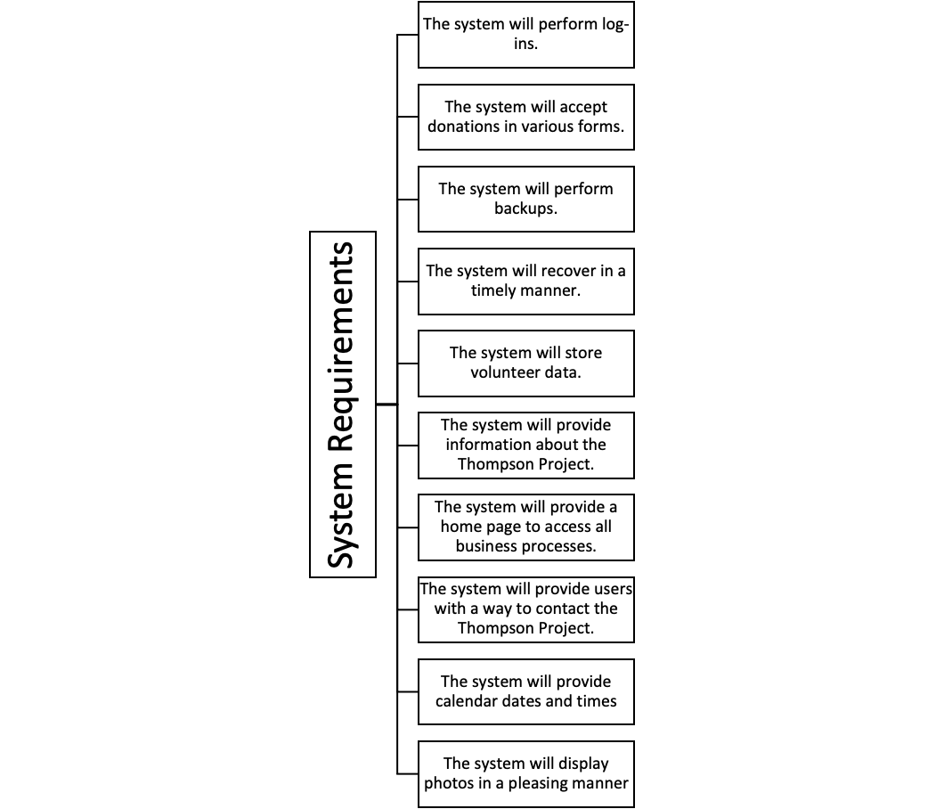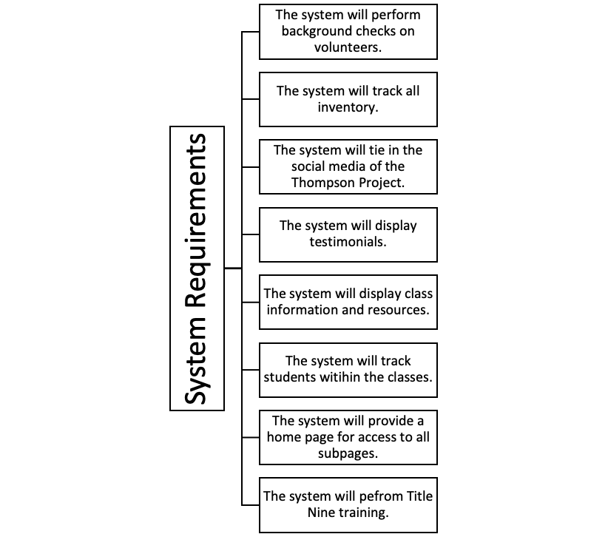

**Use Case Diagrams**

Use case diagrams are a way to model the use cases that a system will cover. There are four main pieces to this simple diagram. First is the actor, which could be either an end user, employee, or system administrator that will be interacting with the use cases. Next is the system boundary, which is represented by the square that excludes the actors. Third is the use cases themselves, represented by the bubbles inside the boundary that detail one specific use of the system. Last is the relationships, which are shown as the lines connecting the actors to the use cases they would interact with. This model is a great way to visualize how each type of actor could interact with the system. The following use case diagrams are associated with the use cases listed.

**Use Case ID: 1-7**

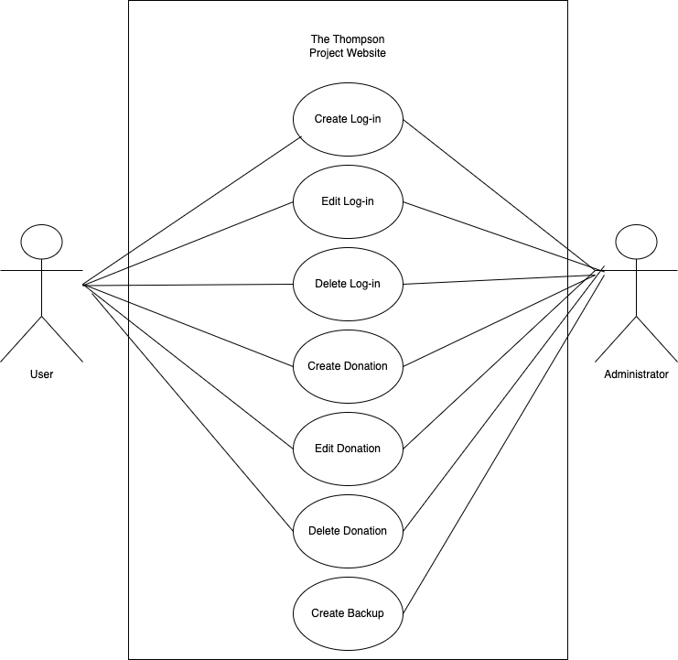

**Use Case ID: 8-14**

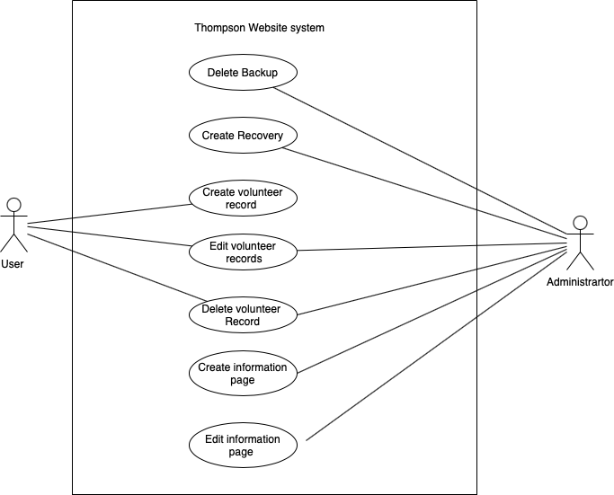

**Use Case ID: 15-21**

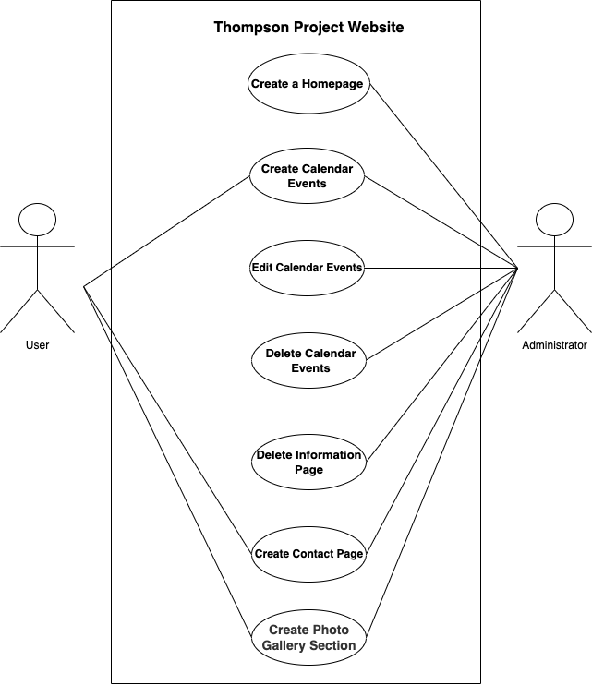

**Use Case ID: 22-27**

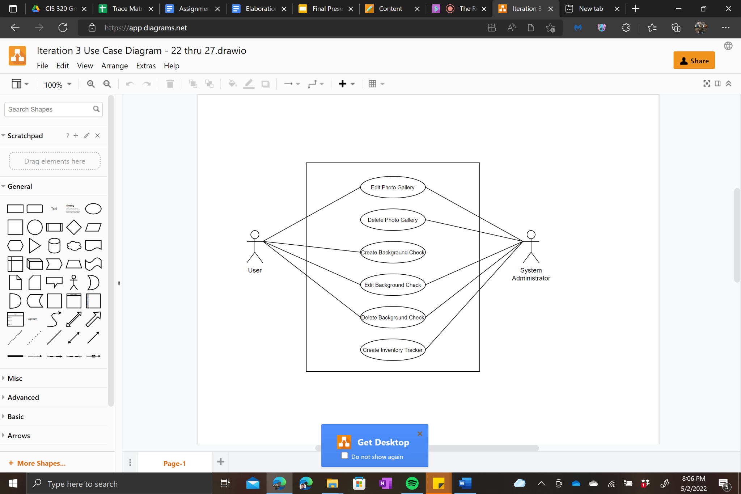

**Use Cases: 28-35**

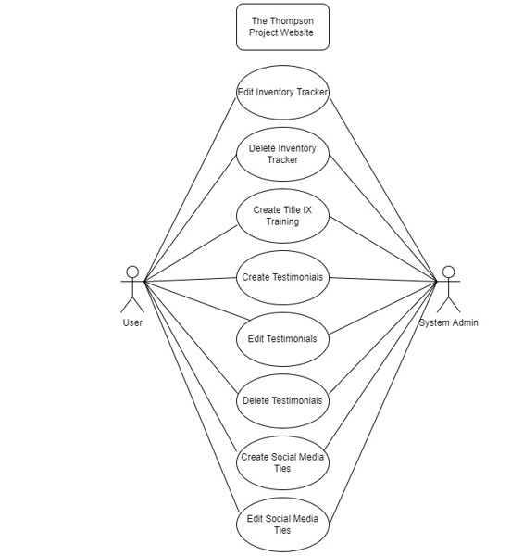

**Use Cases: 36 - 42**

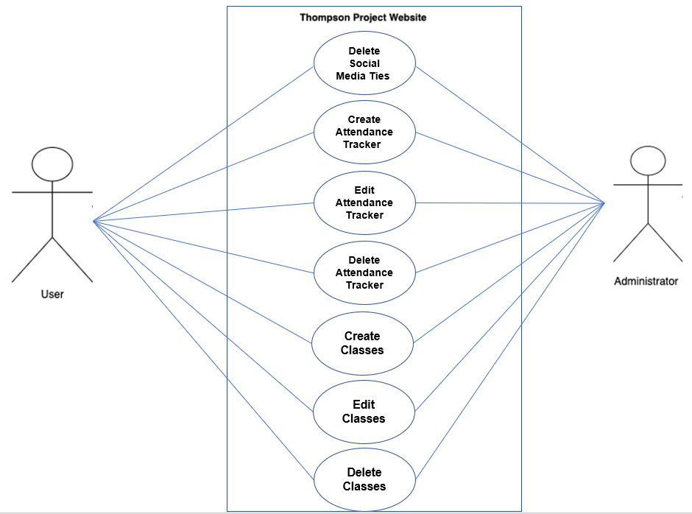

**Trace Matrix**

The trace matrix is a tool that matches a system’s high-level requirements to a specific use case created for the system.The use cases are listed along the left side of the matrix, with the corresponding system requirement listed in red at the top. Each green square represents the union between the use case and the system requirement. This tool allows for a reassurance that all system requirements have been fully covered in the use cases specified.

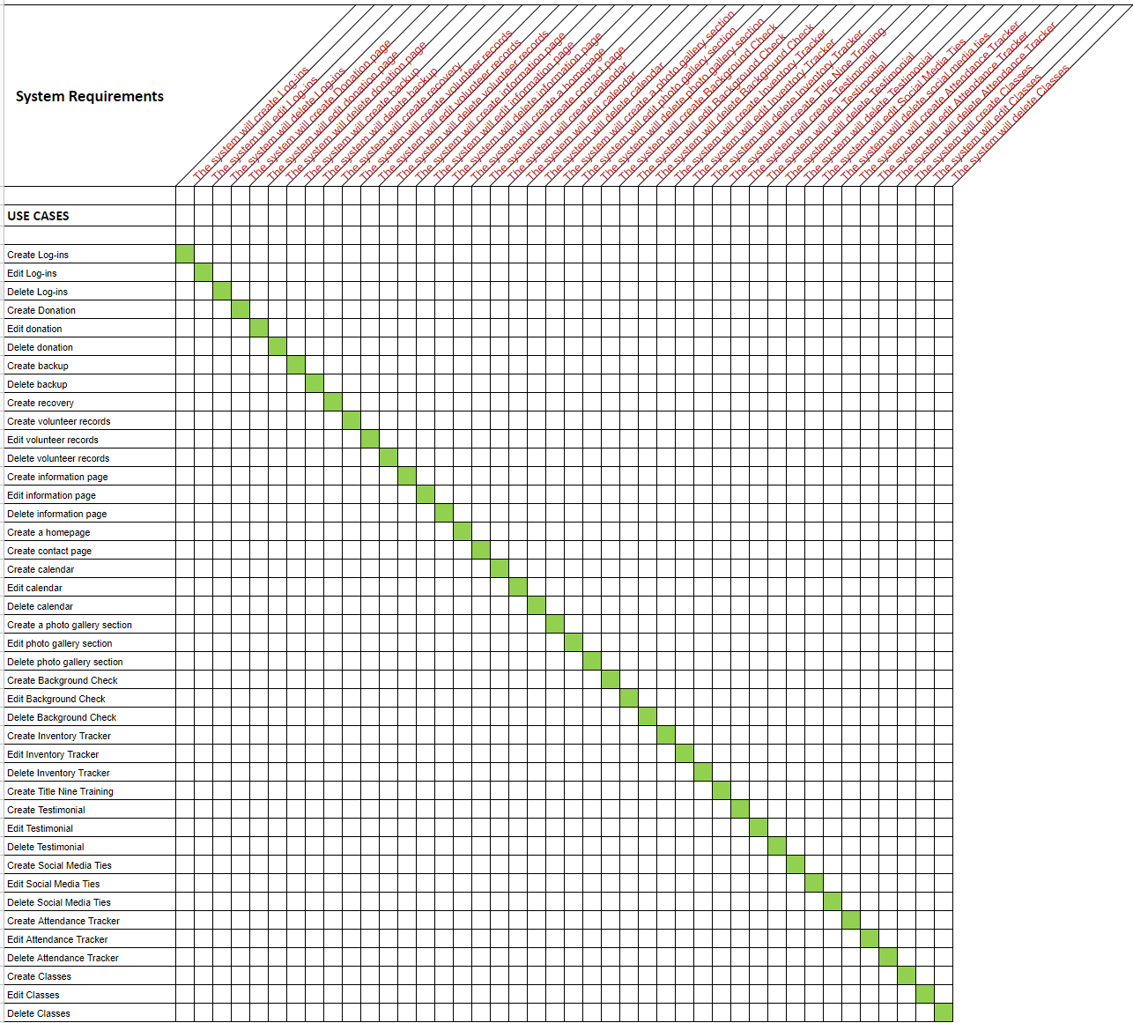

1. **Create Log-ins**

**1.1 Brief Description**

The system must allow for log-ins in order to increase security. Log-ins will also allow for users to have a more personalized experience by saving information and relating it to their log-in.

**2.Flow of Events**

**2.1 Basic Flow**

1. User enters username.
2. User enters password.
3. User submits data.
4. Use case ends.

**2.2 Alternative Flows**

*2.2.1 If user is setting up initial log in, then use the following flow:*

1. *User opens a new account page.*
2. *User enters the email address.*
3. *User enters username.*
4. *User enters password.*
5. *User reenters password.*
6. *User submits data.*
7. *Use case ends.*

**3. Special Requirements**

*No special requirements.*

**4. Pre-conditions**

4.1 The user must have a browser window opened to the website.

4.2 The user must have a stable internet connection.

**5. Post-conditions**

5.1 The user gains secure access to the website.

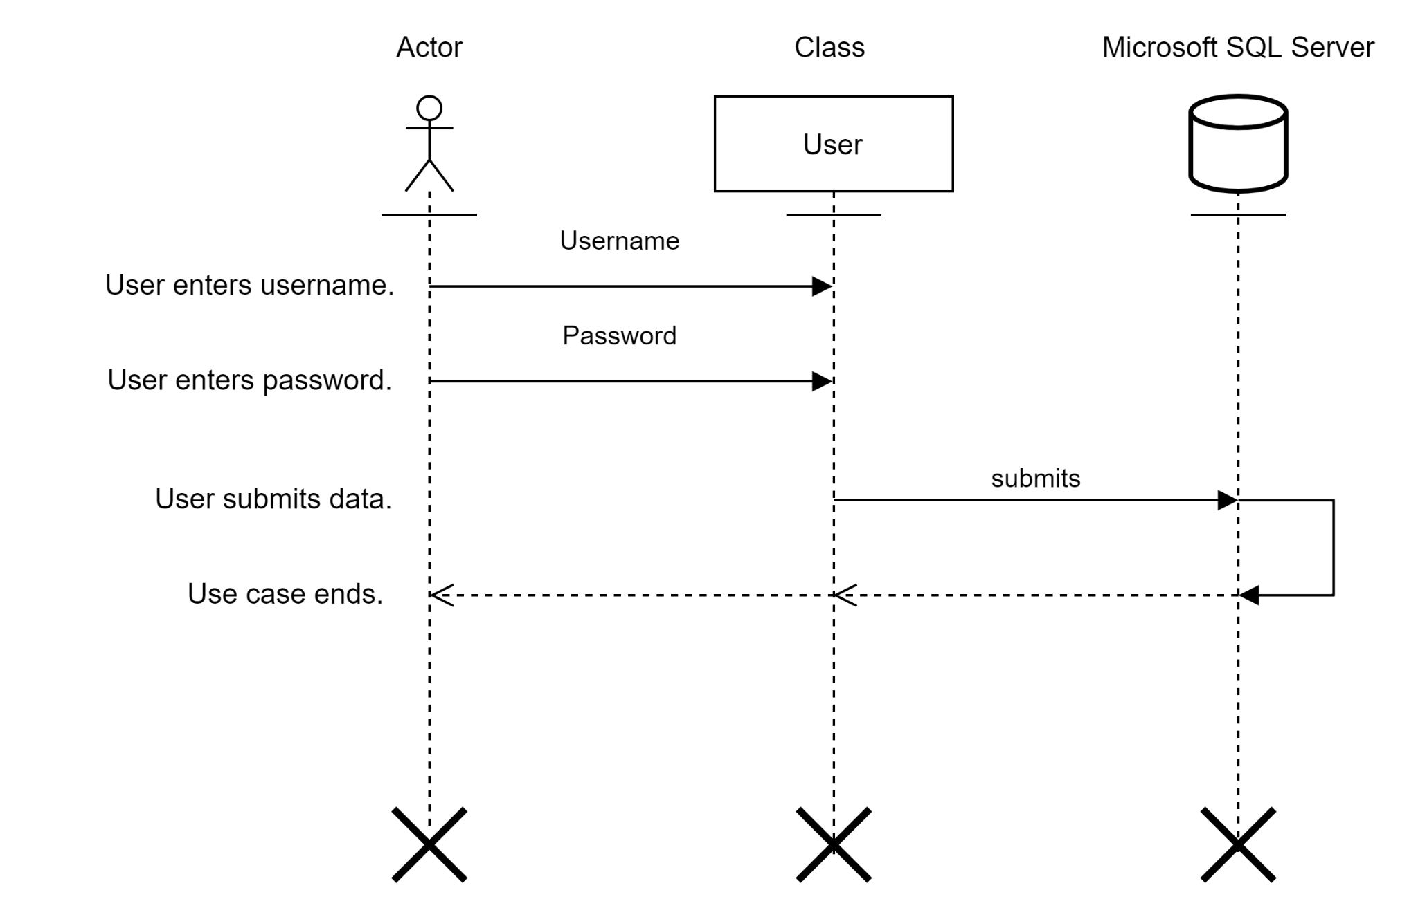

**2. Edit Log-ins**

**1.1 Brief Description**

The system must allow for users to edit their login username or password. This will allow for users to increase security by keeping new passwords or allow for easier recovery of accounts.

**2. Flow of Events**

**2.1 Basic Flow**

1. User opens the “Edit Log-in” page.
2. User enters username.
3. User enters current password.
4. User enters a new password.
5. User reenters the new password.
6. User submits data.
7. Use case ends.

**2.2 Alternative Flows**

*No alternative flows.*

**3. Special Requirements**

*No special requirements.*

**4. Pre-conditions**

4.1 The user must have a browser open to the webpage.

4.2 The user must have a stable internet connection.

4.3 The user must have a current username and password.

4.4 The user must be logged in.

**5. Post-conditions**

**5.1** The user edits their log-in information and the changes are stored in the server.

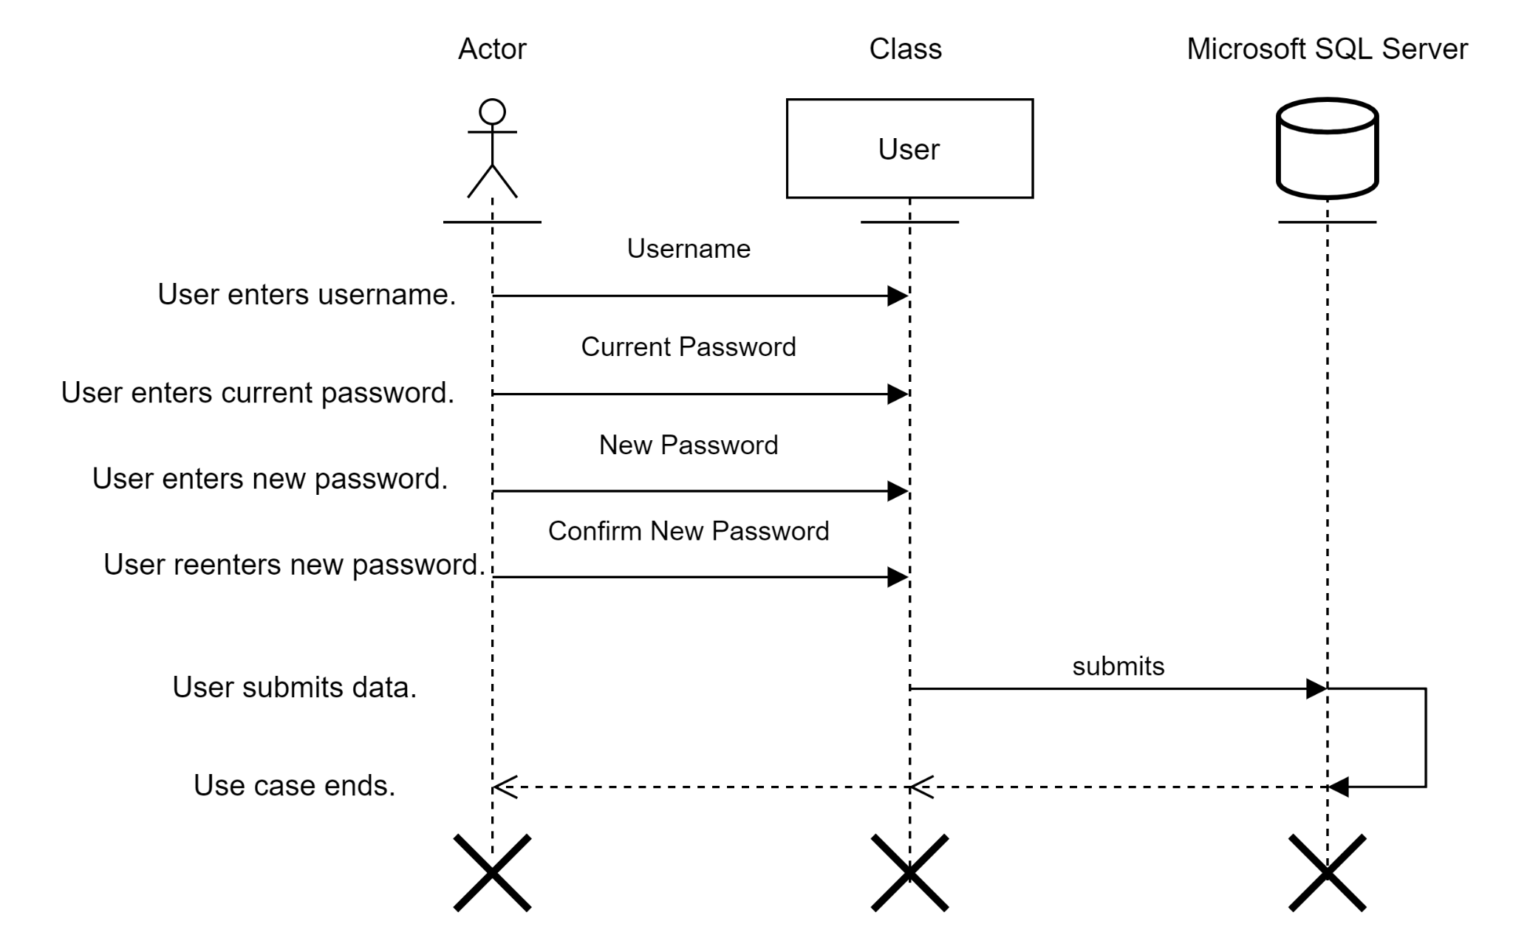

**3. Delete Log-ins**

**1.1 Brief Description**

The system must allow for users or administrators to delete accounts that are no longer needed. This could be because of an individual leaving the organization or an account falling inactive.

**2. Flow of Events**

**2.1 Basic Flow**

1. User opens “Delete Account” page.
2. User enters username.
3. User enters password.
4. User reenters password.
5. User submits data.
6. Use case ends.

**2.2 Alternative Flows**

*No alternative flows.*

**3. Special Requirements**

*No special requirements.*

**4. Pre-conditions**

4.1 The user must have a browser open to the webpage.

4.2 The user must have a stable internet connection.

4.3 The user must have a current username and password.

4.4 The user must be logged in.

**5. Post-conditions**

**5.1** The user edits their log-in information and the changes are stored in the server.

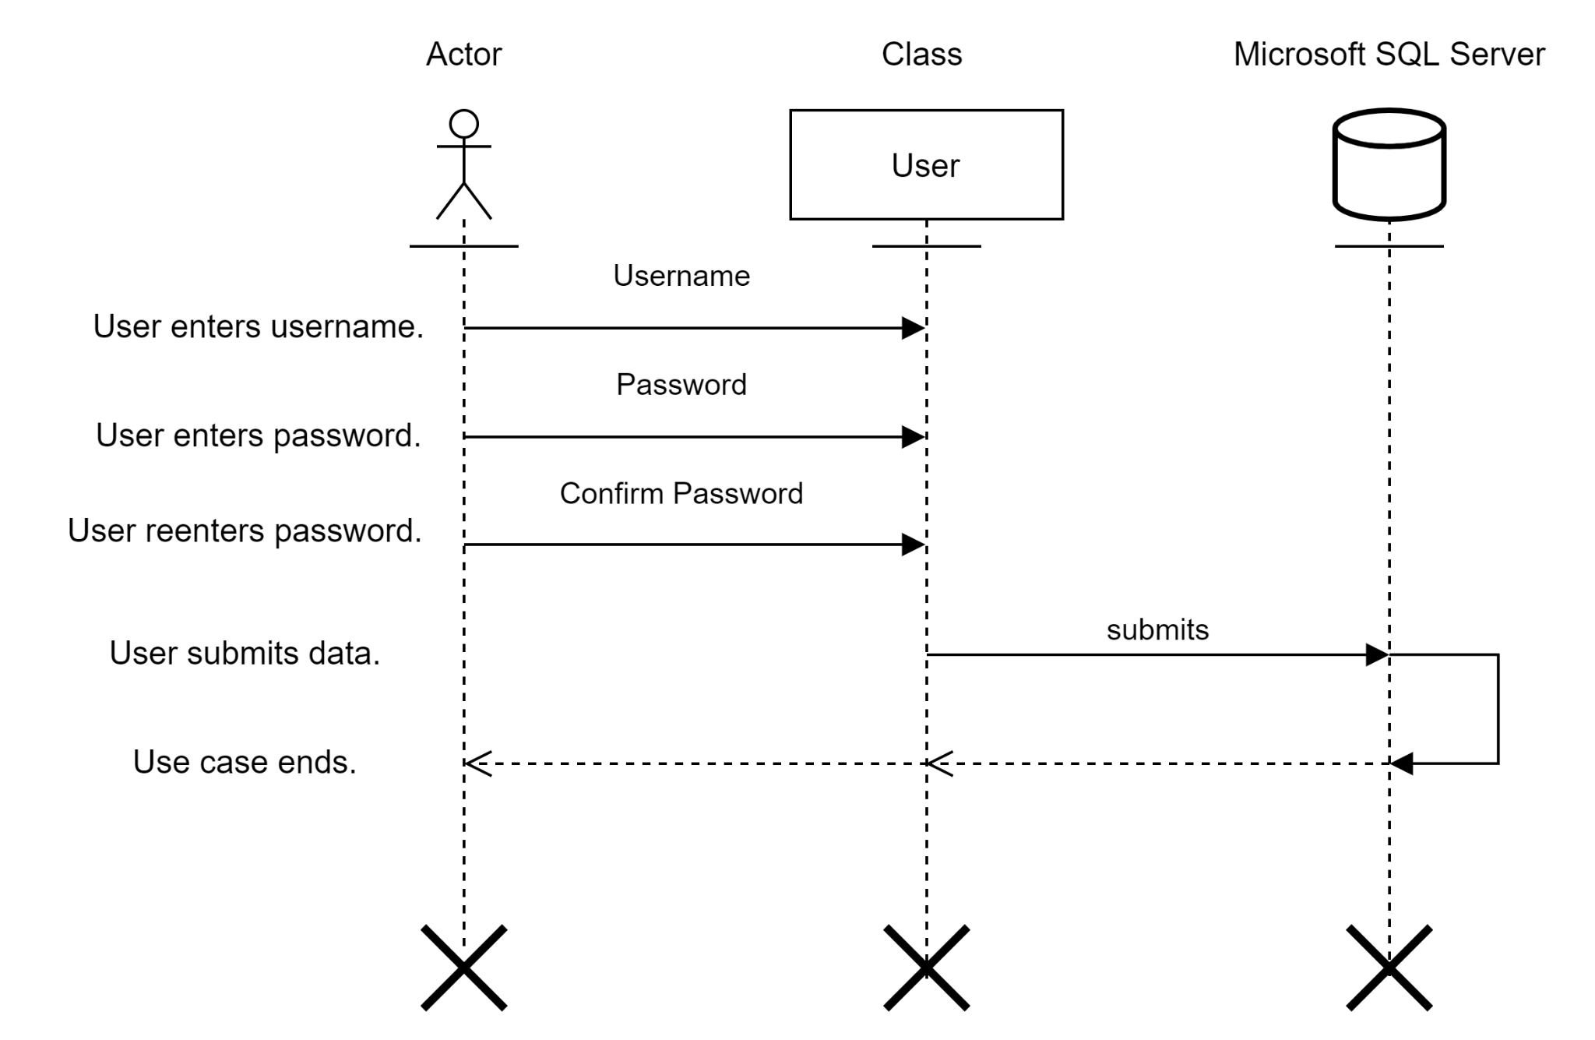

**4. Create Donation**

**1.1 Brief Description**

The system must allow for users to make a one-time donation or create a recurring donation. The system must also allow users to gain access to the Paypal payment system through the website.

**2. Flow of Events**

**2.1 Basic Flow**

1. User clicks the “Donate” tab.
2. User enters the Paypal portal.
3. User selects a recurring or one-time donation.
   1. If user selects a recurring donation, then frequency must be selected.
4. User enters the payment amount.
5. User enters name on card.
6. User enters a card number.
7. User enters card expiration date.
8. User enters CVV code.
9. User submits data.
10. Use case ends.

**2.2 Alternative Flows**

*No alternative flows.*

**3. Special Requirements**

*No special requirements.*

**4. Pre-conditions**

4.1 The user must have the browser open.

4.2 The user must have a stable internet connection.

4.3 The user must have securely logged into the website.

**5. Post-conditions**

5.1 The user submits their payment information and sets up a recurring or one-time donation through Paypal.

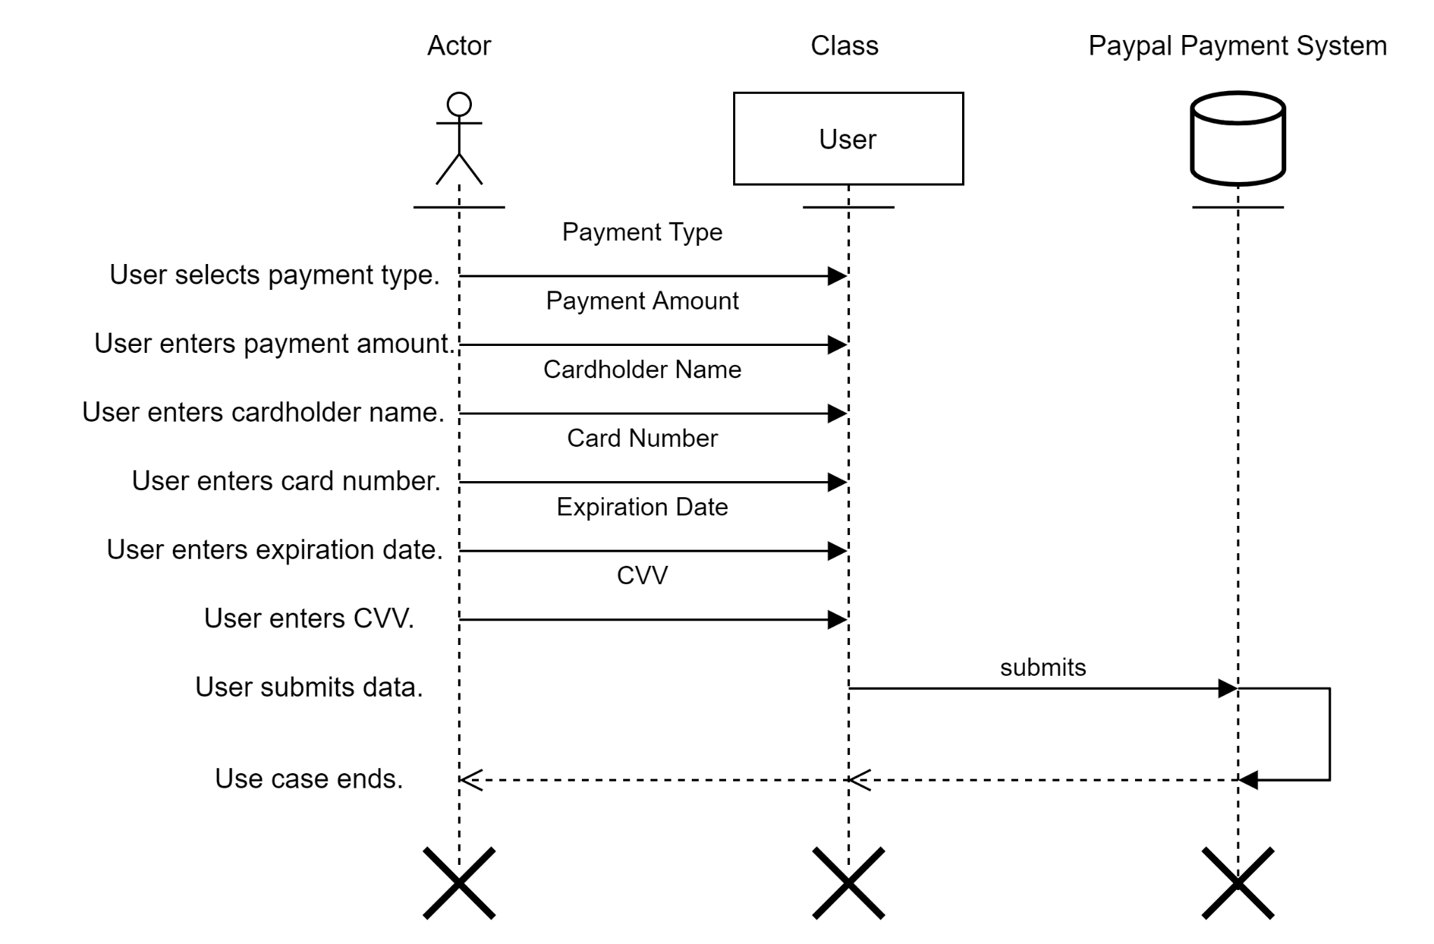

**5. Edit Donation**

**1.1 Brief Description**

The system must allow for users to edit their recurring donations. This would allow users to change their desired amount, frequency, or payment card on their recurring donation.

**2 Flow of Events**

**2.1 Basic Flow**

1. User opens “Donate” tab.
2. User selects “Edit Donation”.
3. User selects recurring donation or one-time donation.
   1. If user selects recurring donation, then a new frequency must be selected, if applicable.
4. User enters new name on card, if applicable.
5. User enters new card number, if applicable.
6. User enters new card expiration date, if applicable.
7. User enters new CVV, if applicable.
8. User submits data.
9. Use case ends.

**2.2 Alternative Flows**

*No alternative flows.*

**3. Special Requirements**

*No special requirements.*

**4. Pre-conditions**

4.1 The user must have the browser open.

4.2 The user must have a stable internet connection.

4.3 The user must have securely logged into the website.

4.4 The user must have a recurring donation already active.

**5. Post-conditions**

5.1 User updates their recurring donation with the new amount, frequency, or card information.



**6. Delete donation**

**1.1 Brief Description**

The system must allow for users or administrators to delete donations. This typically will refer to recurring donations that the user has submitted that they would like to cancel.

**2. Flow of Events**

**2.1 Basic Flow**

1. User opens “Donate” tab.
2. User selects delete donation.
3. User confirms deletion.
4. User submits data.
5. Use case ends.

**2.2 Alternative Flows**

*No alternative flows.*

**3. Special Requirements**

*No special requirements.*

**4. Pre-conditions**

4.1 The user must have the browser open.

4.2 The user must have a stable internet connection.

4.3. The user must have securely logged into the website.

4.4 The user must have a recurring donation already active.

**5. Post-conditions**

5.1 User deletes the recurring donation associated with their account.

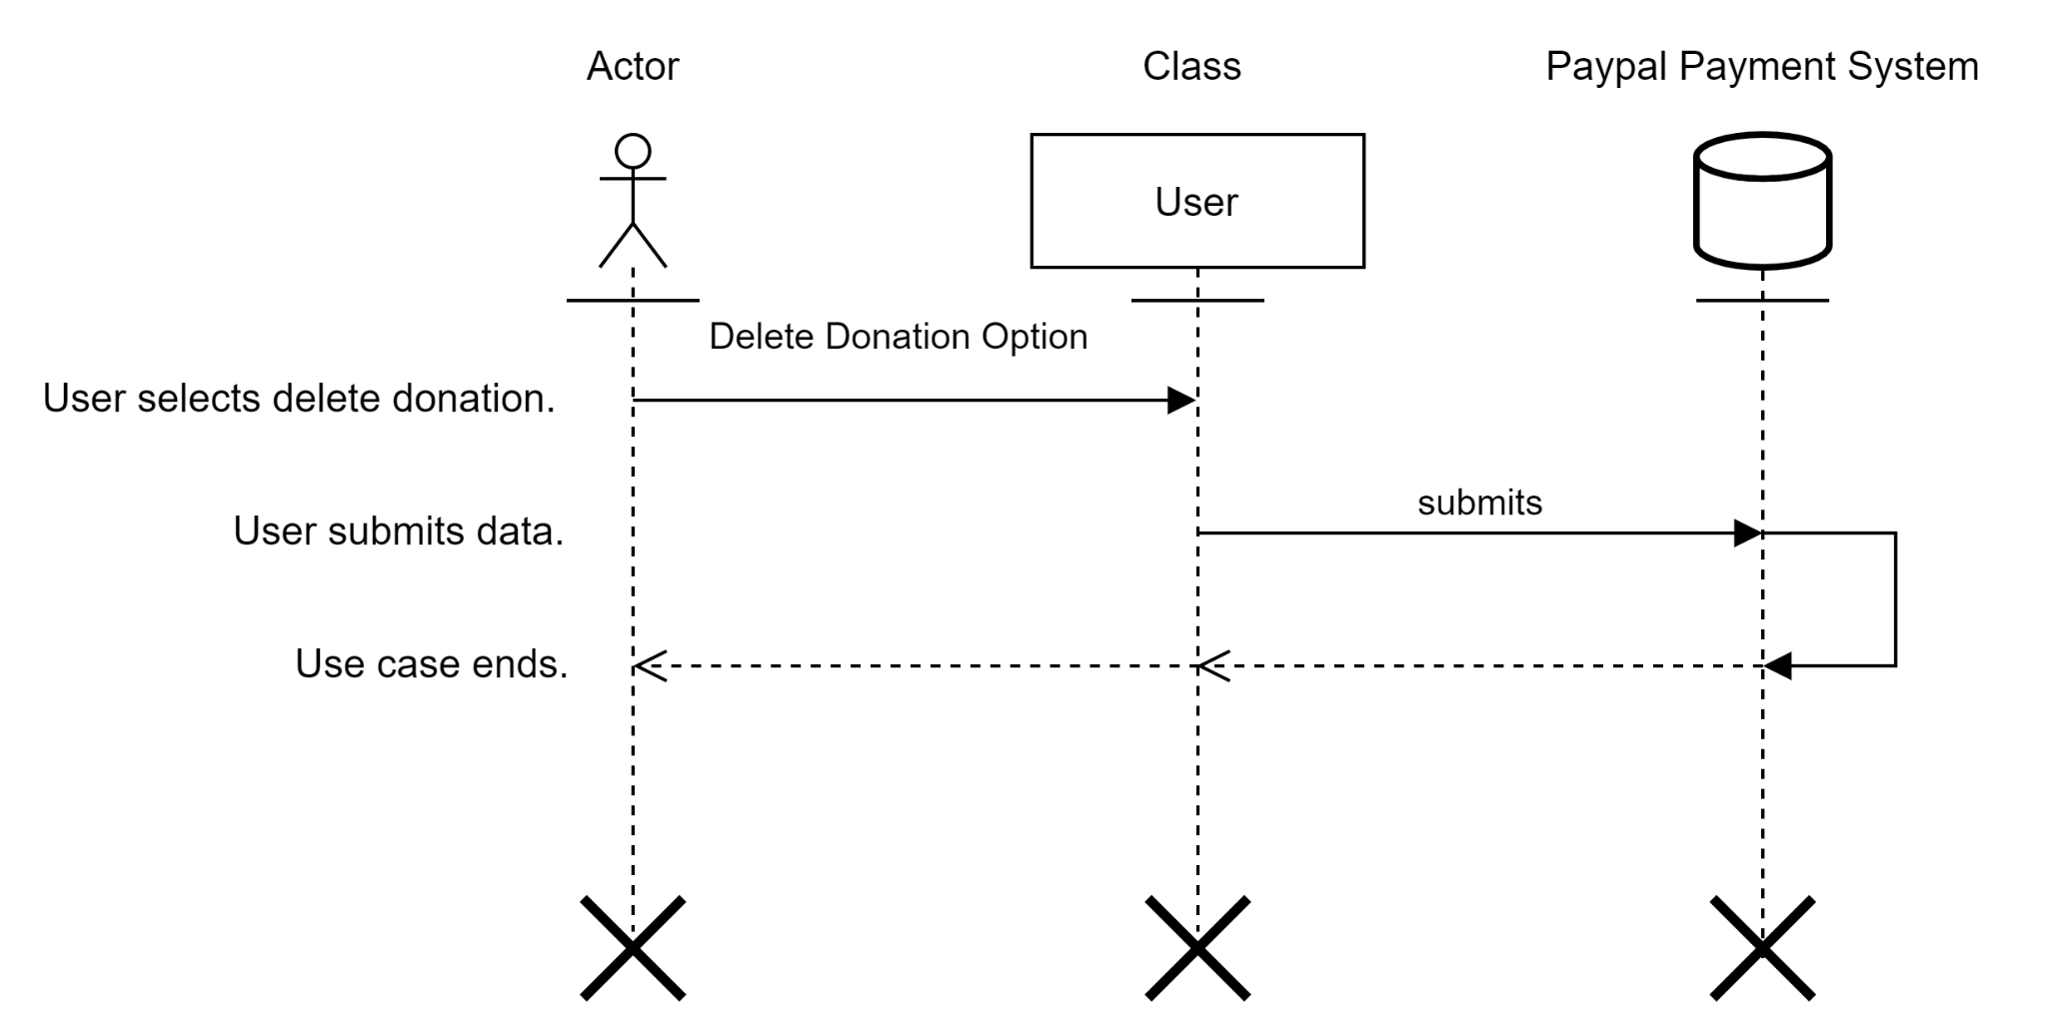

**7. Create backup**

**1.1 Brief Description**

The system must allow for the administrator to manually backup the database associated with the Thompson Project. This will allow for responsible record keeping in the organization.

**2. Flow of Events**

**2.1 Basic Flow**

1. User opens Microsoft SQL Server.
2. User selects Databases in the Object Explorer.
3. User selects Backup Database.
4. User selects where to backup the database.
5. User confirms backup..
6. Use case ends.

**2.2 Alternative Flows**

*No alternative flows.*

**3. Special Requirements**

*No special requirements.*

**4. Pre-conditions**

4.1 The user must be an administrator.

4.2 The user must have access to Microsoft SQL server.

4.3 Data must be present in the database.

**5. Post-conditions**

5.1 A backup is created and stored securely outside of the server.

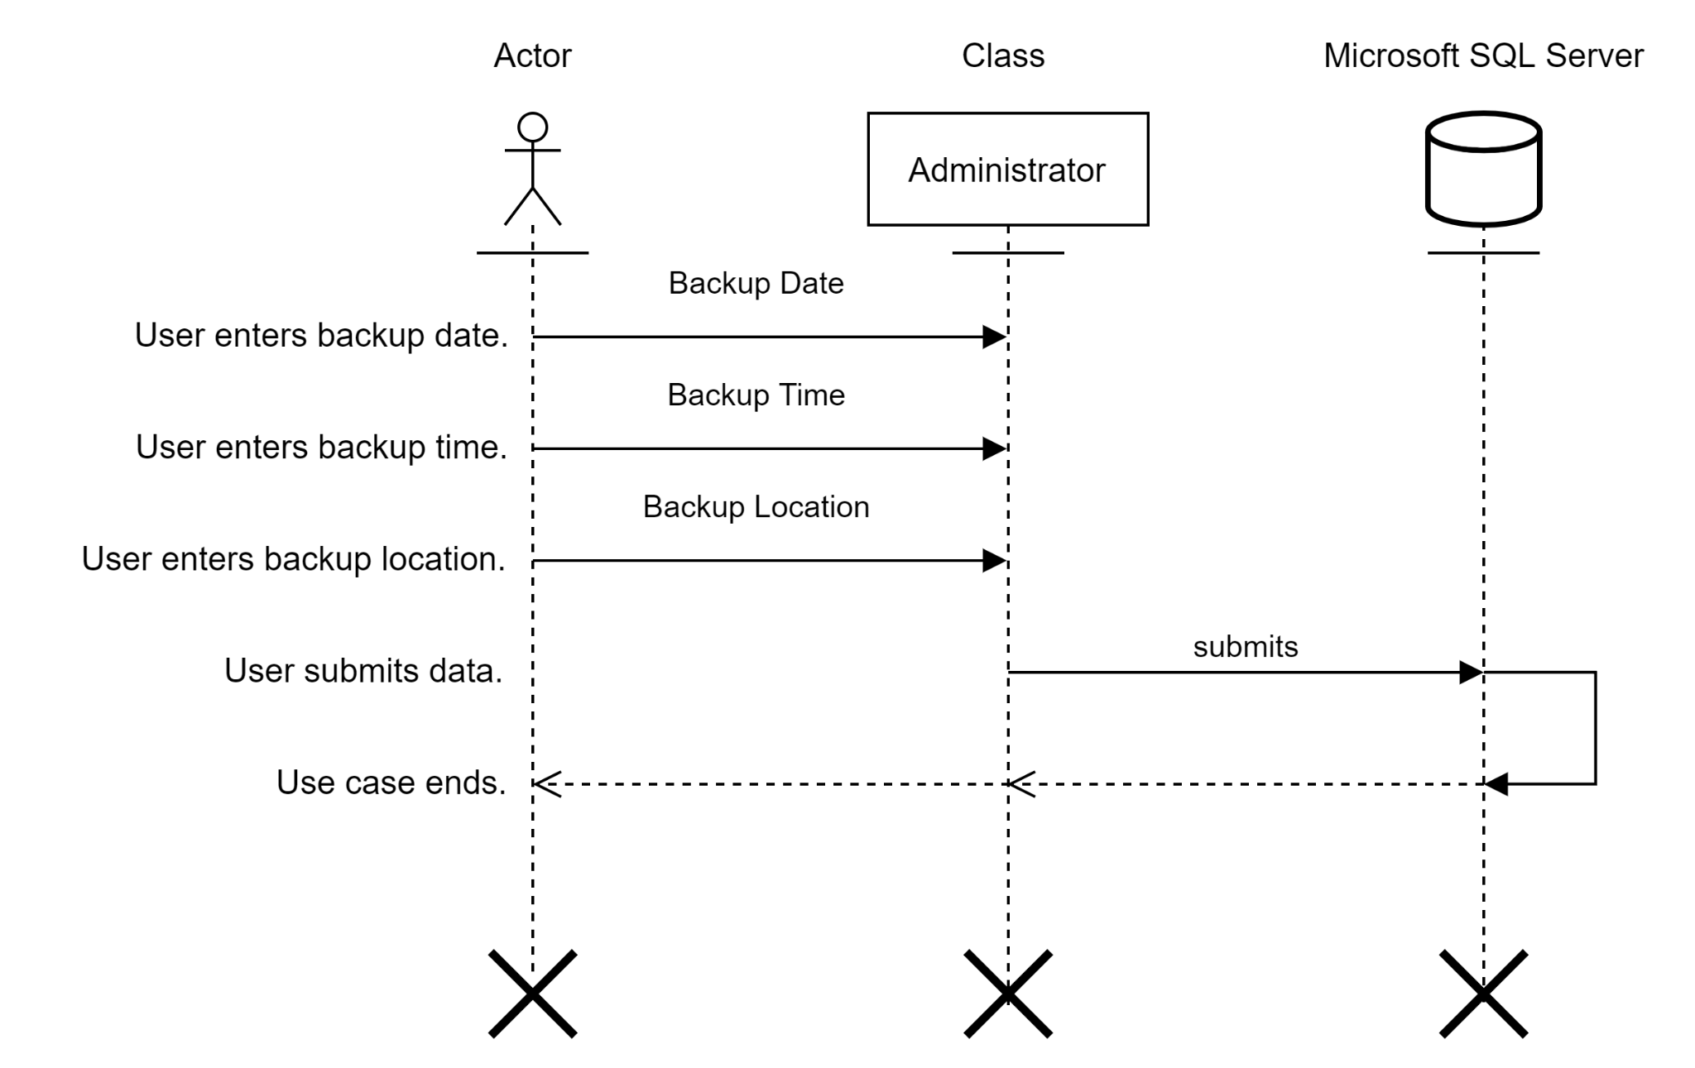

**8. Delete backup**

**1.1 Brief Description**

The delete backup use case is for system admin to help with the process of deleting outdated backup data. The system needs to allow the system admin to delete outdated backups to have more space.

**2. Flow of Events**

**2.1 Basic Flow**

1. System admin clicks the delete file command.
2. The system asks the system admin if they are sure they want to delete the selected file.
3. The system admin clicks “yes” or “no” to confirm
4. When “yes” is clicked, previously stored data is deleted.
5. When “no” is clicked everything remains the same.
6. Use case ends.

**2.2 Alternative Flows**

*No alternate flow.*

**3. Special Requirements**

*No special requirements.*

**4. Pre-conditions**

4.1 There must be previously stored data.

**5. Post-conditions**

5.1 The previously stored data has been deleted.

**Basic Flow Sequence Diagram**

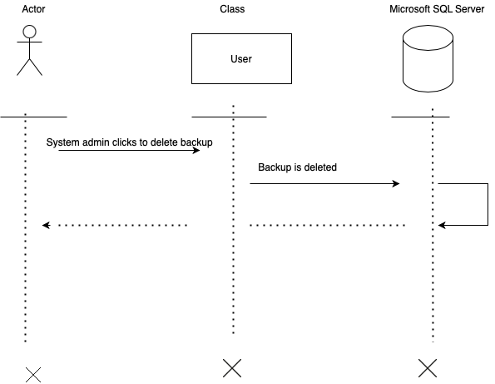

1. System admin clicks the delete file command.
2. The system asks the system admin if they are sure they want to delete the selected file.
3. The system admin clicks “yes” or “no” to confirm
4. When “yes” is clicked, previously stored data is deleted.
5. When “no” is clicked everything remains the same.
6. Use case ends.

**9. Create recovery**

**1.1 Brief Description**

The create recovery use case allows the system administrator to be able to recover previously saved backups. It is the process of restoring data that has been lost, accidentally deleted, corrupted or made inaccessible.

**2. Flow of Events**

**2.1 Basic Flow**

1. System admin checks previously stored data
2. System admin tests previously stored data
3. If all good, the system admin creates a recovery drive
4. Use case ends

**2.2 Alternative Flows**

*No alternative flow.*

**3. Special Requirements**

*No special requirements.*

**4. Pre-conditions**

4.1 The system has old backup data saved.

**5. Post-conditions**

5.1 The system‘s data has been recovered.

5.2 The system does not suffer from data lost

**Basic Flow Sequence Diagram**

1. System admin checks previously stored data.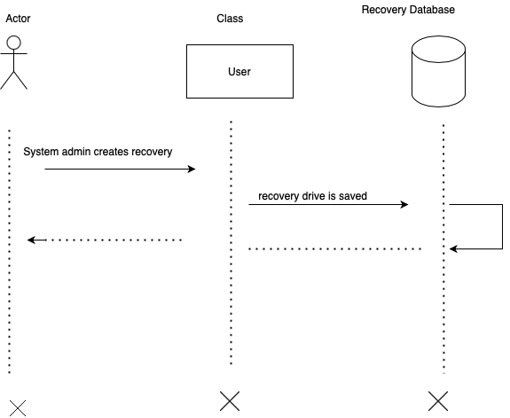
2. System admin tests previously stored data
3. If all good, the system admin creates a recovery drive
4. Use case ends.

**10. Create volunteer records**

**1.1 Brief Description**

The create volunteer use case allows the system admin to create a system that tracks volunteer records. This information will then be used when applying for grants and asking for donations.

**2. Flow of Events**

**2.1 Basic Flow**

1. User signs up to volunteer.
2. User checks in to volunteer.
3. User checks out after volunteering.
4. Use case ends.

**2.2 Alternative Flows**

*No alternative flow.*

**3. Special Requirements**

*No special requirements.*

**4. Pre-conditions**

4.1 The user must be on the volunteer page to enter their information for the data to be collected.

**5. Post-conditions**

5.1 User entered information will now be stored in the system.

5.2 Recurring users don’t have to sign up again, just will need to check in and out.

**Basic Flow Sequence Diagram**

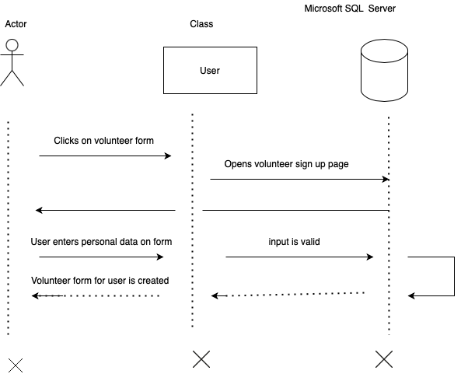

1. User signs up to volunteer.
2. User checks in to volunteer.
3. User checks out after volunteering.
4. Use case ends.

**11. Edit volunteer records**

**1.1 Brief Description**

The edit use case helps facilitate the modification of the volunteer’s data, and can be performed by the user and system admin. When incorrect data is inputted it can be corrected.

**2. Flow of Events**

**2.1 Basic Flow**

1. The user or system admin selects the edit data button on site.
2. The user or system admin then modifies the incorrect data.
3. The user or system admin clicks the save button to lock in the newly inputted data.
4. Use case ends.

**2.2 Alternative Flows**

*No alternative flow.*

**3. Special Requirements**

*No special requirements.*

**4. Pre-conditions**

4.1 There must be previously stored volunteer records there to be edited.

**5. Post-conditions**

5.1 New accurate data is now displayed.

**Basic Flow Sequence Diagram**

1. The user or system admin selects the edit data button on site.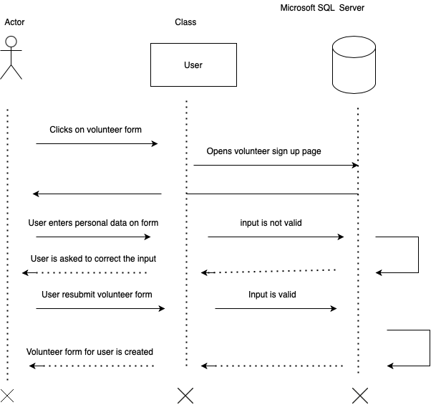
2. The user or system admin then modifies the incorrect data.
3. The user or system admin clicks the save button to lock in the newly inputted data.
4. Use case ends.

**12. Delete volunteer records**

**1.1 Brief Description**

The delete volunteer use case shows the steps necessary to take to delete an inactive account or an account with very wrong data inputted.

**2. Flow of Events**

**2.1 Basic Flow**

1. The user or system admin clicks the delete account button.
2. “Yes” or “No” button appears to confirm the deletion of the account/data.
3. When “yes” is selected, the account is deleted.
4. Use case ends.

**2.2 Alternative Flows**

*No alternative flow.*

**3. Special Requirements**

*No special requirements.*

**4. Pre-conditions**

4.1 There must be an account present in order to use this use case.

4.2 Account must be inactive or contain incorrect data.

**5. Post-conditions**

5.1 Account is no longer visible or accessible.

**Basic Flow Sequence Diagram**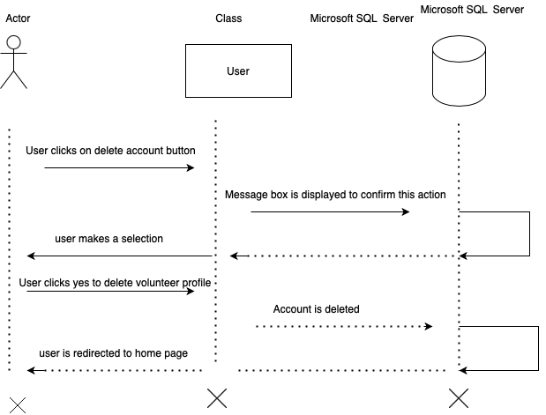

1. The user or system admin clicks the delete account button.
2. “Yes” or “No” button appears to confirm the deletion of the account/data.
3. When “yes” is selected, the account is deleted.
4. Use case ends.

**13. Create information page**

**1.1 Brief Description**

The create information page use case enables the system admin to create a page that will display all the information regarding the organization. Visitors can learn more about the organization and its mission.

**2. Flow of Events**

**2.1 Basic Flow**

1. The system admin clicks on the new page button on Joomla.
2. System admin adds a title.
3. The system admin adds the content of the information page.
4. The information page is published for viewers.
5. Use case ends.

**2.2 Alternative Flows**

*No alternative flow.*

**3. Special Requirements**

*No special requirements.*

**4. Pre-conditions**

4.1 There is no previous information page.

**5. Post-conditions**

5.1 Well formatted details of the organization are published for the users to view.

**Basic Flow Sequence Diagram**

1. The system admin clicks on the new page button on Joomla.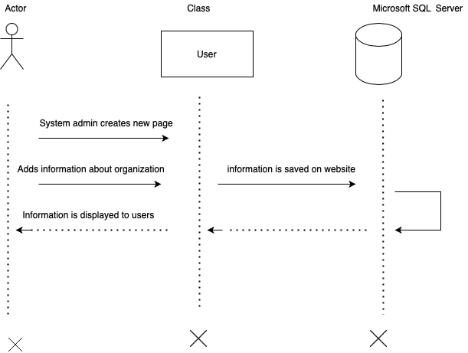
2. System admin adds a title.
3. The system admin adds the content of the information page.
4. The information page is published for viewers.
5. Use case ends.

**14. Edit information page**

**1.1 Brief Description**

The edit information page use case allows for the modification of the information displayed on the information page. The page is updated with recent events, activities or news going on with the organization.

**2. Flow of Events**

**2.1 Basic Flow**

1. The system admin clicks the edit page button on cms
2. The system admin updates the page with current information regarding organization.
3. The system admin clicks save and publish
4. Use case ends.

**2.2 Alternative Flows**

*No alternative flow.*

**3. Special Requirements**

*No special requirements.*

**4. Pre-conditions**

4.1 There must be an information page already displayed.

**5. Post-conditions**

5.1 Information page will now display new information about the organization.

**Basic Flow Sequence Diagram**

1. The system admin clicks the edit page button on Joomla. 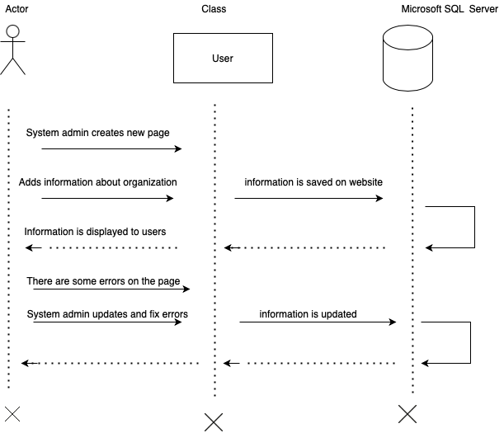
2. The system admin updates the page with current information regarding organization.
3. The system admin clicks save and publish
4. Use case ends.

**15. Delete information page**

**1.1 Brief Description**

The delete information page use case is to ensure that accurate information about the company is being displayed. This is if the stakeholder would like to take away the current information page that is being displayed on the website. This is helpful for the stakeholder when the information being displayed is no longer accurate or if they are going through a rebranding of the company/website.

**2. Flow of Events**

**2.1 Basic Flow**

1. Administrator selects information page.
2. Administrator selects edit button.
3. Administrator selects delete button.
4. Administrator deletes information page
5. Administrator saves changes
6. Use case ends.

**2.2 Alternative Flows**

*No alternative flows.*

**3.Special Requirements**

*No special requirements.*

**4. Pre-conditions**

4.1.The system must already have an information page in place in order to delete the page.

4.2. The system must already have content being displayed on the information page in place in order to delete the specific content within the page.

**5. Post-conditions**

5.1. The system now has no information page and no information about the company.

5.2. The system no longer displays the content that has been deleted and can now be edited to display different information.

**Delete Information Page** 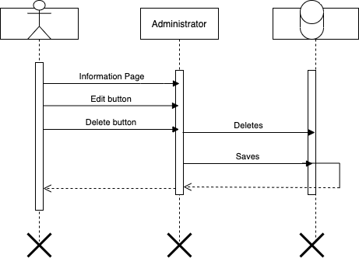

Administrator selects information page.

Administrator selects edit button.

Administrator selects delete button.

Administrator deletes information page

Administrator saves changes

Use case ends.

**16. Create a homepage**

**1.1 Brief Description**

The create a homepage use case is used to make a place that users first see and can refer back to in the website. A homepage will provide a place for each subpage to be displayed and accessed. This is helpful for the stakeholder because it will provide outside users with ease of use of the website.

**2. Flow of Events**

**2.1.Basic Flow**

1. Administrator selects edit mode
2. Administrator selects add new page
3. Administrator adds title
4. Administrator adds hyperlinks
5. Administrator adds photos
6. Administrator saves changes
7. Use case ends

**2.2 Alternative Flows**

*No alternative flows.*

**3.Special Requirements**

*No special requirements.*

**4. Pre-conditions**

4.1. The website must already be created and active.

4.2. There must not be a homepage that exists or the homepage must be deleted before creating the new one.

**5. Post-conditions**

5.1. The system now has a website that can function more properly because of the created homepage.

5.2. The users have easy access to other pages within the website.

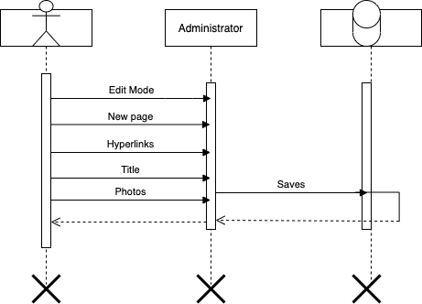

**Create a Homepage**

Administrator selects edit mode

Administrator selects add new page

Administrator adds title

Administrator adds hyperlinks

Administrator adds photos

Administrator saves changes

Use case ends

**17. Create contact page**

**1.1 Brief Description**

The create contact page use case is used to make a page where users can get contact information on the website. A contact page will provide a place for users to write down any questions or concerns along with their contact information for the company to refer back to. This is helpful for the stakeholder because it will provide an efficient way for users to contact them.

**2. Flow of Events**

**2.1 Basic Flow**

1. Administrator selects edit mode.
2. Administrator adds new page.
3. Administrator adds contact information.
4. Administrator saves changes.
5. Use case ends.

**2.2 Alternative Flows**

*No alternative flow.*

**3. Special Requirements**

*No special requirements.*

**4. Pre-conditions**

4.1. The website must already be created and active.

4.2. There must not be a contact page that exists or the current contact page must be deleted before creating the new one.

**5. Post-conditions**

5.1. The system now has a website that can function more properly for the user to contact the business because of the created contact page.

**Create Contact Page**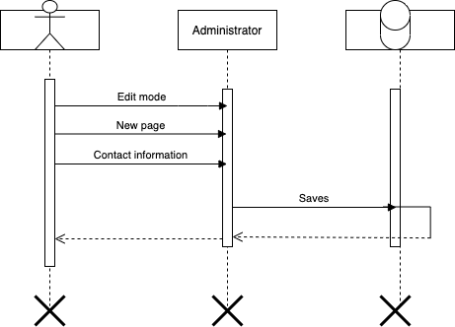

Administrator selects edit mode.

Administrator adds new page.

Administrator adds contact information.

Administrator saves changes.

Use case ends.

**18. Create calendar events**

**1.1.Brief Description**

The create calendar events use case is used to make a place where users can get information about the businesses events on the website. A calendar of events will provide a place for users to see what upcoming events are happening. This is helpful for the stakeholder because users can have a place to go to for all calendar events.

**2. Flow of Events**

**2.1 Basic Flow**

1. Administrator selects edit mode
2. Administrator adds calendar.
3. Administrator adds events
4. Administrator saves changes.
5. Use case ends

**2.2 Alternative Flows**

*No alternative flows.*

**3.Special Requirements**

*No special requirement.*

**4. Pre-conditions**

4.1. The website must already be created and active.

4.2. There must not be a calendar of events that exists or the current calendar of events must be deleted before creating the new one.

**5. Post-conditions**

5.1. The system now has a website that can function more properly for the user to look at and attend events because of the calendar of events that has been made.

**Create Calendar Events**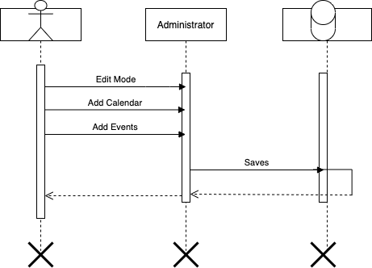

Administrator selects edit mode

Administrator adds calendar.

Administrator adds events

Administrator saves changes.

Use case ends

**19. Edit calendar events**

**1.1.Brief Description**

The edit calendar events use case is used to edit the current calendar of events where users can get information about the businesses events on the website. The calendar of events will provide a place for users to see what upcoming events are happening but need to be updated as new events arise. This is helpful for the stakeholder because users can have a place to go to for all calendar events and know they’re getting the most up to date information.

**2. Flow of Events**

**2.1 Basic Flow**

1. Administrator selects calendar.
2. Administrator selects edit mode.
3. Administrator adds event.
4. Administrator saves changes.
5. Use case ends**.**

**2.2 Alternative Flows**

*No alternative flows.*

**3. Special Requirements**

*No Special Requirements.*

**4. Pre-conditions**

4.1. The website must already be created and active.

4.2. There must be a calendar of events that exists so that it can be edited.

**5. Post-conditions**

5.1. The system now has a website that can function more properly for the user to look at and attend events because of the calendar of events that can be constantly updated.

**Edit Calendar Events**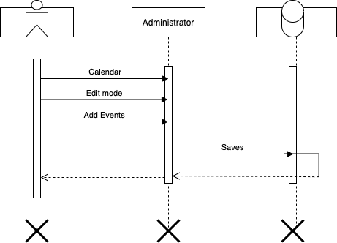

Administrator selects calendar.

Administrator selects edit mode.

Administrator adds event.

Administrator saves changes.

Use case ends**.**

**20. Delete calendar events**

**1.1 Brief Description**

The delete calendar events use case is used to delete the business’ events on the website. Being able to delete calendar events will allow for old information that is no longer relevant to be deleted. This is helpful for the stakeholder because users will have the most useful information present and not get distracted with old events.

**2. Flow of Events**

**2.1 Basic Flow**

1. Administrator selects calendar.
2. Administrator selects edit mode.
3. Administrator deletes event.
4. Administrator saves changes.
5. Use case ends.

**2.2 Alternative Flows**

*No alternative flows.*

**3. Special Requirements**

*No Special Requirements.*

**4. Pre-conditions**

4.1. The website must already be created and active.

4.2. There must be a calendar of events that exists so that its contents can be edited.

**5. Post-conditions**

5.1. The system now has a website that can function more properly for the user to look at and attend events because of the calendar of events that can be constantly updated.

**Delete Calendar Events**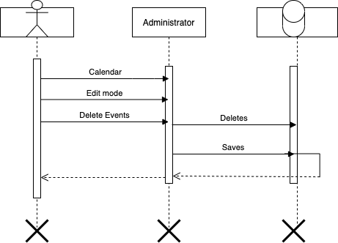

Administrator selects calendar.

Administrator selects edit mode.

Administrator deletes event.

Administrator saves changes.

Use case ends.

**21. Create a photo gallery section**

**1.1 Brief Description**

The create photo gallery section use case is used to allow system administrators to add photos to the site to show what the organization is about and its impact on the community. This is helpful for the stakeholder because users will visually see the impact that this organization makes. It will also drive larger donations.

**2. Flow of Events**

**2.1 Basic Flow**

1. Administrator selects home page.
2. Administrator selects edit mode.
3. Administrator adds photos.
4. Administrator saves changes.
5. Use case ends.

**2.2 Alternative Flows**

*No alternative flow.*

**3.Special Requirements**

*3.1. The website must allow for pictures to be uploaded.*

*3.1. The website must allow for pictures to be scrolled through.*

**4. Pre-conditions**

4.1. The website must already be created and active.

4.2. There must not be a calendar of events that exists or the current calendar of events must be deleted before creating the new one.

**5. Post-conditions**

5.1. The system now has a website that can function more properly for the user to look at and attend events because of the calendar of events that has been made.

**Create Photo Gallery Section**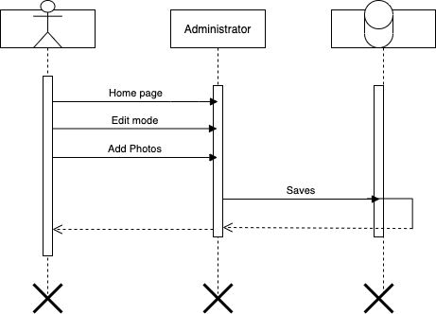

Administrator selects home page.

Administrator selects edit mode.

Administrator adds photos.

Administrator saves changes.

Use case ends.

**22. Edit photo gallery contents**

**1.1 Brief Description**

With this use case, the administrator can access the content management system (Joomla) and edit the photo gallery displayed on the webpage. This would improve the appearance of the website as it could be regularly updated, provided users or stakeholders have new photos to add to the gallery. The photo gallery is critical to promoting the organization as it shows the work the organization has completed. Functions would include adding, editing, and removing photos from the website gallery.

**2. Flow of Events**

**2.1 Basic Flow**

1. Administrator enters CMS.

2. Administrator edits photos.

3. Administrator saves changes.

4. Administrator exits CMS.

5. Use case ends.

**2.2 Alternative Flows**

*2.2.1 Administrator reverses decision, exits page.*

The administrator after accessing the editor decides to not change any of the current photos, leaving the page promptly and logging out of the system.

1. Administrator edits photos.
2. Administrator reverses decision.
3. Administrator does not save changes.
4. Administrator exits editor.
5. Use case ends.

*2.2.2 The administrator adds photos to the editor, leaving original photos in place.*

Once the administrator decides to enter the editor, they decide to leave all original photos as they are and add more photos to the library.

1. Administrator enters editor.
2. Administrator makes no changes.
3. Administrator exits editor.
4. Use case ends.

**3. Special Requirements**

*3.1 Permissions to Access Editor*

The administrator must have elevated rights prior to accessing the editor. Regular users and those with non-elevated permissions will not be able to access the photo library editor.

**4. Pre-conditions**

**4.1 Administrator Connected to Webpage**

The administrator needs to be able to connect to the webpage, whether it is over the internet or on local connection to the database.

**4.2 Administrator Verifies Photos to be Edited**

The administrator checks with management to confirm changes to the website before accessing the editor.

**5. Post-conditions**

**5.1 Joomla saves changes and updates the webpage.**

The common post-condition. The administrator saves changes and exits the editor. The content management system (Joomla) saves new assets/changes and updates the live webpage.

**5.2 The administrator does not edit and exits the editor, no change.**

Less likely to occur but is possible. The administrator, after logging in to the editor, decides to not change any current photos on the website. No changes are made, current photos and their orientation stay the same on the live webpage.

**Basic Flow Sequence Diagram**

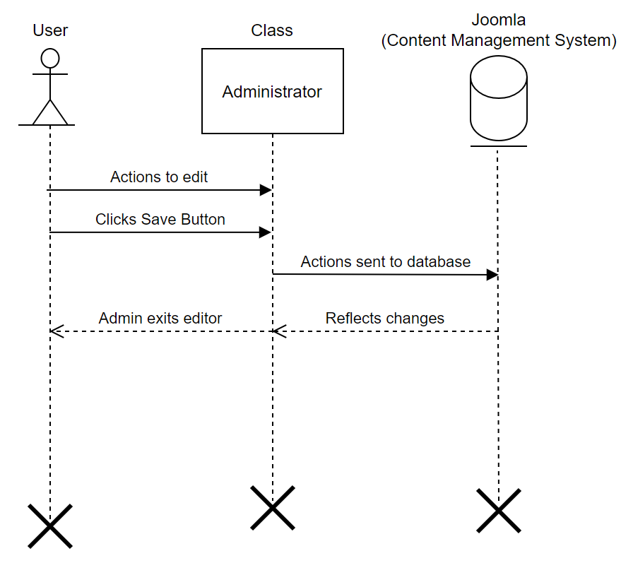

1. Administrator enters CMS.

2. Administrator edits photos.

3. Administrator saves changes.

4. Administrator exits CMS.

5. Use case ends.

**23. Delete photo gallery contents**

**1.1 Brief Description**

With this use case, the administrator can enter the content management system (Joomla) and delete the entire photo gallery. This can be done to reorganize the webpage or hide it from the public view when undergoing maintenance. The administrator can also delete all the photos within the gallery but preserve the function of the photo gallery if Armond or management wants to completely change the layout.

**2. Flow of Events**

**2.1 Basic Flow**

1. Administrator accesses editor.

2. Administrator deletes gallery.

3. Administrator saves changes.

4. Administrator exits editor.

5. Use case ends.

**2.2 Alternative Flows**

*2.2.1 Administrator exits and makes no changes.*

The administrator may decide to not delete the gallery once they enter the editor. They can simply exit the editor without making any changes and the website will retain its previous state.

1. Administrator accesses editor.
2. Administrator makes no changes.
3. Administrator exits editor.
4. Use case ends.

**3. Special Requirements**

*3.1 Administrator has access to Joomla.*

The administrator is required to have access to Joomla to make changes on the website. Without it, they will need permissions granted or have another administrator access the editor.

**4. Pre-conditions**

4.1 Administrator verifies deletion of gallery content with management.

The administrator before deleting the gallery content(s) must verify with management or the person responsible for organizational content to determine it is needed.

**5. Post-conditions**

5.1 The website updates changes, and gallery content is removed.

Once the deletion is completed, the website will reflect changes after a short period of time.

**Basic Flow Sequence Diagram**

1. Administrator accesses editor.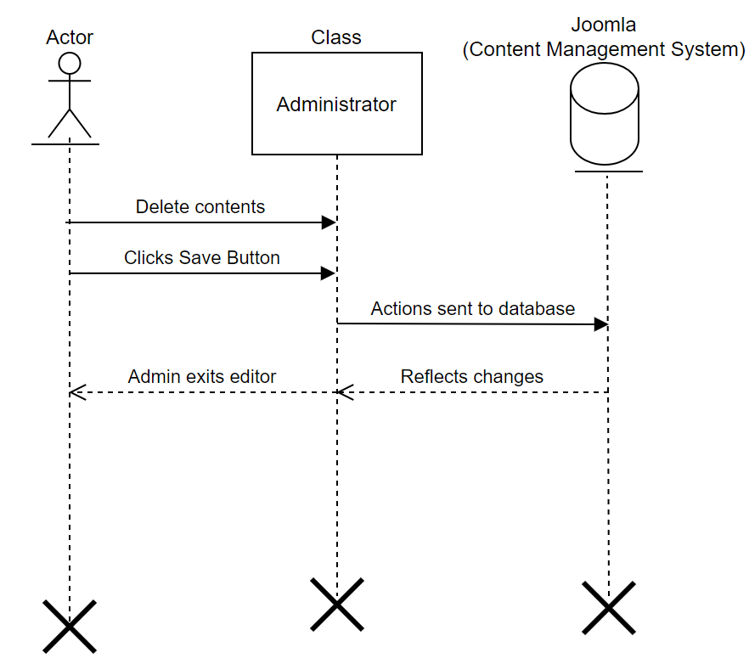

2. Administrator deletes gallery.

3. Administrator saves changes.

4. Administrator exits editor.

5. Use case ends.

**24. Create Background Check**

**1.1 Brief Description**

In this use case, the user can enter information into the webpage for a background check, including sensitive PPI. They are a prerequisite for all future volunteers to maintain the safety of organization members and the youth that the organization works with. Without this use case, the organization would not be able to best determine who could work with them in a safe manner.

**2. Flow of Events**

**2.1 Basic Flow**

1. User accesses web page.

2. User inputs first name.

3. User inputs last name.

4. User inputs date of birth.

5. User inputs social security number.

6. User verifies entries.

7. User submits information.

8. User exits web page.

9. Use case ends.

**2.2 Alternative Flows**

*2.2.1 User decides to not submit background check.*

The user may decide after starting to input information that they do not want to submit a background check. It can be for various reasons, but it can be assumed the user will close the webpage. No information would be retained as the information was not submitted to the database; therefore, the user is not at risk of having sensitive information exposed.

1. User accesses web page.
2. User inputs information.
3. User decides to not submit.
4. User exits web page.
5. Use case ends.

**3. Special Requirements**

*3.1 The user must be logged into the webpage.*

Assuming the webpage wants to filter out false/fake applications, the user will need to create an account with the organization to begin a background check submission.

**4. Pre-conditions**

4.1 The user must have access to the Internet.

Without internet access, the user will not be able to complete a background check as they cannot access the webpage necessary.

**5. Post-conditions**

5.1 The information is submitted to the database server and retained.

Once the user clicks submit information, the user will be prompted that it was successfully submitted and that they can close the webpage. The data is added into the records and can be accessed later for volunteer approval.

5.2 Information is not retained, database server sees no change.

If the user does not click to submit information on the web page, the data will be lost. Data will have to be re-entered by the user if they want to submit their information.

**Basic Flow Sequence Diagram**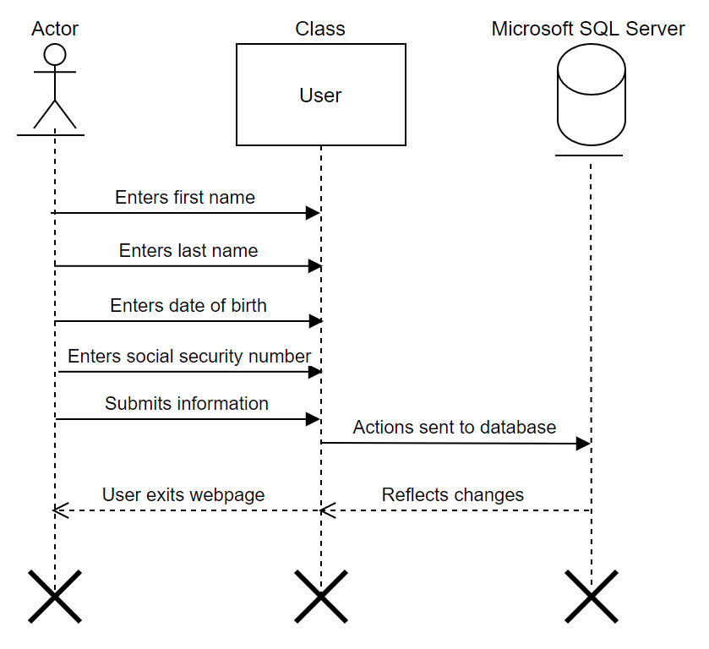

1. User accesses web page.

2. User inputs first name.

3. User inputs last name.

4. User inputs date of birth.

5. User inputs social security number.

6. User verifies entries.

7. User submits information.

8. User exits web page.

9. Use case ends.

**25. Edit Background Check**

**1.1 Brief Description**

With this use case, the administrator can access the database records if it is known that there was a clerical error in the information submitted by a user. This is needed as if there were no option, incorrect information could be submitted to background check services and delay the acceptance of a new volunteer.

**2. Flow of Events**

**2.1 Basic Flow**

1. Administrator accesses database.
2. Administrator locates background check.
3. Administrator edits data.
4. Administrator saves changes.
5. Administrator exits database.
6. Use case ends.

**2.2 Alternative Flows**

*2.2.1 Administrator determines information is correct and exits without changes.*

The administrator upon entering the database finds out that the information submitted by the user is correct. They exit the database and make no changes; the database maintains the previous state.

1. Administrator accesses database.
2. Administrator makes no changes.
3. Administrator exits database.
4. Use case ends.

**3. Special Requirements**

*3.1 Administrator determines information is correct and exits without changes.*

If the administrator does not have permissions or the ability to access the database, changes cannot be made to the data contained. Thus, it would increase the time of fixing errors within the database.

**4. Pre-conditions**

4.1 Administrator must be connected to the database.

### They must be connected to the database, whether it is on a local hard-wired connection or on the Internet.

**5. Post-conditions**

5.1 The data is changed, and it is retained.

After the administrator saves changes to the database, it will update the records and changes are retained.

**Basic Flow Sequence Diagram**

1. Administrator accesses database. 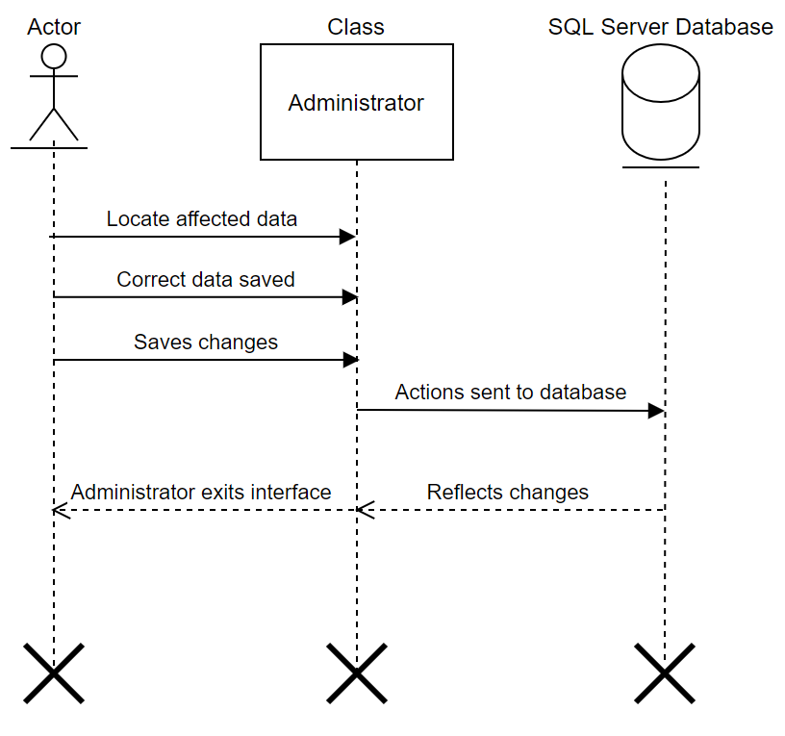
2. Administrator locates background check.
3. Administrator edits data.
4. Administrator saves changes.
5. Administrator exits database.
6. Use case ends.

**26. Delete Background Check**

**1.1 Brief Description**

With this use case, the administrator or user can delete background check information from the database server. This is useful as a volunteer may decide to leave the organization and not have their information stored.

**2. Flow of Events**

**2.1 Basic Flow**

1. Administrator accesses database.
2. Administrator locates data.
3. Administrator deletes data.
4. Administrator confirms changes.
5. Administrator clicks save.
6. Administrator exits database.
7. Use case ends.

**2.2 Alternative Flows**

*2.2.1 The user requests to delete their submitted data.*

Instead of the administrator seeking user data to be deleted, the user seeks to remove their data from the database. This can be done by either submitting a request through the “Contact Us” page or having a management page for the user when they login.

1. User logs in.
2. User accesses profile.
3. User submits request.
4. Administrator verifies request.
5. Administrator approves request.
6. Data is deleted.
7. Use case ends.

*2.2.2 The administrator decides not to delete data.*

The administrator may find that there is a rule/regulation that prevents organizations from discarding sensitive information for a fixed time period.

1. Administrator verifies data regulation.
2. Administrator determines not to delete data.
3. Administrator exits database.
4. Use case ends.

**3. Special Requirements**

*3.1 Administrator needs access to the database.*

The administrator needs prior permissions to access the database. This allows them to view data and be able to delete necessary information.

*3.2 User has to have an account prior to request.*

The user must have an account prior to their data removal request. Otherwise, no action will be taken.

**4. Pre-conditions**

4.1 Administrator must be connected to the database.

The administrator needs to be connected to the database, whether it is a hard-wired connection locally or over the internet on a virtual machine.

4.2 User must have an active internet connection.

The user needs to have an internet connection to connect to the webpage.

**5. Post-conditions**

5.1 Background check information is deleted, changes are saved to the database.

When successful, the data requested to be removed is deleted from the database server.

**Basic Flow Sequence Diagram**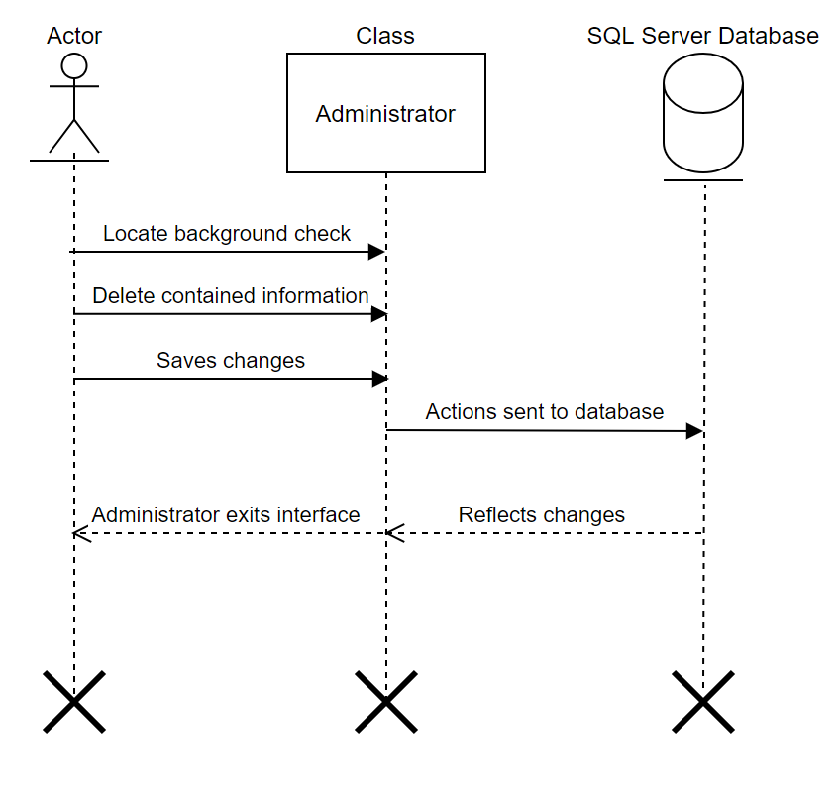

1. Administrator accesses database.
2. Administrator locates data.
3. Administrator deletes data.
4. Administrator confirms changes.
5. Administrator clicks save.
6. Administrator exits database.
7. Use case ends.

**27. Create Inventory Tracker**

**1.1 Brief Description**

With this use case, the administrator can create an inventory tracker for site users with permissions and access. This inventory tracker would help the organization manage their revolving inventory of donated goods and supplies. Creating the inventory tracker provides the organization’s management and leadership a concise system of items in organization inventory.

**2. Flow of Events**

**2.1 Basic Flow**

1. Administrator accesses database.
2. Administrator creates inventory list.
3. Administrator adds desired items to list.
4. Administrator saves changes.
5. Administrator creates formulas.
6. Administrator saves changes.
7. Administrator exits database.
8. Administrator accesses CMS.
9. Administrator creates new page.
10. Administrator links spreadsheet to page.
11. Administrator creates permissions.
12. Administrator saves changes.
13. Administrator exits Joomla.
14. Use case ends.

**2.2 Alternative Flows**

*2.2.1 Administrator decides not to make the inventory tracker accessible on the website.*

The administrator may decide it is better to maintain security around the inventory tracker and only make it accessible to those who are able to get into Joomla or the database server. This makes tracking items more difficult as there would not be a landing page on the website to access.

1. Administrator accesses database.
2. Administrator creates spreadsheet.
3. Administrator creates formulas.
4. Administrator saves changes.
5. Administrator exits database.
6. Use case ends.

**3. Special Requirements**

*3.1 Administrator needs permissions to access Joomla.*

If the administrator does not have the correct permissions, they will be unable to access Joomla and modify the website. Without permissions, the inventory tracker spreadsheets cannot be linked to the webpage.

*3.2 Administrator needs permissions to access the database server.*

If the administrator is not able to access the database server, they cannot create the necessary spreadsheets and formulas for the creation of the inventory tracker. Without these, the inventory tracker webpage would have no data shown and could not be updated accurately.

**4. Pre-conditions**

4.1 Administrator must have a connection for Joomla and to the database.

The administrator must either have a local hard-wired connection to the database or through a virtual machine. They also need a connection to access Joomla.

**5. Post-conditions**

5.1 Inventory tracker is created, data is displayed for users with permissions.

Once the spreadsheet data is linked with the web page, the administrator(s) and users with applicable permissions can track current inventory.

**Basic Flow Sequence Diagram**

1. Administrator accesses database. 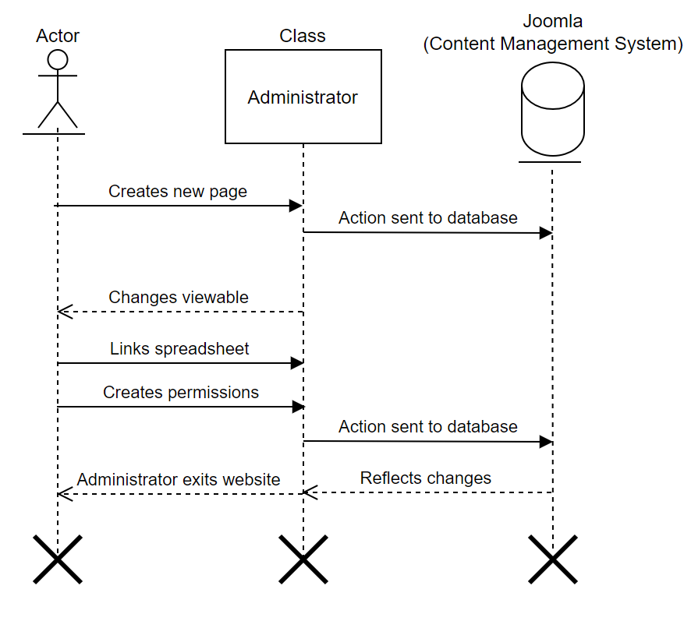
2. Administrator creates inventory list.
3. Administrator adds desired items to list.
4. Administrator saves changes.
5. Administrator creates formulas.
6. Administrator saves changes.
7. Administrator exits database.
8. Administrator accesses CMS.
9. Administrator creates new page.
10. Administrator links spreadsheet to page.
11. Administrator creates permissions.
12. Administrator saves changes.
13. Administrator exits Joomla.
14. Use case ends.

**28. Edit Inventory Tracker**

**1.1 Brief Description**

System needs to allow for automatic deductions and additions of the inventory donations and distributions. It will facilitate the need to be edited every time the number is changed.

**2. Flow of Events**

**2.1 Basic Flow**

1. User deducts inventory.
2. User edits tracker.
3. Use case ends.

**2.2 Alternative Flows**

*2.2.1 The actor takes inventory from stock as needed throughout the week.*

*2.2.2 At the end of each week the number of available inventories is calculated.*

*2.2.3 Any donations brought in will be calculated.*

*2.2.4 The total of each item in inventory is edited to reflect the current numbers by the actor*

**3. Special Requirements**

*3.1 First Special Requirement*

There needs to be a function that allows for editing the tracker.

**4. Pre-conditions**

4.1 An inventory tracking database needs to be in place prior to editing.

4.2 Exact inventory numbers will also have to be calculated before it's edited.

**5. Post-conditions**

5.1 User must keep the inventory tracker up to date to relay the current inventory levels.

**Basic Flow Sequence Diagram**

1. 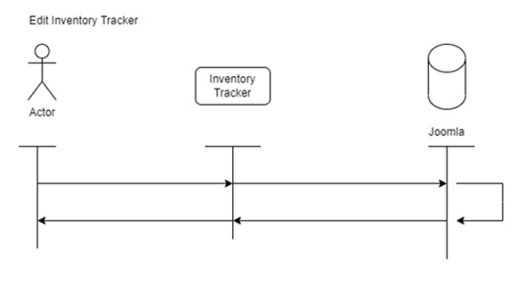User deducts inventory.
2. User edits tracker.
3. Use case ends.

**29. Delete Inventory Tracker**

**1.1 Brief Description**

The system needs to allow for deletion of inventory in cases there is any discrepancy between online inventory count and actual physical inventory.

**2. Flow of Events**

**2.1 Basic Flow**

1. User opens tracker.
2. User deletes tracker.
3. Use case ends.

**2.2 Alternative Flows**

*2.2.1 First Alternative Flow*

1. User edits tracker.
2. User deletes unwanted information.
3. Use case ends.

**3.Special Requirements**

*3.1 First Special Requirement*

There is a tracker that needs to be deleted. Additionally, there has to be a function on the tracker that allows it to be deleted.

**4. Pre-conditions**

4.1 There must be a need for the Inventory tracker to be deleted.

4.2 There needs to be a delete button.

**5.Post-conditions**

5.1 Deletion of the Tracker must be recorded to show what was deleted and when it was deleted.

5.2 A new tracker for inventory is in place.

**Basic Flow Sequence Diagram**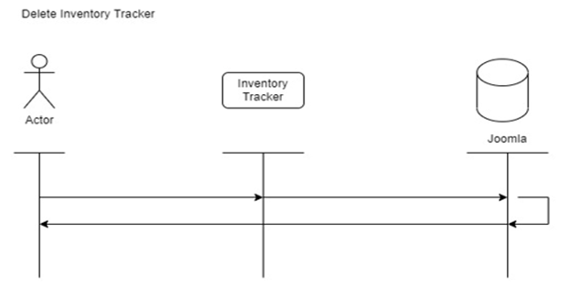

1. User opens tracker.
2. User deletes tracker.
3. Use case ends.

**30. Create Title Nine Training**

**1.1 Brief Description**

The system needs to allow for title nine training to be conducted on site by volunteers. This would include having a place for volunteers to find information and forms to fill out and the training to complete.

**2. Flow of Events**

**2.1 Basic Flow**

1. User uploads title nine training.
2. User gathers information from the user.
3. User publishes the training for public use.
4. Use case ends.

**2.2.Alternative Flows**

*2.2.1 First Alternative Flow*

1. User uploads the necessary documents to website.
2. User creates the training.
3. User publishes the training to website.
4. Use case ends.

**3.Special Requirements**

*3.1 First Special Requirement*

There has to be a website for the training to be put on.

**4. Pre-conditions**

4.1 There needs to be a way for volunteers to complete their training on their own.

4.2 There needs to be areas to put user information.

**5.Post-conditions**

5.1 There needs to be a way for staff to see the record that the training was completed.

5.2 The training needs to be able to be completed by volunteers.

**Basic Flow Sequence Diagram** 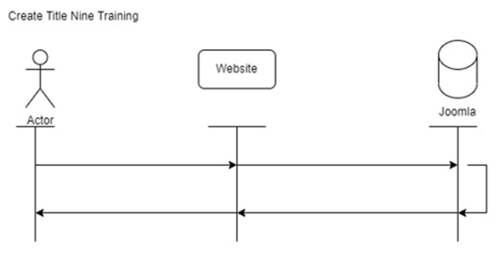

1. User uploads title nine training.
2. User gathers information from the user.
3. User publishes the training for public use.
4. Use case ends.

**31. Create Testimonial**

**1.1 Brief Description**

The system needs to allow for a testimonial page, showing the impact of the organization and its works for the community.

**2. Flow of Events**

**2.1 Basic Flow**

1. User gather the information for the testimonial.
2. User creates a tab for testimonials.
3. User inserts testimonial.
4. User saves testimonial.
5. Use case ends.

**2.2 Alternative Flows**

*2.2.1 First Alternative Flow*

1. User creates the testimonial page on site.
2. User puts information on the page.
3. User saves testimonial.
4. Use case ends.

**3. Special Requirements**

*3.1. First Special Requirement*

There needs to be a website in place to put a testimonial tab.

**4. Pre-conditions**

4.1. There needs to be information collected about the work the organization has made on the community.

4.2. The organization needs to do things that can be added to the testimonial page.

**5. Post-conditions**

5.1 The organization needs to keep the testimonial up to date with recent testimonials.

5.2 There needs to be a way to edit the testimonial at any time if needed.

**Basic Flow Sequence Diagram**

1. User gather the information for the testimonial.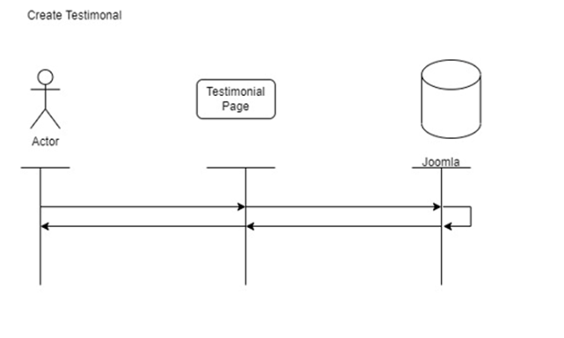
2. User creates a tab for testimonials.
3. User inserts testimonial.
4. User saves testimonial.
5. Use case ends.

**32. Edit Testimonial**

**1.1 Brief Description**

The system needs to allow for system administrators to edit the information displayed on the testimonial page.

**2. Flow of Events**

**2.1 Basic Flow**

1. User goes into edit mode on the website.
2. User fixes the information needed.
3. User exits edit mode.
4. Use case ends.

**2.2 Alternative Flows**

*2.2.1. First Alternative Flow*

1. User goes into edit mode on the website.
2. User fixes the information.
3. User leaves edit mode.
4. Use case ends.

**3. Special Requirements**

*3.1 First Special Requirement*

There needs to be a website in place that needs editing.

**4. Pre-conditions**

4.1 There needs to be something in the testimonial that needs to be fixed

4.2. The user needs to go into edit mode in order to fix the mistake.

**5. Post-conditions**

5.1. The user needs to leave edit mode on the website to not delete the changes.

5.2. There needs to be a way to only allow certain people to make changes to the website to stop others from making unwanted changes.

**Basic Flow Sequence Diagram**

1. User goes into edit mode on the website.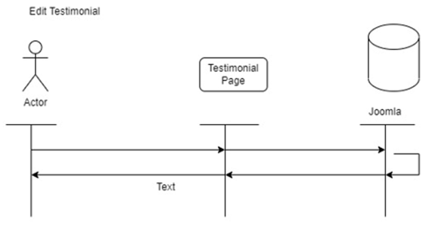
2. User fixes the information needed.
3. User exits edit mode.
4. Use case ends.

**33. Delete Testimonial**

**1.1 Brief Description**

The system needs to allow for system administrators to delete old testimonies and incorrect information.

**2. Flow of Events**

**2.1 Basic Flow**

1. User opens testimonial.
2. User deletes old testimonials.
3. User saves changes.
4. User leaves testimonial.
5. Use case ends.

**2.2 Alternative Flows**

*2.2.1 First Alternative Flow*

1. User opens testimonial.
2. User erases the testimonial statements.
3. User leaves the testimonial page.
4. Use case ends.

**3. Special Requirements**

*3.1 First Special Requirement*

There needs to be a website where testimonials are located.

**4. Pre-conditions**

4.1 There needs to be a testimonial that needs to be taken out and replaced or taken out completely.

4.2 There needs to be testimonials on the website for them to need to be deleted.

**5. Post-conditions**

5.1 Edits and deletion of testimonials need to be saved and backed up.

5.2 New testimonials should be added after so tabs on the website are not empty.

**Basic Flow Sequence Diagram**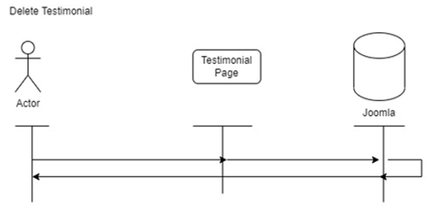

1. User opens testimonial.
2. User deletes old testimonials.
3. User saves changes.
4. User leaves testimonial.
5. Use case ends.

**34. Create Social Media Ties**

**1.1 Brief Description**

The system needs to allow for organizations other social media pages to be directly linked on the site for easy access by users.

**2. Flow of Events**

**2.1 Basic Flow**

1. User links social medias to site.
2. User uploads pictures of social medias.
3. User connects links to pictures.
4. Use case ends.

**2.2 Alternative Flows**

*2.2.1 First Alternative Flow*

1. User uploads pictures of social medias.
2. User links pictures to social media links.
3. Use case ends.

**3. Special Requirements**

*3.1 First Special Requirement*

There needs to be a social media link that can be used to link the website to social medias.

**4. Pre-conditions**

4.1 There needs to be links on a social media tab or logos that can be linked to the organization's social media.

4.2 There needs to be a tab that includes an area for social media links.

**5. Post-conditions**

5.1 The links need to be frequently checked to ensure that they work correctly.

5.2 The links need to be checked after to make sure they go to the correct social media pages.

**Basic Flow Sequence Diagram**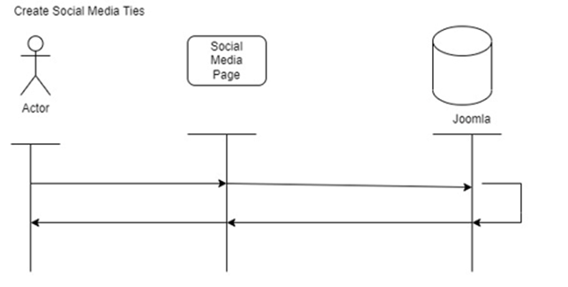

1. User links social medias to site.
2. User uploads pictures of social medias.
3. User connects links to pictures.
4. Use case ends.

**35. Edit Social Media Ties**

**1.1 Brief Description**

The system needs to allow for the fixing of incorrect social media display(s).

**2. Flow of Events**

**2.1 Basic Flow**

1. User deletes wrong information.
2. User enters the correct information.
3. User saves information on the website.
4. Use case ends.

**2.2. Alternative Flows**

*2.2.1. First Alternative Flow*

1. User deletes the wrong information.
2. User fixes the information.
3. User saves the information on the website.
4. Use case ends.

**3. Special Requirements**

*3.1. First Special Requirement*

There needs to be a mistake with the social media ties that requires the user to fix it.

**4. Pre-conditions**

4.1. There needs to be social media ties on the website currently that need fixed

4.2. The social media platform needs to be working correctly in order to link it to the website correctly.

**5. Post-conditions**

5.1 The website needs to have the most up to date version of the organization's social media pages to ensure that visitors go to the correct social media sites.

5.2 After links are put in, the user needs to ensure that the new links work correctly.

**Basic Flow Sequence Diagram**

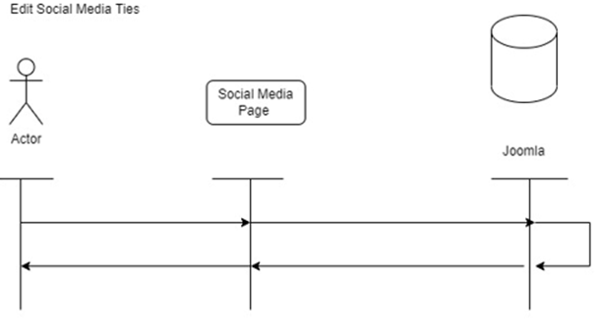

1. User deletes wrong information.
2. User enters the correct information.
3. User saves information on the website.
4. Use case ends.

**36. Delete Social Media Ties**

1. Brief Description: The system needs to allow for designated user(s) or administrators to delete social media ties.
2. Basic Flow
   1. User(s) select social media account page
   2. User(s) select item to delete
   3. User(s) select delete
   4. Use case ends.
3. Special Requirements: No special requirement
4. Pre-conditions: There needs to be social media ties on the website currently that need deletion
5. Post-conditions: The social media tie will be removed

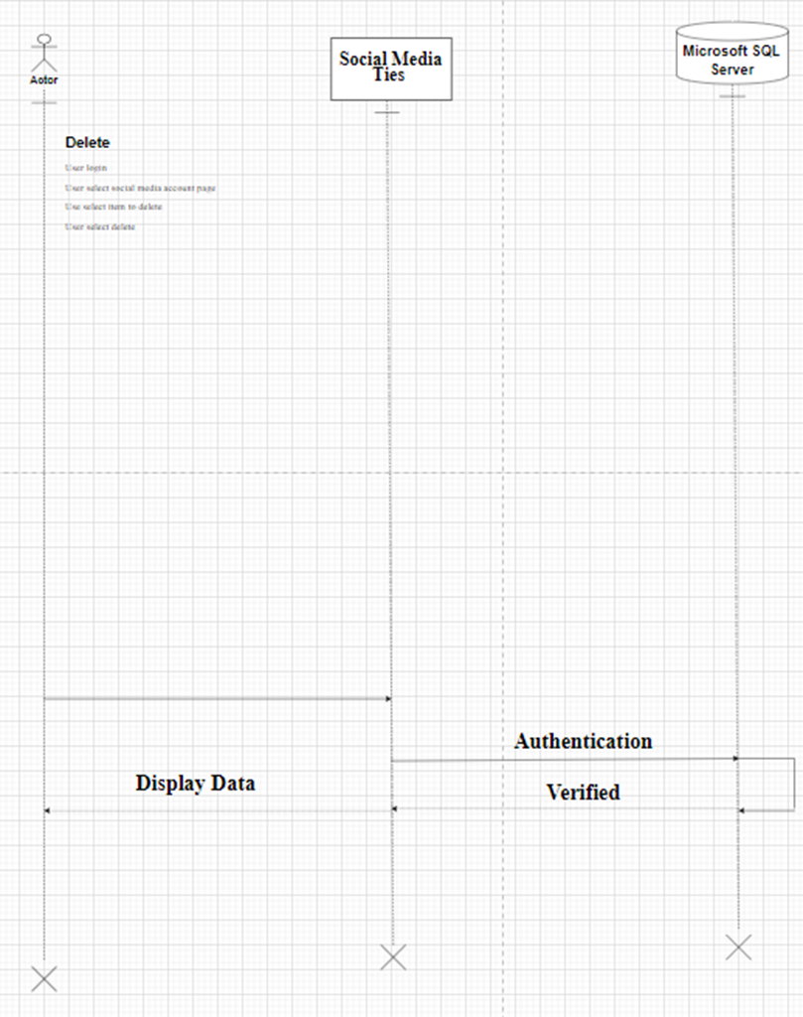

**37, 38, 39 Attendance Tracker**

1. Brief Description:

The system will allow designated user(s) or Admin to create, edit and delete attendance tracker.

1. Basic Flow

**37. Create Attendance Tracker**

* 1. User login
  2. User enter New Attendance Tracker
  3. Users enter class name
  4. Users enters student first name
  5. Users enters student middle name
  6. Users enter student last name
  7. Users enters location of class
  8. Users enters instructor first name
  9. Users enters instructor middle name
  10. Users enter instructor last name
  11. Users enter instructor phone number
  12. Users enter instructor email address
  13. Users will select “Confirm” button
  14. Use Case ends

**38. Edit Attendance Tracker**

* 1. User login
  2. Users will select “Attendance Tracker”.
  3. System will provide user with all existing Attendance Tracker information.
  4. User will modify necessary fields.
     1. Users edit class name
     2. Users edit student first name
     3. Users edit student middle name
     4. Users edit student last name
     5. Users edit location of class
     6. Users edit instructor first name
     7. Users edit instructor middle name
     8. Users edit instructor last name
     9. Users edit instructor phone number
     10. Users edit instructor email address
  5. User will select “Save Changes”.
  6. System will provide user with a confirmation of changes.
  7. Use case ends.
* **39. Delete Attendance Tracker**
  1. Administrator inputs the student’s first name
  2. Administrator inputs the student’s last name
  3. System will provide a list Attendance Tracker who matches the administrator’s search.
  4. Administrator will select the student.
  5. Administrator selects “Delete Student”
  6. System will provide a notice stating, “Are you sure you wish to remove the student from class?”
  7. Administration will select “Confirm”
  8. System will provide a message of confirmation.
  9. Use case ends.

1. Pre-conditions: Class will need to be created first, once attendance tracker is created, options to edit or delete will proceed.
2. Post-conditions: Updated Attendance Tracer containing Class/Students/Instructor information is published.

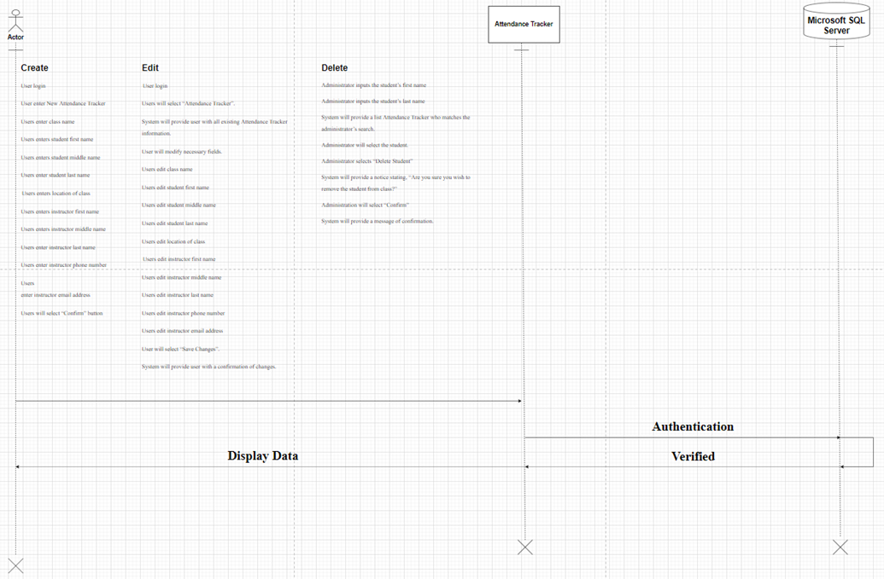

**40, 41, 42 Class / Programs Offered**

1. Brief Description:

The system will allow designated user(s) or administrator to create, edit and delete classes and resources offered by my organization.

1. Basic Flow

**41. Create Programs**

* 1. User login
  2. User enter Add New Class
  3. Users enter class name
  4. Users enters Class ID
  5. Users enters class location
  6. Users enter class description
  7. Users enters class instructor full name
  8. Users enters class date
  9. Users enters class start time
  10. Users enter class end time
  11. User will select “Confirm” button
  12. Use Case ends

**42. Edit Programs**

* 1. User login
  2. Users will select “Edit Class”.
  3. System will provide user with all existing Class information.
  4. User will modify necessary fields.
     1. Users edit class ID
     2. Users edit class location
     3. Users edit class description
     4. Users edit class instructor full name
     5. Users edit class date
     6. Users edit class start time
     7. Users edit class end time
  5. User will select “Save Changes”.
  6. System will provide user with a confirmation of changes.
  7. Use case ends.
* **43. Delete Programs** 
  + - 1. User login
      2. Users will select “Edit Class”.
      3. Administrator inputs the class ID
      4. Administrator selects Class
      5. Administrator selects “Delete Class”.
      6. System will provide a notice stating, “Are you sure you wish to delete class?”
      7. Administration will select “Confirm”
      8. System will provide a message of confirmation.
      9. Use case ends.

1. Pre-conditions: Class will need to be created first, once class is created, options to edit or delete will proceed.
2. Post-conditions: Updated Class / Program containing Class/Instructor information is published.

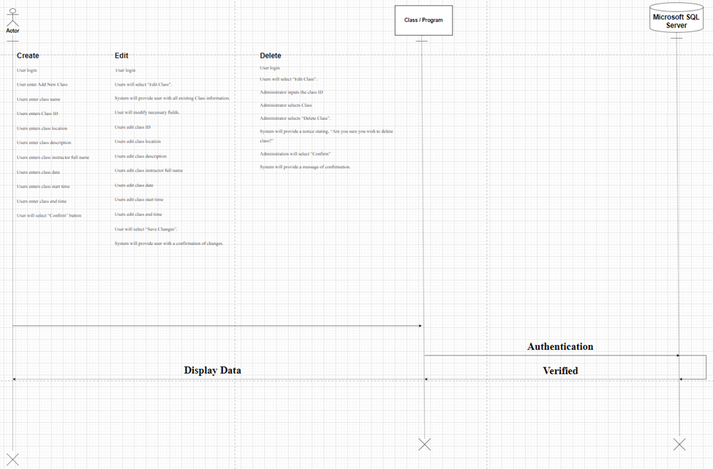

**Class Diagram**

In object-oriented programming, a class is a template that programmers can use to create unique instances of data, which is called an object. The below diagram shows all of the classes associated with our proposed system for the Thompson Project. Each class has three main parts. First, the class name, which is shown at the top of each box. Second is the attributes, which are located in the middle section. Attributes are pieces of information that will be stored inside of each instance of the class. Last is the methods, which are located at the bottom of each box. These are actions that each object class is associated with in each of our use cases.

In order to create this class diagram, we used two methods of taking our use-cases and converting them into classes for the system. First is noun-verb analysis. This technique breaks down the use cases into nouns, which are either the class itself or attributes, and verbs, which become the methods of each class. We also used prototype analysis, which allows us to create classes from the mockups that we have created in previous iterations.

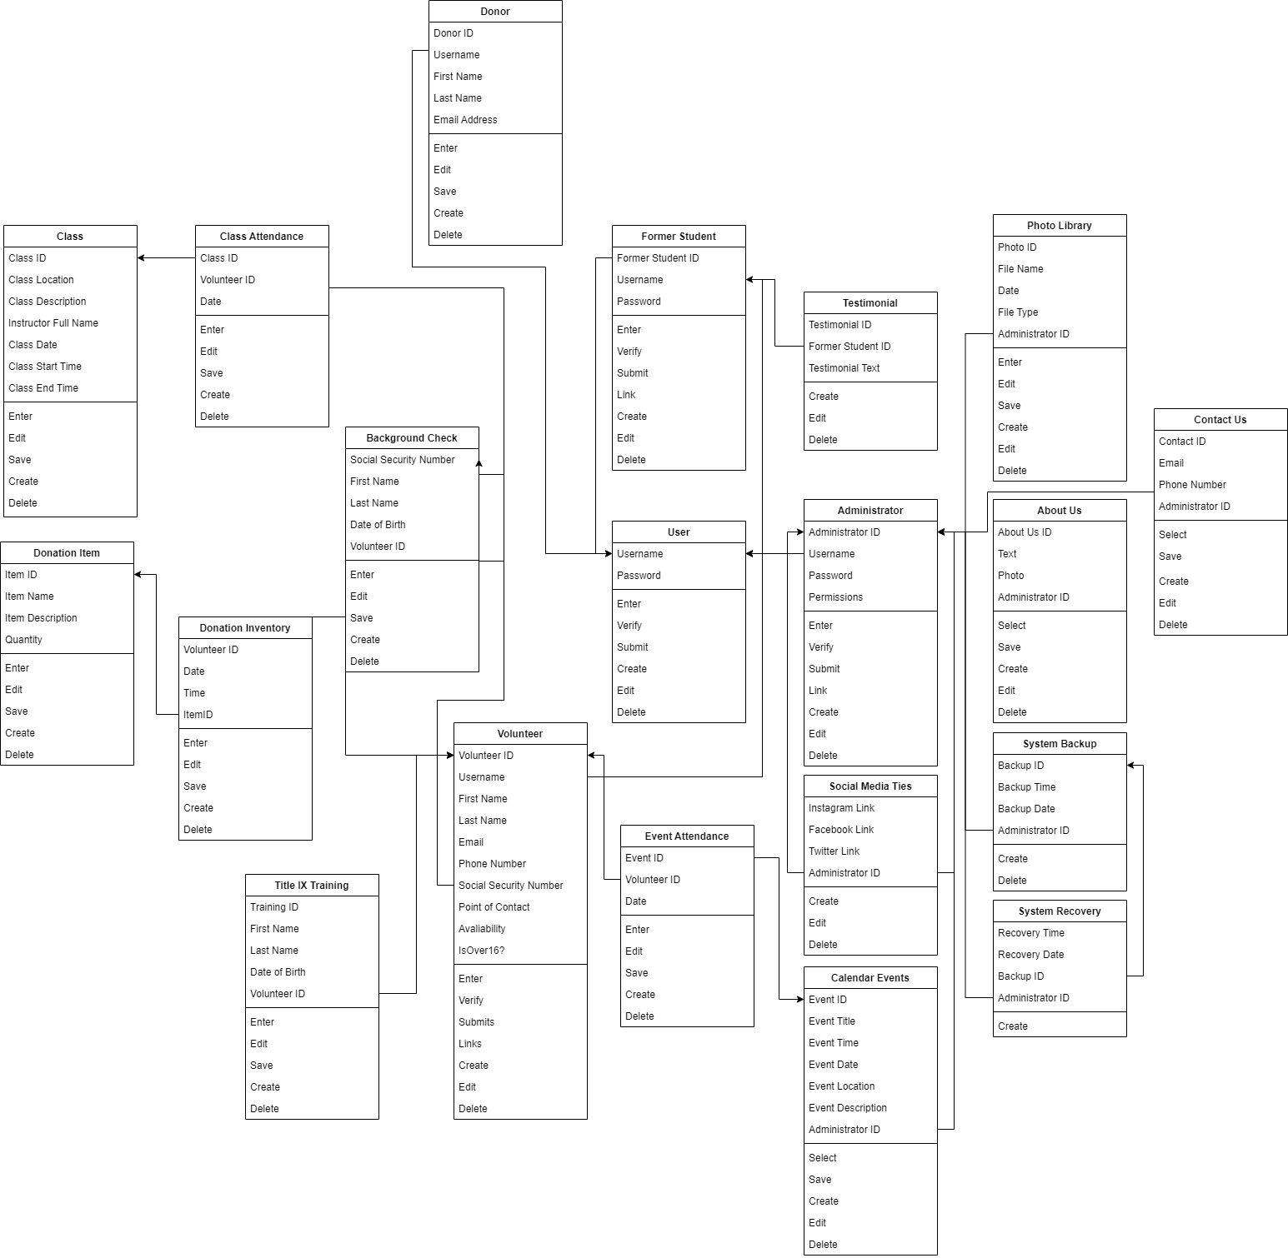

**Entity-Relationship Diagram and Data Dictionary**

Database design is a crucial part of each system’s infrastructure. The typical way to present the relationships in a database is through an Entity-Relationship Diagram, commonly referred to as an ERD. ERDs have two major parts. First is the entity, which is represented by the boxes on the diagram. These are the tables that will populate the database. Each entity has a title and attributes listed, as well as a primary key attribute that is bolded. Foreign keys, noted by underlined text, are primary keys of one entity that appear on another table. The second piece is the relationship, which are the lines that connect the entities. Each relationship features a cardinality, which shows how many times that relationship can be repeated, and if it is a mandatory or optional relationship. Cardinality is designated by the lines at each end of a relationship, and our ERD follows crow’s foot notation.

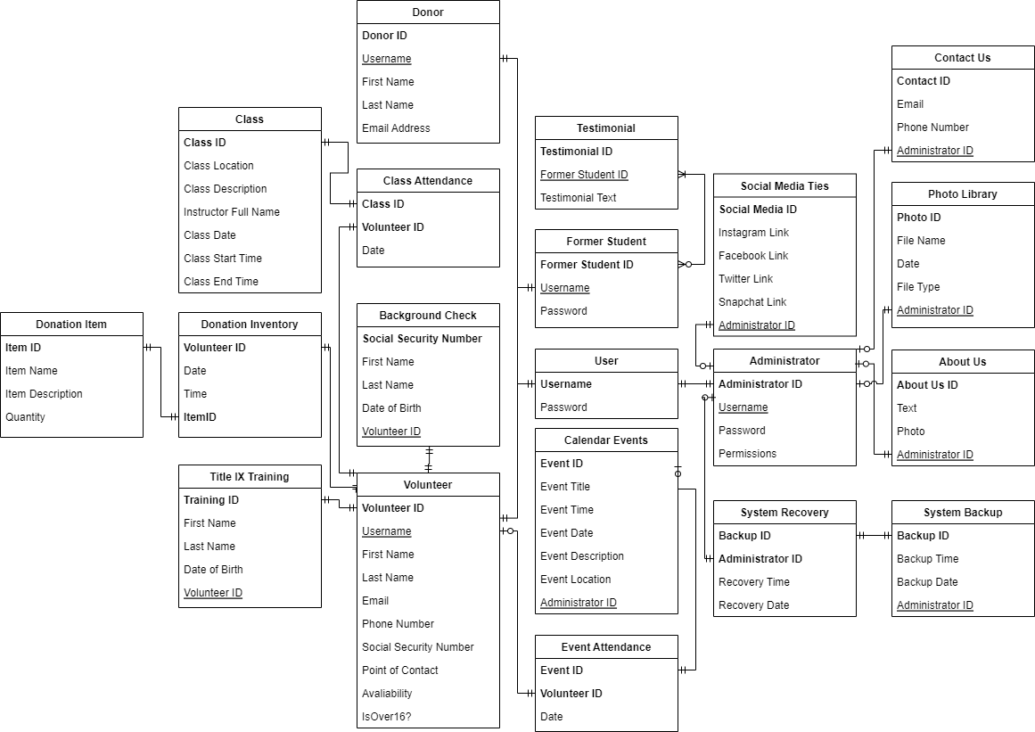

We also have included a data dictionary for each of our entities. These following tables outline each attribute in each entity. The name, definition, attribute size, attribute type, and primary or foreign key designation are listed.

**User Table:**

| **Attribute** | **Attribute definition** | **Attribute size** | **Attribute Type** | **Primary or foreign key** |
| --- | --- | --- | --- | --- |
| User Name | The users unique username to log in | 20 bytes | string | Primary |
| Password | Users unique password to log in securely | 30 bytes | string | n/a |

**Former Student Table:**

| **Attribute** | **Attribute definition** | **Attribute size** | **Attribute Type** | **Primary or foreign key** |
| --- | --- | --- | --- | --- |
| Former Student ID | ID that identifies former student | 4 bytes | uint | Primary |
| User name | Users unique username to log in | 20 bytes | string | Foreign |
| Password | Users unique password used to log in securely | 30 bytes | string | n/a |

**Administrator Table:**

| **Attribute** | **Attribute definition** | **Attribute size** | **Attribute Type** | **Primary or foreign key** |
| --- | --- | --- | --- | --- |
| Admin ID | ID identifies administrator | 4 bytes | uint | Primary |
| User Name | Users unique username to log in | 20 bytes | String | Foreign |
| Password | Users unique password to log in securely | 30 bytes | String | n/a |
| Permissions | Actions Administrators are allowed to do | 20 bytes | string | n/a |

**Photo Library Table:**

| **Attribute** | **Attribute definition** | **Attribute size** | **Attribute Type** | **Primary or foreign key** |
| --- | --- | --- | --- | --- |
| Photo ID | ID that correlates to a photo | 4 bytes | uint | Primary |
| File Name | Name of file | 40 bytes | string | n/a |
| Date | Date image was taken | 8 bytes | date | n/a |
| File Type | Indicates what kind of file it is | 4 bytes | string | n/a |
| Admin ID | ID that correlates to admin | 4 bytes | uint | Foreign |

**Background Check Table:**

| **Attribute** | **Attribute definition** | **Attribute size** | **Attribute Type** | **Primary or foreign key** |
| --- | --- | --- | --- | --- |
| Background ID | Unique identifier for background checks | 4 bytes | Uint | Primary |
| First Name | User’s first name | 20 bytes | string | n/a |
| Last Name | User’s last name | 20 bytes | string | n/a |
| Date of Birth | User’s birthday | 8 bytes | date | n/a |
| Social Security Number | User’s social security number | 9 bytes | Integer- 8 digits | Primary |

**Title IX Training Table:**

| **Attribute** | **Attribute definition** | **Attribute size** | **Attribute Type** | **Primary or foreign key** |
| --- | --- | --- | --- | --- |
| Training ID | ID that correlates to users training | 4 bytes | uint | Primary |
| First Name | Users first name | 20 bytes | string | n/a |
| Last Name | Users last name | 20 bytes | string | n/a |
| Date of Birth | Users date of birth | 8 bytes | date | n/a |
| Social Security Number | Users social security number | 9 bytes | Integer- 8 digits | n/a |
| Volunteer ID | ID that correlates to volunteers | 8 bytes | uint | Foreign |

**Donor Table:**

| **Attribute** | **Attribute definition** | **Attribute size** | **Attribute Type** | **Primary or foreign key** |
| --- | --- | --- | --- | --- |
| Donor ID | ID that identifies donors | 4 bytes | uint | Primary |
| User name | Users unique username to log in | 20 bytes | string | Foreign |
| Password | Users unique password used to log in securely | 30 bytes | string | n/a |
| Email | Donor’s email address | 40 bytes | string | n/a |

**Volunteer Table:**

| **Attribute** | **Attribute definition** | **Attribute size** | **Attribute Type** | **Primary or foreign key** |
| --- | --- | --- | --- | --- |
| Volunteer ID | Unique identifier for volunteer | 8 bytes | Uint | Primary |
| Username | Volunteer username on site | 20 bytes | String | n/a |
| Password | Volunteer password on site | 30 bytes | String | n/a |
| First Name | Volunteer first name | 20 bytes | String | n/a |
| Last Name | Volunteer last name | 20 bytes | String | n/a |
| Email | Volunteer email address for contact purpose | 40 bytes | String | n/a |
| Phone Number | Volunteer phone number for contact purpose | 10 bytes | Uint | n/a |
| Social Security Number | Volunteer SSN for identification purposes. | 9 bytes | Uint | Foreign |
| Point of Contact | “How did you hear about us?” | 20 bytes | String | n/a |
| Availability | Volunteer preferred days to serve | 60 bytes | String | n/a |
| IsOver16? | Is the volunteer over 16? | 1 byte | Boolean | n/a |

**Testimonial Table:**

| **Attribute** | **Attribute definition** | **Attribute size** | **Attribute Type** | **Primary or foreign key** |
| --- | --- | --- | --- | --- |
| Testimonial ID | Unique ID for testimonial. | 4 bytes | Uint | Primary Key |
| Testimonial Text | Description of testimonies made by former students. | Max 255 bytes | String | n/a |
| Former Student ID | ID that is associated with student testimonials. | 4 bytes | Uint | Foreign key |

**Social Media Ties Table:**

| **Attribute** | **Attribute definition** | **Attribute size** | **Attribute Type** | **Primary or foreign key** |
| --- | --- | --- | --- | --- |
| Social Media ID | Unique identifier for social media. | 4 bytes | Uint | Primary key |
| Instagram Link | Link for instagram page | Max 255 bytes | String | n/a |
| Facebook Link | Link for facebook page | Max 255 bytes | String | n/a |
| Twitter Link | Link for Twitter page. | Max 255 bytes | String | n/a |
| Snapchat Link | Link for Snapchat page. | Max 255 bytes | String | n/a |
| Administrator ID | Admin has access to all socials. | 4 Bytes | Uint | Foreign key |

**Event Table:**

| **Attribute** | **Attribute definition** | **Attribute size** | **Attribute Type** | **Primary or foreign key** |
| --- | --- | --- | --- | --- |
| Event ID | Unique identifier for the calendar period displayed on page. | 4 bytes | Uint | Primary Key |
| Event Title | Title for the calendar event | Max 255 bytes | String | n/a |
| Event Time | Time for the calendar events | 6 bytes | TIme | n/a |
| Event Date | Dates for the events on calendar | 8 bytes | Date | n/a |
| Event Location | Location of the event | 60 bytes | String | n/a |
| Event Description | Displays information regarding events. | Max 255 bytes | String | n/a |
| Administrator ID | Administrator responsible | 4 Bytes | Unit | Foreign key |

**About Us Table:**

| **Attribute** | **Attribute definition** | **Attribute size** | **Attribute Type** | **Primary or foreign key** |
| --- | --- | --- | --- | --- |
| About Us ID | Unique identifier for About Us page. | 4 bytes | Uint | Primary key |
| Text | The text displayed to the user. | Max 255 bytes | String | n/a |
| Photo | The photos displayed to the user. | Max 255 bytes | String | n/a |
| Administrator ID | The administrator is able to control what's on the about us page. | 4 bytes | Uint | Foreign key |

**Contact Us Table:**

| **Attribute** | **Attribute definition** | **Attribute size** | **Attribute Type** | **Primary or foreign key** |
| --- | --- | --- | --- | --- |
| Contact Us ID | Unique identifier for the contact record | 4 bytes | Uint | Primary Key |
| First Name | Users first name for identification purpose. | 20 bytes | String | n/a |
| Last Name | Users last name for identification purpose | 30 bytes | String | n/a |
| Email | Users email for contact purpose | 40 bytes | string | n/a |
| Description | Information regarding users reasons for reaching out | Max 255 bytes | String | n/a |

**Class Table:**

| **Attribute** | **Attribute definition** | **Attribute**  **Size** | **Attribute**  **Type** | **Primary or foreign key** |
| --- | --- | --- | --- | --- |
| Class ID | Unique identifier for each class | 4 bytes | Uint | Primary key |
| Class Description | Description of class. | Max 255 bytes | String | n/a |
| Class Location | Location of class | 60 bytes | String | n/a |
| Instructor Full Name | Full name of teacher | 40 bytes | String | n/a |
| Class Date | Date of the class | 8 bytes | Date | n/a |
| Class Start Time | Start time of the class | 6 bytes | Time | n/a |
| Class End Time | End time of the class | 6 bytes | Time | n/a |

**Class Attendance Table:**

| **Attribute** | **Attribute definition** | **Attribute**  **Size** | **Attribute**  **Type** | **Primary or foreign key** |
| --- | --- | --- | --- | --- |
| Class ID | Unique identifier for each class | 4 bytes | Uint | Primary key |
| Volunteer ID | unique identifier for volunteer attendance record | 4 bytes | Uint | Primary key |
| Date | Date of each volunteer event. | 8 bytes | Date | n/a |

**Donation Inventory Table:**

| **Attribute** | **Attribute definition** | **Attribute**  **Size** | **Attribute**  **Type** | **Primary or foreign key** |
| --- | --- | --- | --- | --- |
| Volunteer ID | Unique identifier for volunteer. | 4 bytes | Uint | Primary key |
| Date | Date for donation inventory | 8 bytes | Date | n/a |
| Time | Time of donation inventory | 6 bytes | Time | n/a |
| ItemID | Unique identifier for item donated. | 4 bytes | Uint | Primary key |

**Donation Item Table:**

| **Attribute** | **Attribute definition** | **Attribute**  **Size** | **Attribute**  **Type** | **Primary or foreign key** |
| --- | --- | --- | --- | --- |
| Item ID | Unique identifier for item donated. | 4 bytes | Uint | Primary key |
| Item Name | Name of item donated | Max 255 bytes | String | n/a |
| Item Description | Description of item donated | Max 255 bytes | String | n/a |
| Quantity | Number of item donated | 4 bytes | String | n/a |

**Event Attendance Table:**

| **Attribute** | **Attribute definition** | **Attribute**  **Size** | **Attribute**  **Type** | **Primary or foreign key** |
| --- | --- | --- | --- | --- |
| Event ID | Unique identifier for event attendance. | 4 bytes | Uint | Primary key |
| Volunteer ID | Unique identifier of volunteer at event | 4 bytes | Uint | Primary key |
| Date | Date that event take place | 8 bytes | Date | n/a |

**System Recovery Table:**

| **Attribute** | **Attribute definition** | **Attribute**  **Size** | **Attribute**  **Type** | **Primary or foreign key** |
| --- | --- | --- | --- | --- |
| Backup ID | Unique identifier for backup number. | 4 bytes | Uint | Primary Key |
| Administrator ID | Unique identifier of administrator doing the backup | 4 bytes | Uint | Primary Key |
| Recovery Time | Time that recovery is performed | 6 bytes | Time | n/a |
| Recovery Date | Date that recovery is performed. | 8 bytes | Date | n/a |

**System Backup Table:**

| **Attribute** | **Attribute definition** | **Attribute**  **Size** | **Attribute**  **Type** | **Primary or foreign key** |
| --- | --- | --- | --- | --- |
| Backup ID | Unique identifier for backup. | 4 bytes | Uint | Primary key |
| Backup Time | Time that backup is performed | 6 bytes | Time | n/a |
| Backup Date | Date backup is performed. | 8 bytes | Date | n/a |
| Administrator ID | Unique identifier for admin performing backup. | 4 bytes | Uint | Foreign key |

**Window Navigation Diagram**

The window navigation diagram gives a top-level view of the paths on the landing page. For example, when the user clicks on the News/Events button, it takes them to the News/Events window and finally the calendar window. These attributes are distinguished by terms such as “Form”, “Button”, “Window”, and “Hyperlink Report”. All buttons within the main box in the top half of the diagram represent buttons and links you can find on the landing page of the website.

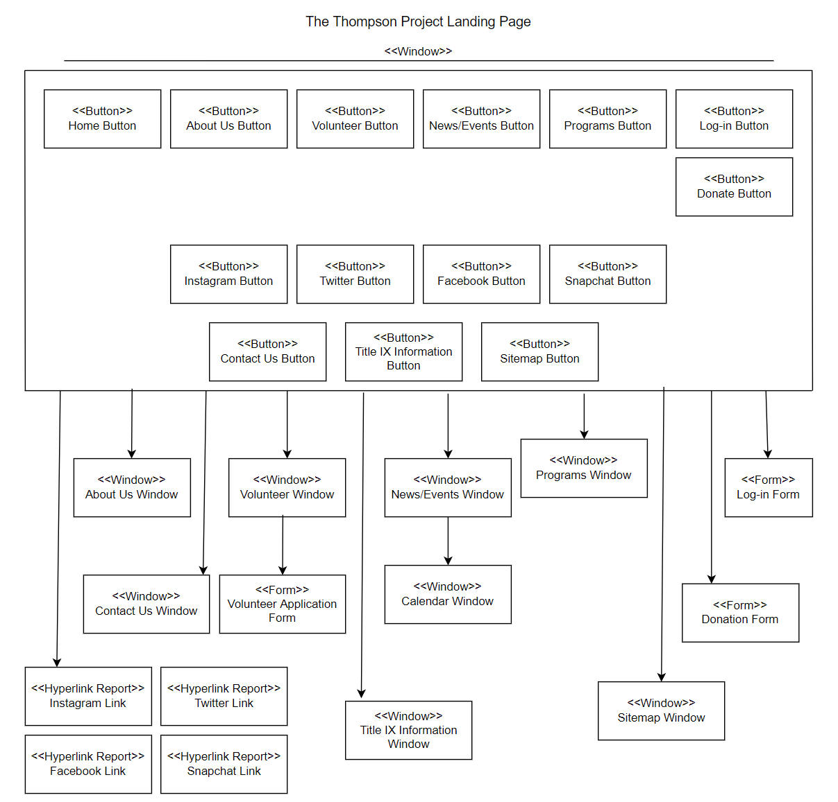

**Screen Layouts - Data Capture Forms**

In this section, several wireframes represent the various forms that would be used to collect data from the users of the organization website. These screen layouts help the organization leaders and planners have a greater understanding of what the website can look like for the end user. For example, the create account form wireframe below represents what new users would see when completing an initial setup of their account.

**Create Account Form**

This form is necessary for volunteers and members of the organization as they can utilize locked pages such as access to information for volunteers, volunteer events, etc. The website will prompt the user for an email address (necessary for newsletter & password reset), a username, password, and confirmation of the password. This wireframe relates to the use case “Create Log-in” from the list of previously determined use cases.

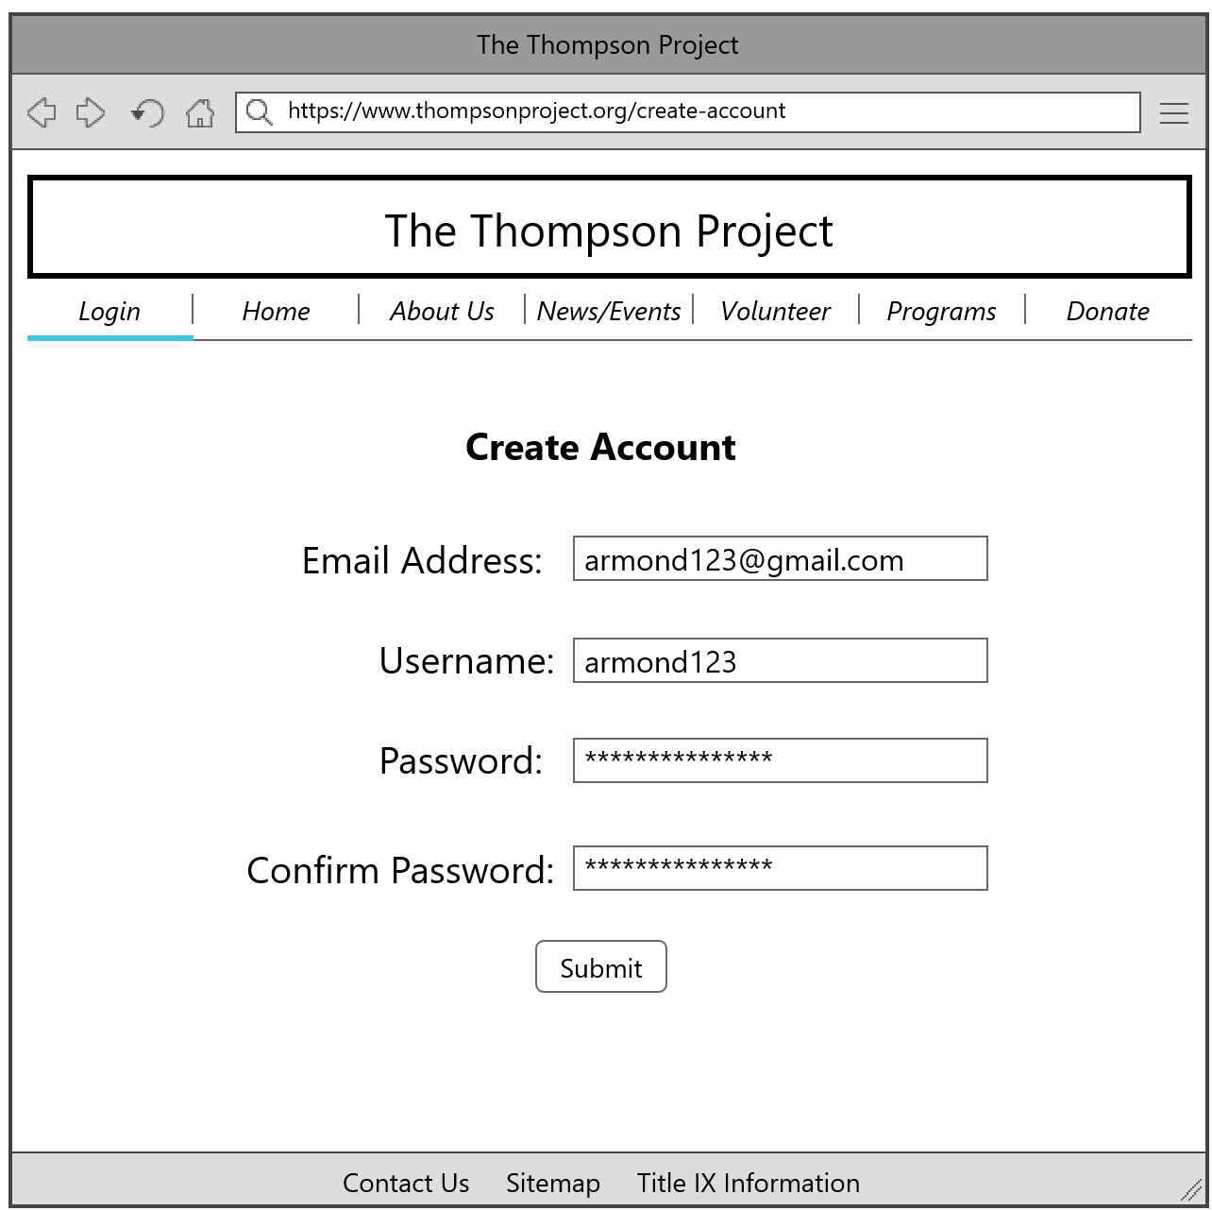

**Log-in Screen**

This form is essential to the website as it gives access to locked pages for the volunteers and members of the organization. The login-screen prompts the user for a username and password to submit. If the user does not remember their username/password, “Forgot?” links are located below the text input fields, where they can receive a username/password reset to their associated email with the account. This form is associated with the use case “Edit Log-in?”.

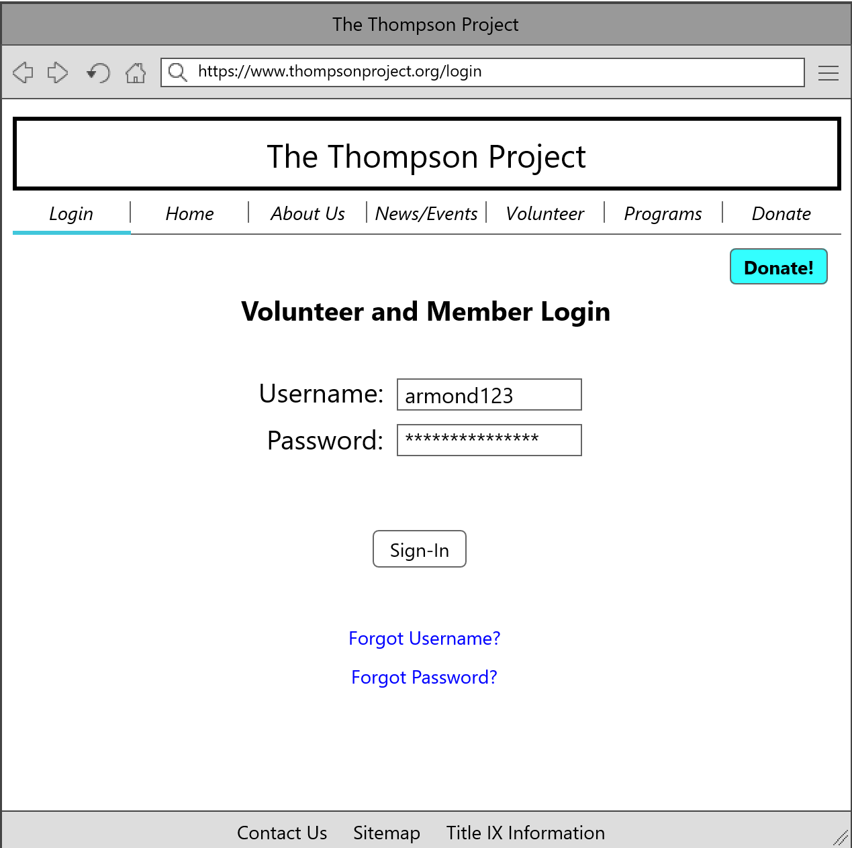

**Reset Password**

This form is necessary to have as users can easily forget their login credentials. Having a login system requires troubleshooting methods such as the user resetting their password. After receiving a password reset email, the user will open this page, where it prompts for a username, new password, and confirmation of the new password. This wireframe relates to the use case “Edit Log-in”.

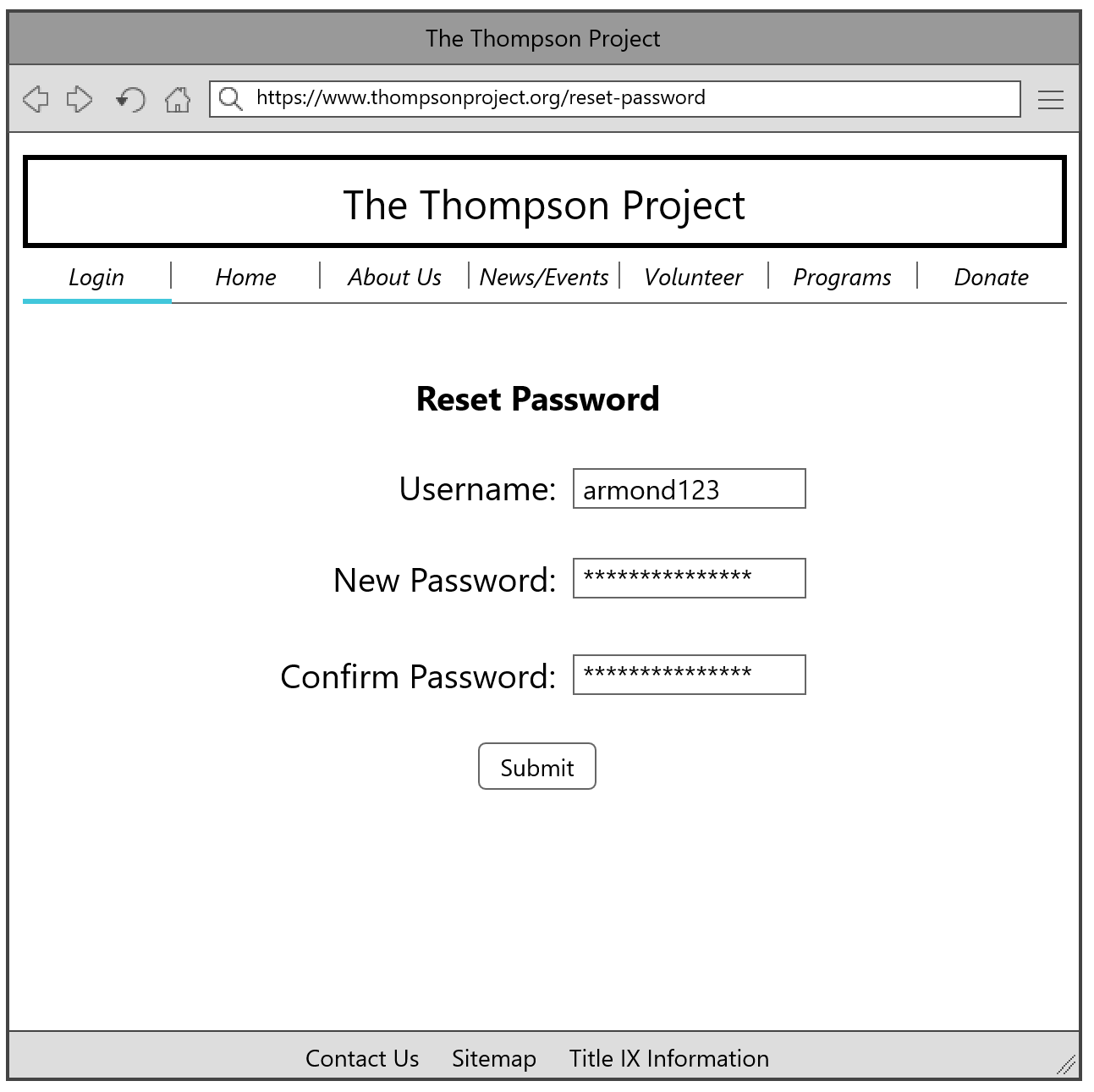

**User Delete Account**

This form is necessary to include within the website’s layout as previous users may want to have their account deleted from the organization’s server(s). It is associated with the use case “Delete Log-in”.

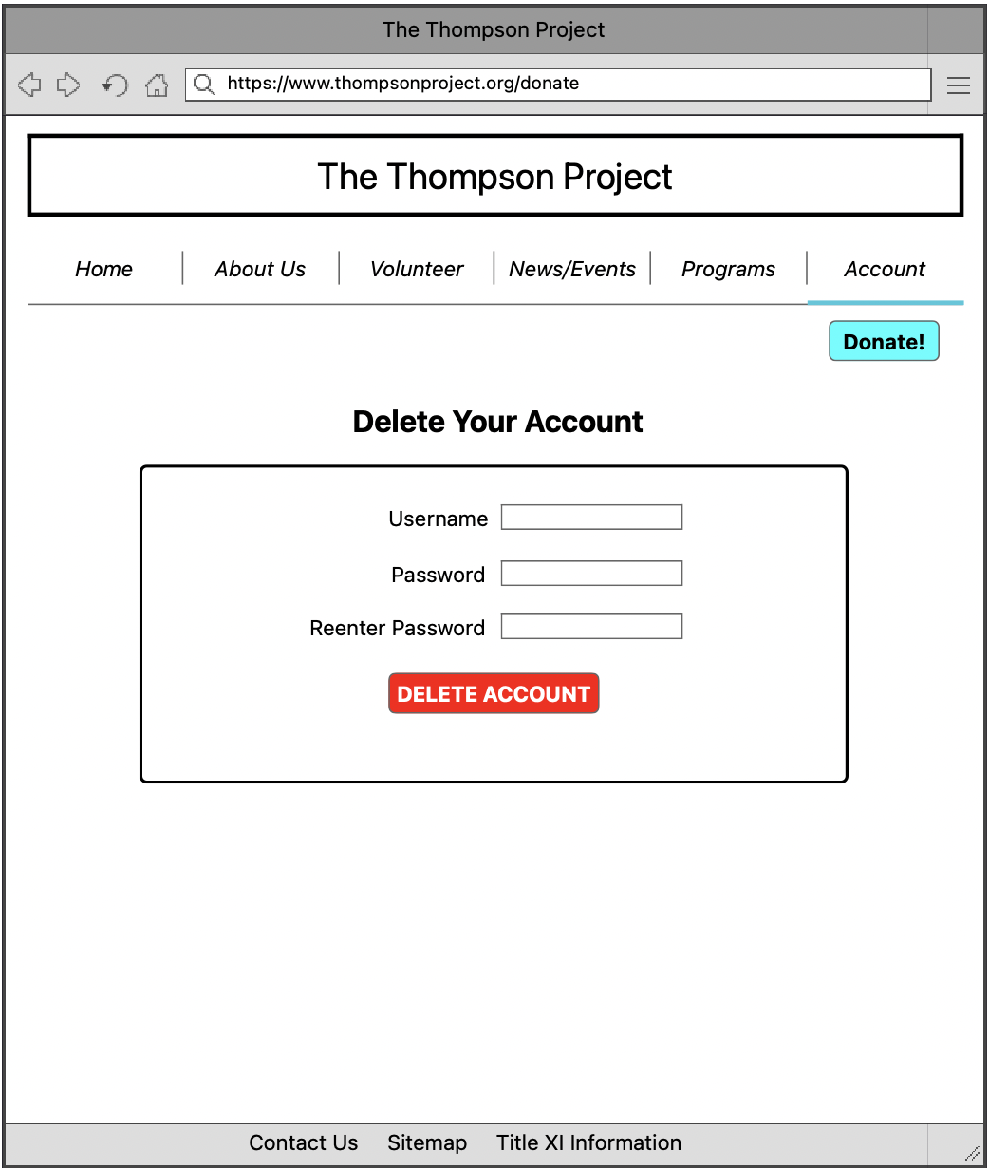

**Create/Edit Background Check Information**

This form is necessary to the website as it allows potential/current volunteers to submit basic information for a background check to be conducted by the organization. This screen layout relates to the use cases “Create Background Check” and “Edit Background Check”.

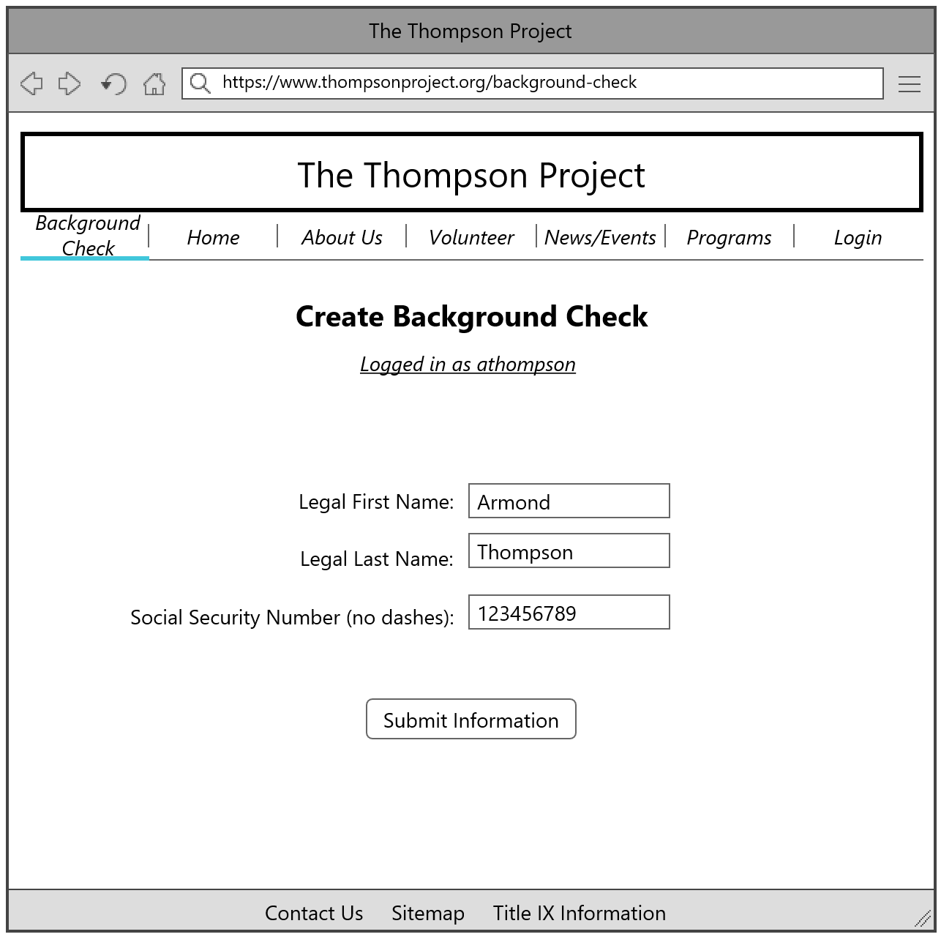

**Submit Testimonial**

This form is necessary for the website as the organization would want to feature testimonials from previous volunteers, mentors, and participants involved with the organization in the past. It would be associated with the use cases “Create Testimonial” and “Edit Testimonial”.

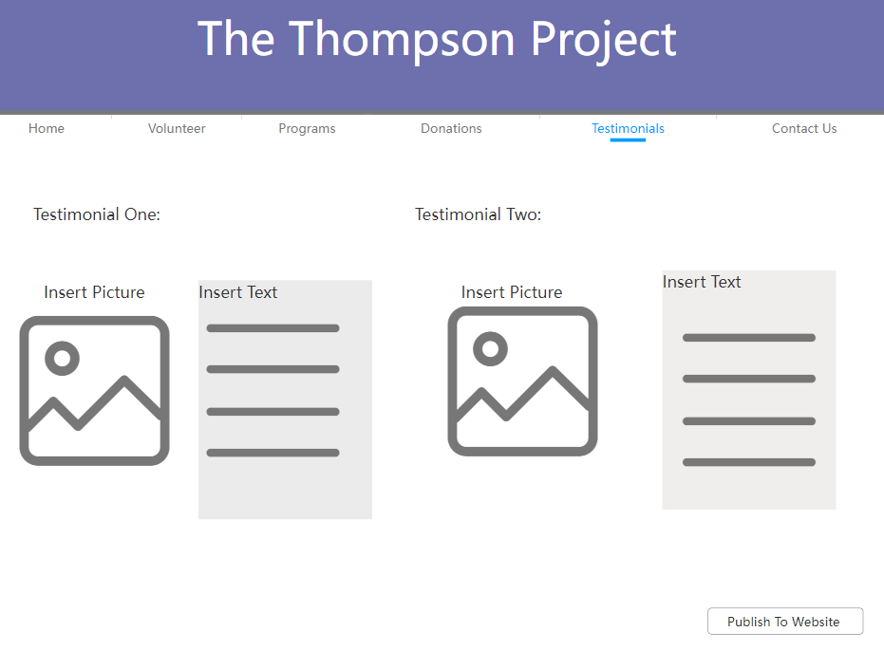

**Physical Architecture Design**

Physical architecture designs illustrate adobe the process of viewing and accessing the website. It is composed of hardware and software parts that make up the system. In this diagram there are four computers shown: Armond’s, students, parents, and community members. All the personal computers will access the website through the local area network (LAN). Next the users will go through the firewall, which ensures the safety of the website and the data stored. The application server and content management system will be used to create the website. There will be a cloud server to store backups in case there is an emergency with the database.

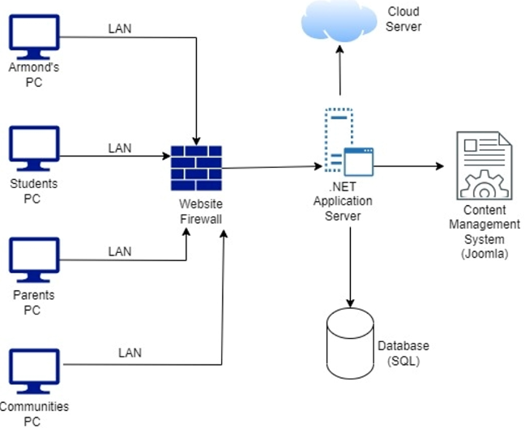

**Design Procedures for Security Concerns and Non-Functional Requirements**

Hardware and System Software

Technology can play a dynamic role in the context of nonprofit organization. Technological innovations will contribute to the increase of efficiency and effectiveness for the Thompson Project, emphasizing the role of computing systems, social media, and mobile technologies would add benefits to the organization.

It is vital that the Thompson Project has the appropriate hardware and software. Reliability and security have high business impact and focus regarding hardware and software are considered from the start. We recommend the Thompson Project to invest in Windows laptops/desktops. These laptops/desktops should include the latest version of Windows as well as an anti-virus software to prevent the laptops/desktop from being hacked. Furthermore,the organization will need to invest into a backup system with a terabyte external hard drive and or Cloud storage space. Backing-up data is very important just in case something goes wrong.

Database

There is a lot of sensitive information on the Thompson Project database. There is a need to manage who has access to certain information. To do so, access is only given on a need base for the user. The Thompson Project should grant access to all the information to the board members and should deny access for any users who do not need certain material. This would prevent the leak of sensitive information and allow certain users to suitably maintain the information they need.

Financials

Finances are a huge part of the Thompson Project business process. Without this process of raising donations and funding, the Thompson Project would not be able to operate. Using a system like PayPal would best fit this process. PayPal will collect payments in a safe and easy way. Users are familiar with PayPal, so they are comfortable with making donations online.

Background Checks

After the Thompson Project receives requests for new volunteers or program instructors, it is important they do a full background check. This is an important process because the Thompson Project is working with underage youth.

The non-functional requirements defined below are just as important as all the functionality in our system.

| **Maintainability –** the Thompson Project staff have little technical knowledge and needs to have a website that is easy to maintain and requires minimal updates. | | | | | | | | | |
| --- | --- | --- | --- | --- | --- | --- | --- | --- | --- |
| **Requirement** | | | | | | | | | **Priority** |
| System must be easy to maintain and update after project team leaves | | | | | | | | | High |
| Training should be conducted to ensure staff understands how to use the CMS (Content Management System) and is able to maintain the system internally | | | | | | | | | High |
| Provide full documentation to the Thompson Project staff which can use if internal maintenance or updating is required; create a quick reference guide to troubleshoot common issues | | | | | | | | | High |
| Customize CMS (Content Management System) to meet the Thompson Project needs so that little internal customization is needed after the project team leaves | | | | | | | | | High |
| **Portability –** the Thompson Project website will be viewed from several different platforms and browsers, which makes compatibility a crucial aspect. | | | | | | | | | |
| **Requirement** | | | | | | | | | **Priority** |
| Check cross-browser compatibility (IE 7, IE 8, Firefox, Google Chrome, Safari) | | | | | | | | | High |
| Downloadable content must be compatible with different platforms (Windows, Mac) | | | | | | | | | High |
| **Scalability –** the Thompson Project has relatively few staff numbers. The Thompson Project hopes to expand its volunteers each year, so the Content Management System (CMS) can handle growing data storage and servers can handle increasing traffic. | | | | | | | | | |
|  |  |  |  |  |  |  |  |  |  |
| **Requirement** | | | | | | | | | **Priority** |
| Ensure that CMS provides database that has the capacity for the potential growth | | | | | | | | | High |
| **Security –** A multi-level access system needs to be in place so only admins have full back-end access. | | | | | | | | | |
| **Requirement** | | | | | | | | | **Priority** |
| Multi-level access for staff (admin, teacher, etc.) | | | | | | | | | High |
| Password login for each portal | | | | | | | | | High |
| Secure online payment and credit card systems for donations. | | | | | | | | | Medium |

**Gantt Chart**

The following Gantt Chart details the tasks that the team has worked on during this iteration. Each task is assigned an ID number, a name, start and end date, who is responsible for the task, and anything that the task may be dependent on to complete it.

| **Task ID** | **Task Name** | **Start Date** | **End Date** | **Duration. (in days)** | **Task Responsibility** | **Task Dependencies** |
| --- | --- | --- | --- | --- | --- | --- |
| 1 | Use Cases | 3/7/22 | 3/28/22 | 21 | All | The use cases were developed out of system requirements from Iteration 2 and 3. Each team member was assigned use cases to write out and create basic flows. |
| 2 | Use Case Diagrams | 3/7/22 | 3/28/22 | 21 | All | This task depended on the use cases that were written in I4. Each team member worked on the diagrams that covered their assigned use cases. |
| 3 | Individual Class Diagrams | 3/7/22 | 3/28/22 | 21 | All | This task depended on the use cases that were written in I4. Each team member worked on the diagrams that covered their assigned use cases. |
| 4 | Sequence Diagrams | 3/7/22 | 3/28/22 | 21 | All | This task depended on the use cases that were written in I4. Each team member worked on the diagrams that covered their assigned use cases. |
| 5 | Overall Class Diagram | 4/4/22 | 4/13/22 | 9 | All | This task depended on corrections made to the individual class diagrams made in I4. Each team member was responsible for correcting their class diagrams and creating the combined document. |
| 6 | Entity-Relationship Diagram | 4/4/22 | 4/13/22 | 9 | All | This task depended on the overall class diagram being completed. |
| 7 | Data Dictionary | 4/4/22 | 4/13/22 | 9 | All | This task depended on the ERD being completed. |
| 8 | Windows Navigation Diagram | 4/4/22 | 4/13/22 | 9 | Daniel | This task depended on the prototypes that were developed in I4. |
| 9 | Updated I5 Gantt Chart | 4/4/22 | 4/13/22 | 9 | Chris | This task depended on the team meeting after I5 began. |
| 10 | Prototypes (with updates) | 4/4/22 | 4/13/22 | 9 | All | This task depended on feedback given after I4. |
| 11 | Design Procedures for Security Concerns and Non-functional Requirements | 44664 | 44684 | 20 | Mohamed | This task depended on the completion of I5. |
| 12 | Physical Architecture Design | 44664 | 44684 | 20 | Rachel | This task depended on the completion of I5. |
| 13 | Corrections to Diagrams and Data Dictionary | 44664 | 44684 | 20 | All | This task depended on the feedback given after I5 |

**User Interface Prototypes**

Similar to the screen layouts previously shown, the user interface prototypes are wireframe models to represent each use case in the system requirements. Some feature text inputs, buttons, links, among other common attributes with websites today. These are not final versions of what the website pages would look like, but it gives a great representation of the general layout and attributes for each page.

1. **Create Log-ins**

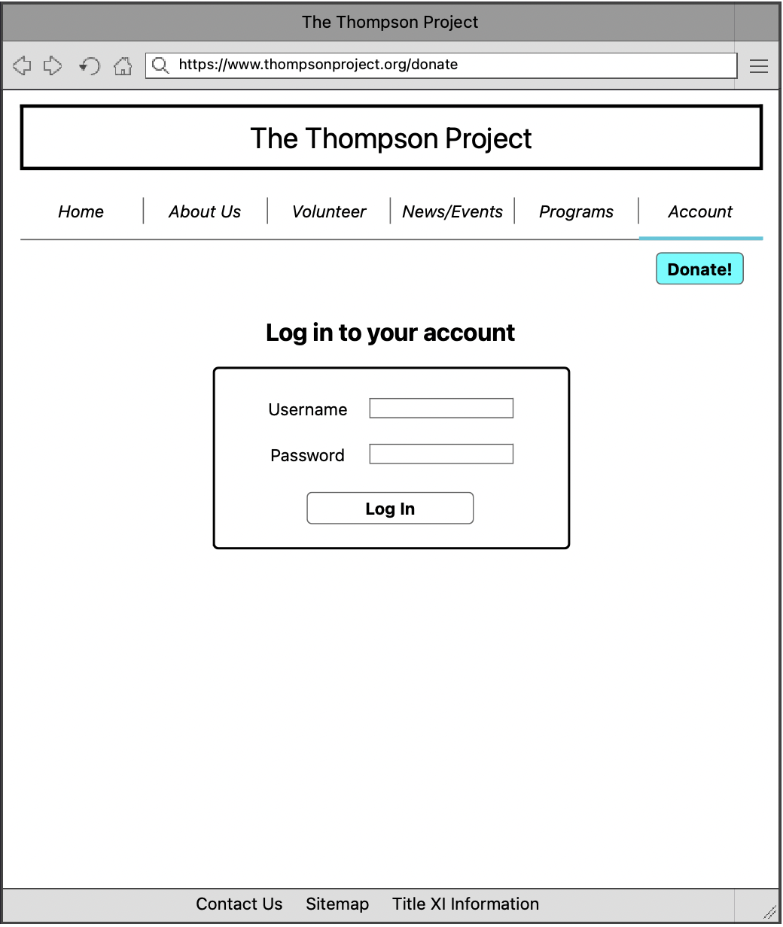

1. **Edit Log-ins**

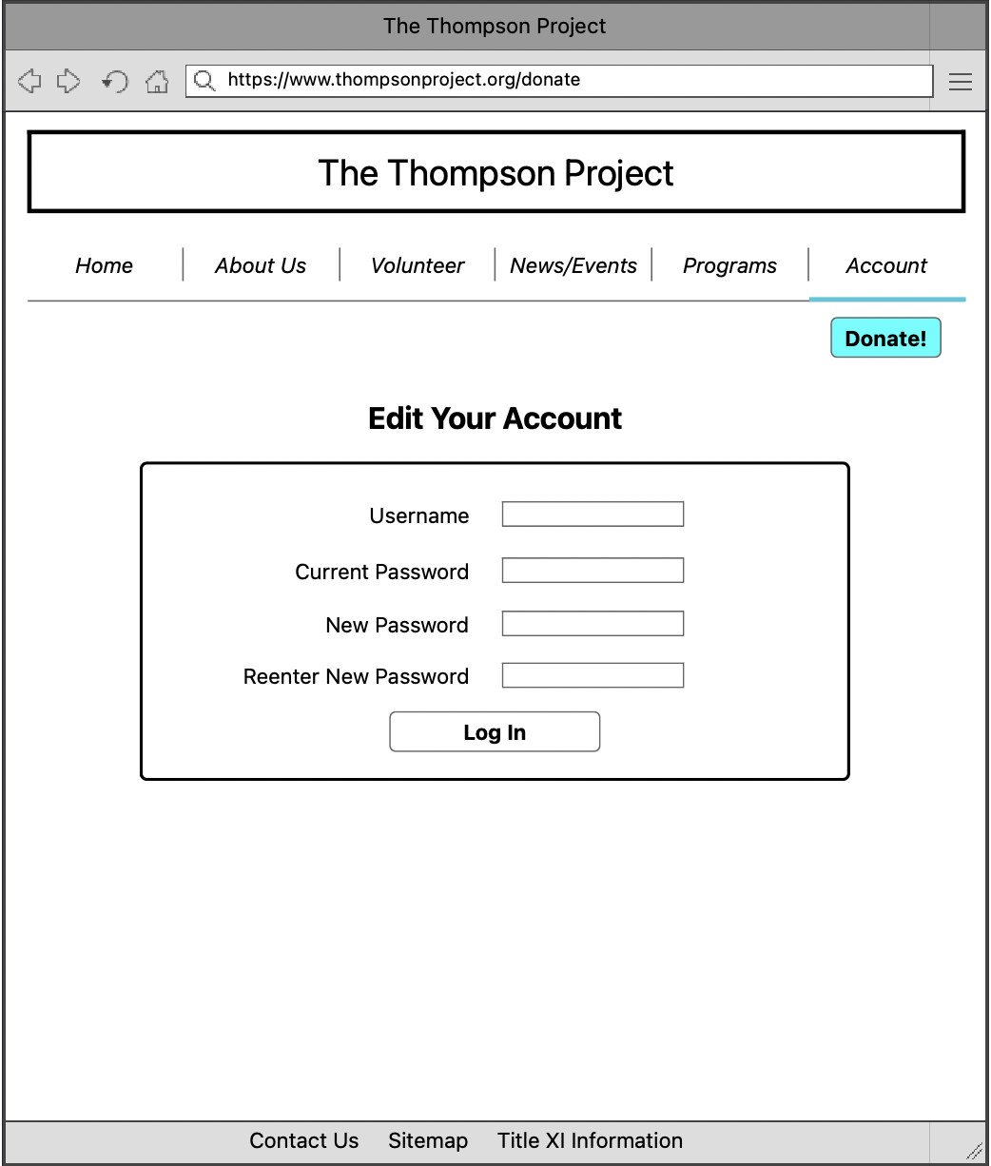

1. **Delete Log-ins**



1. **Create Donation**

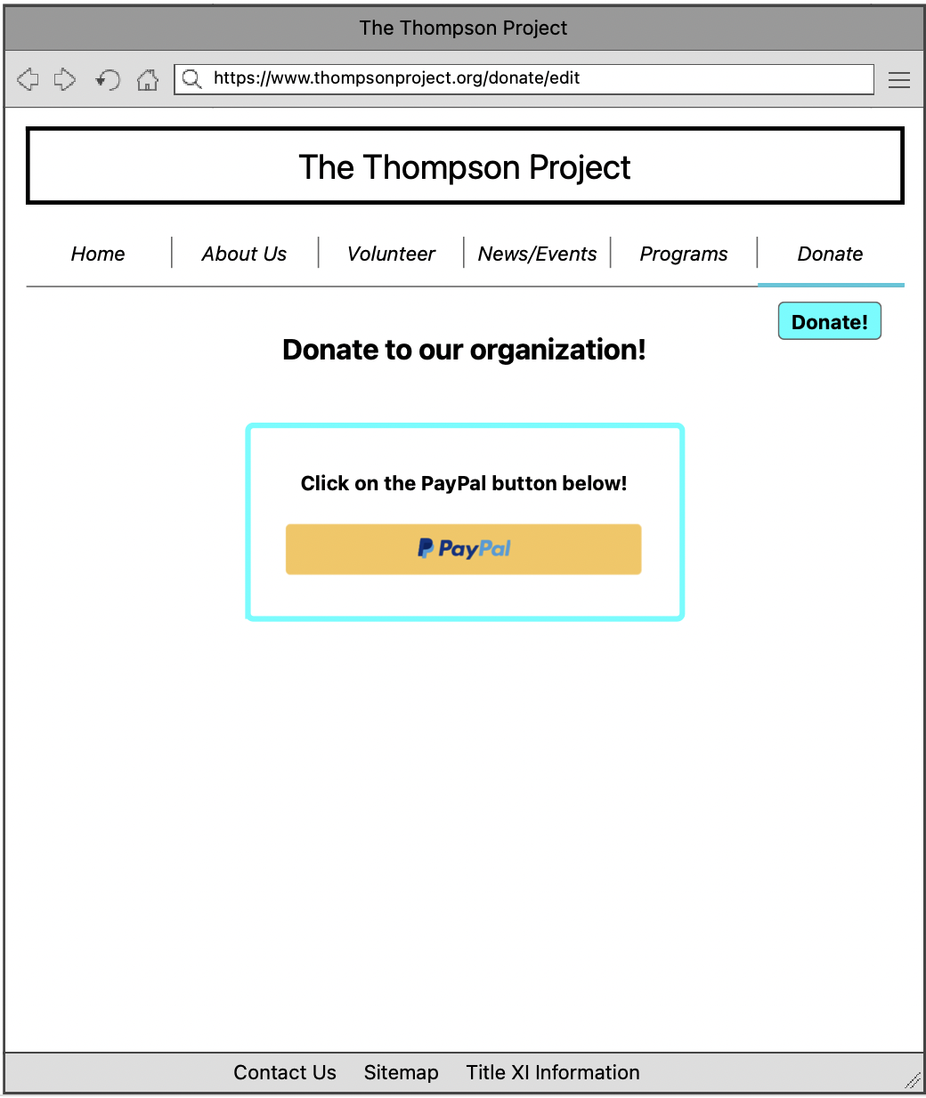

1. **Edit Donation**

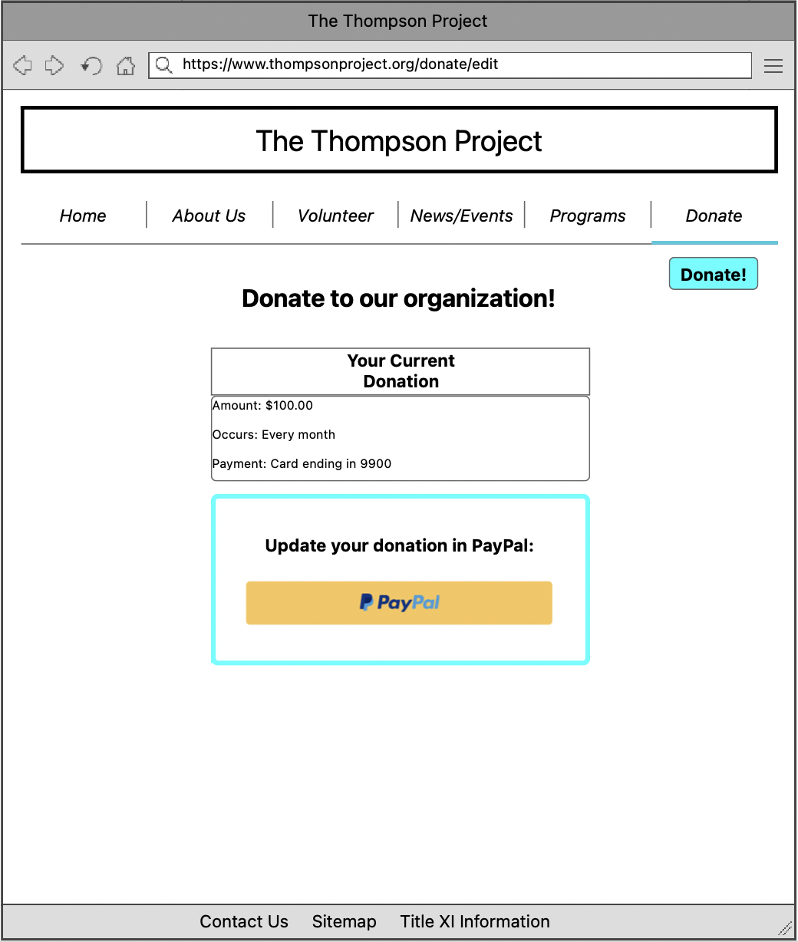

1. **Delete Donation**

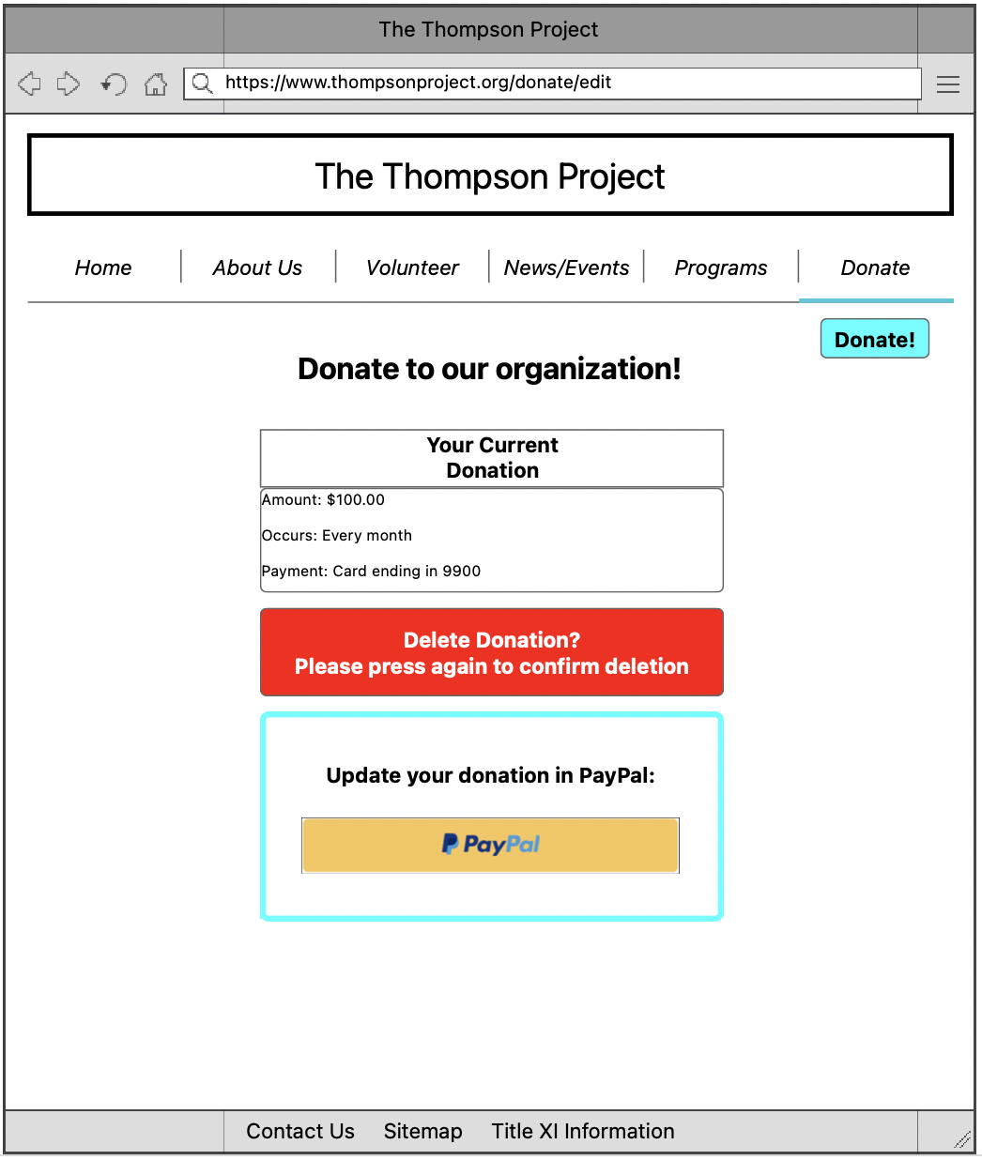

1. **Create Backup**

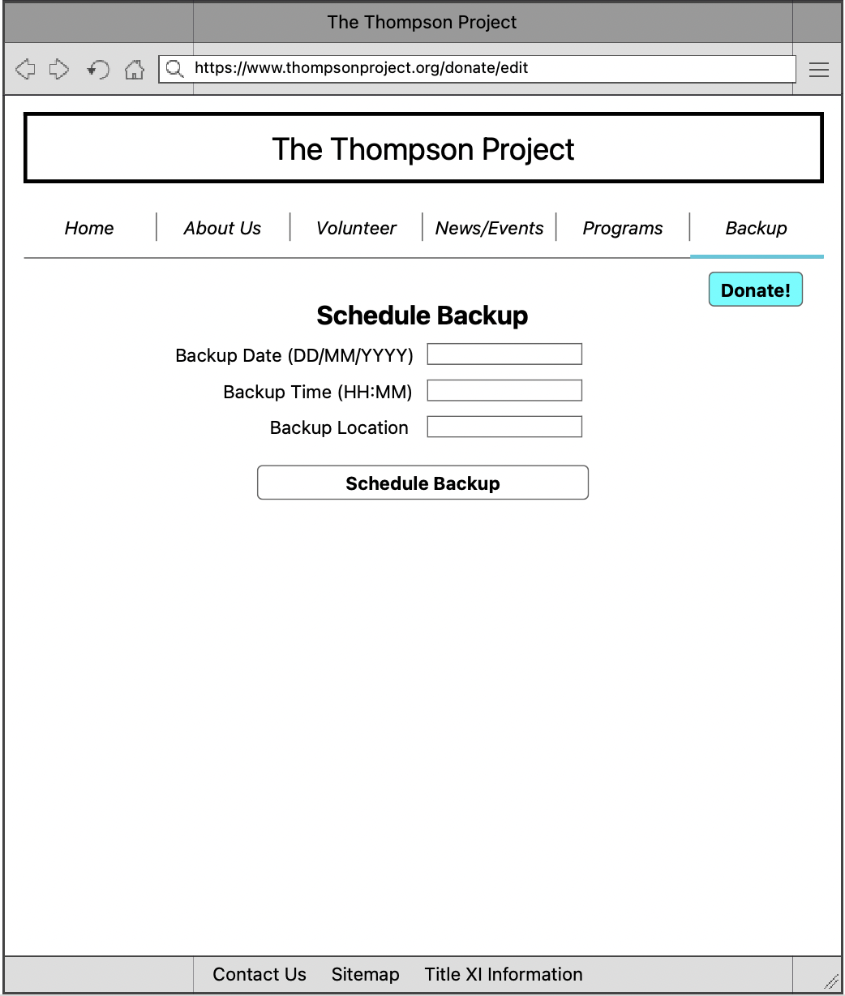

1. **Delete Backup**

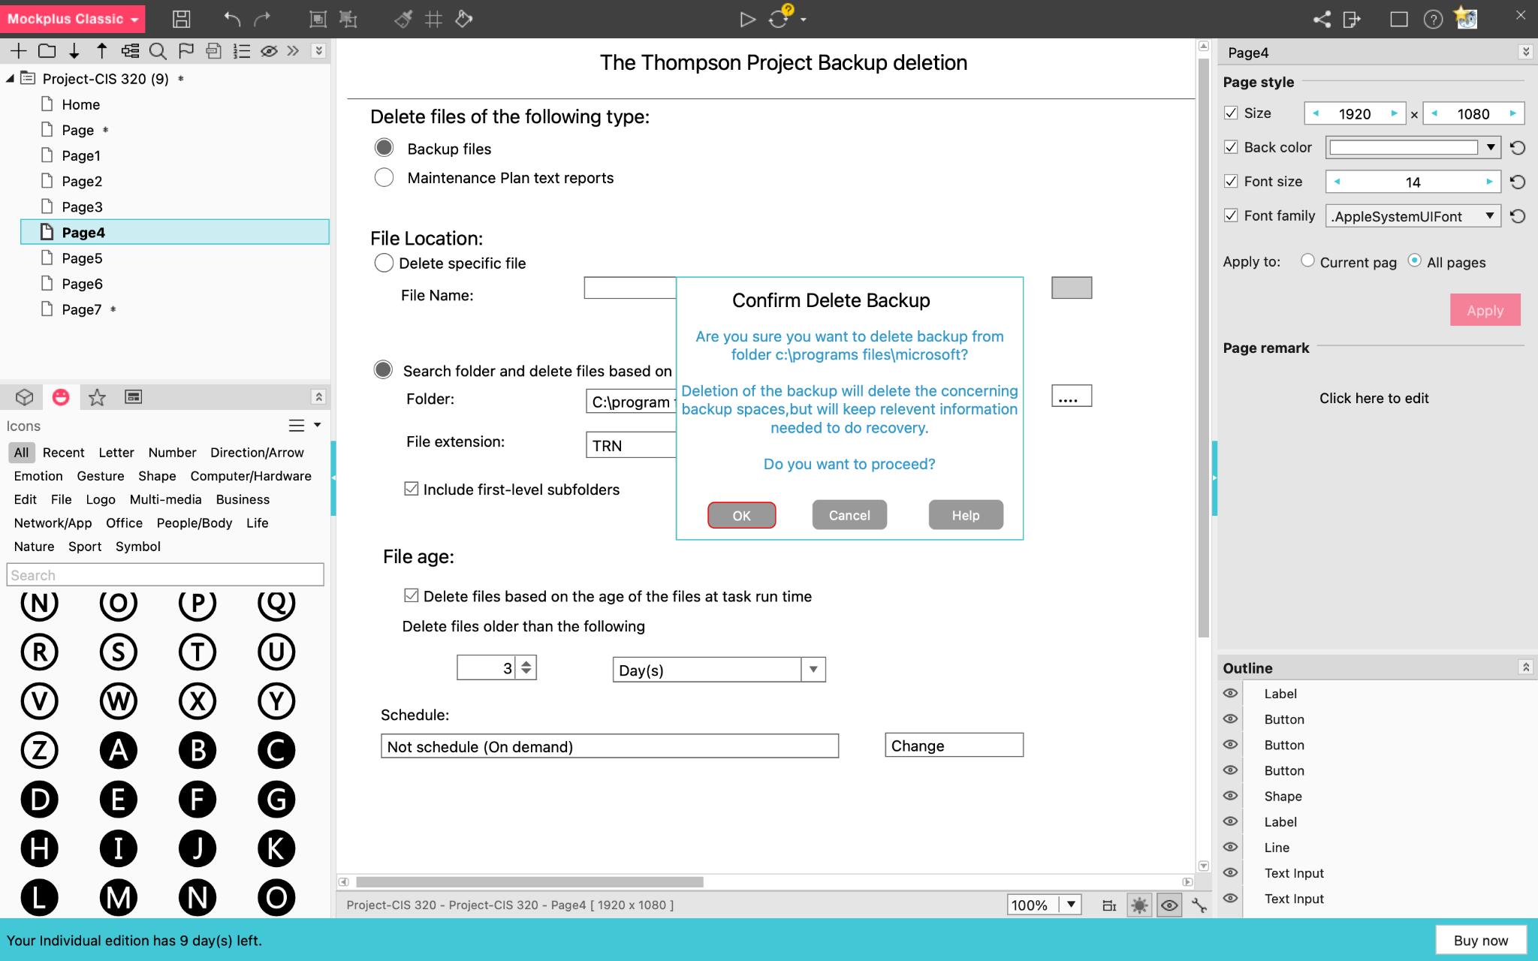

1. **Create Recovery**

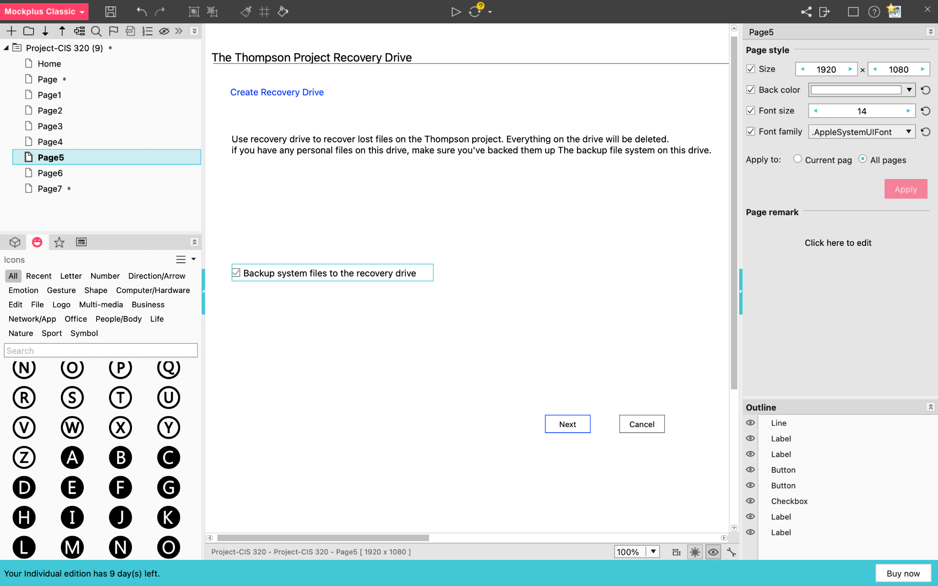

1. **Create Volunteer Records**

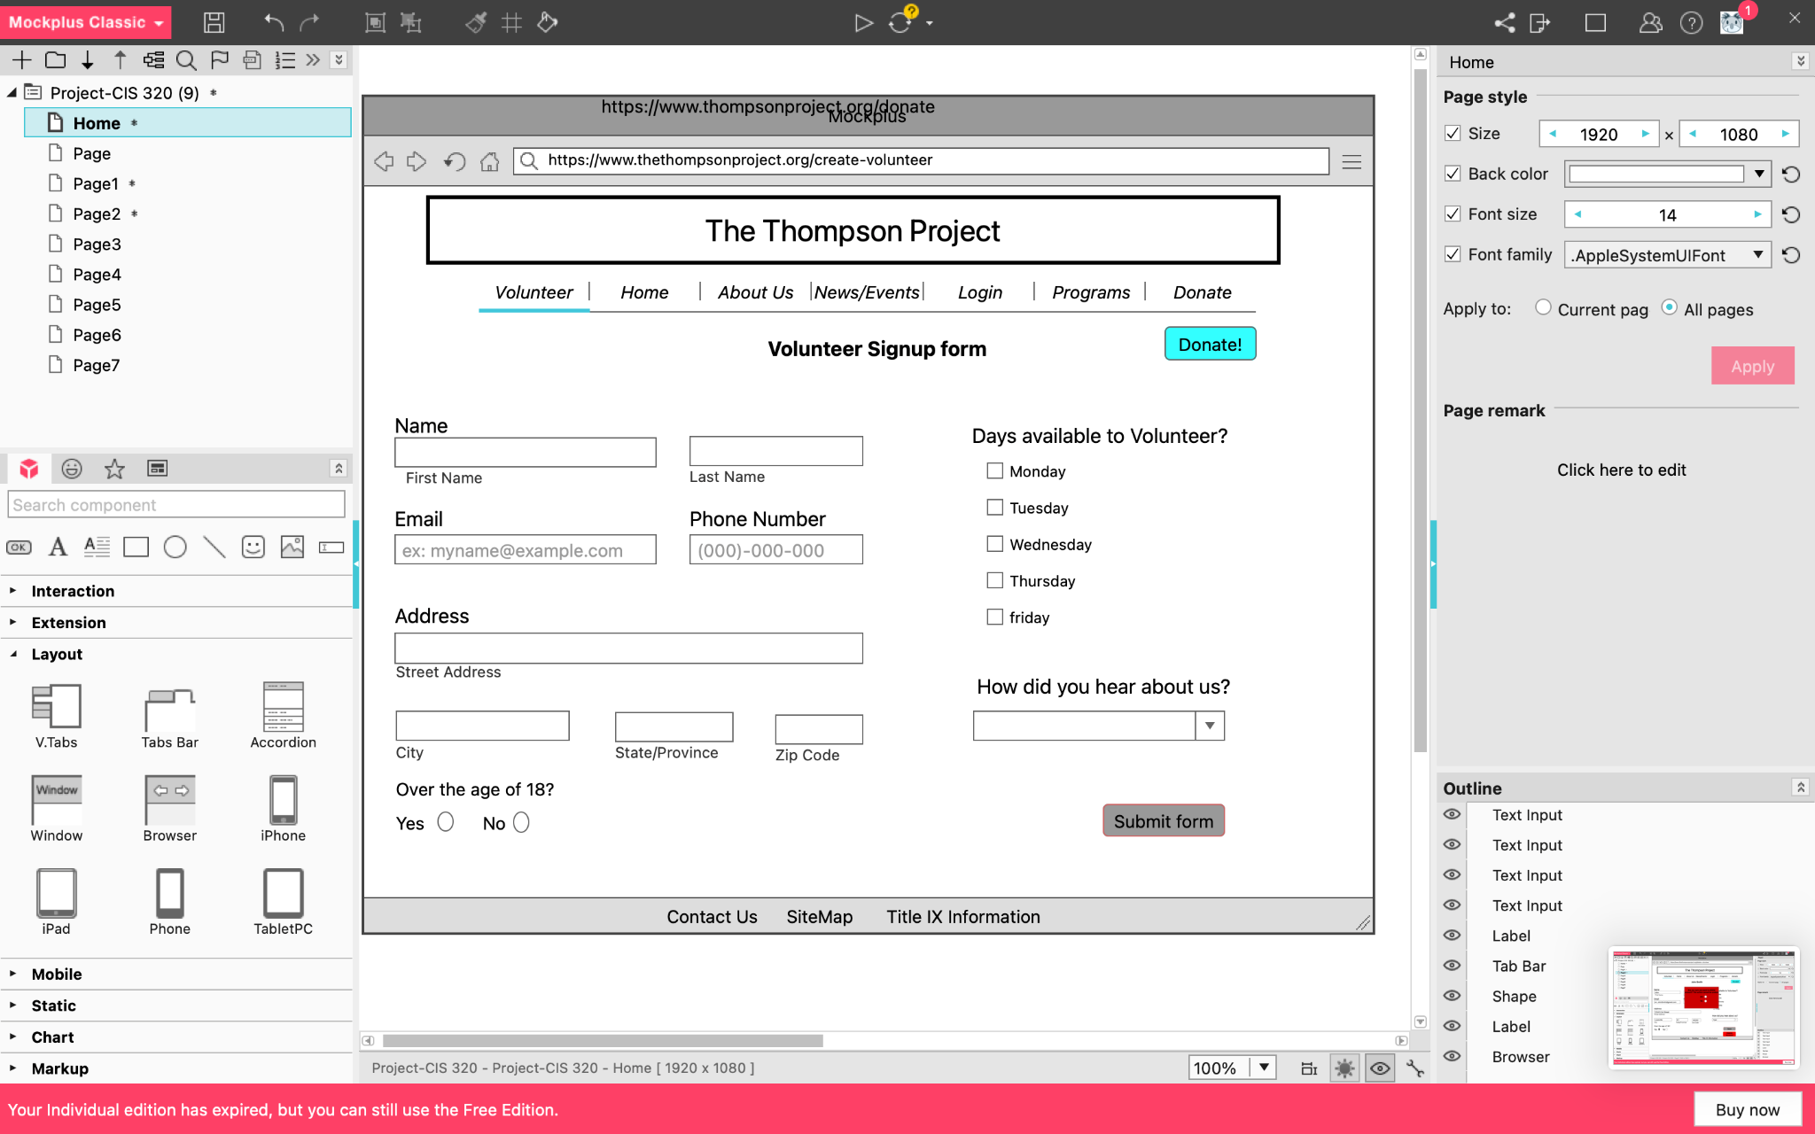

1. **Edit Volunteer Records**

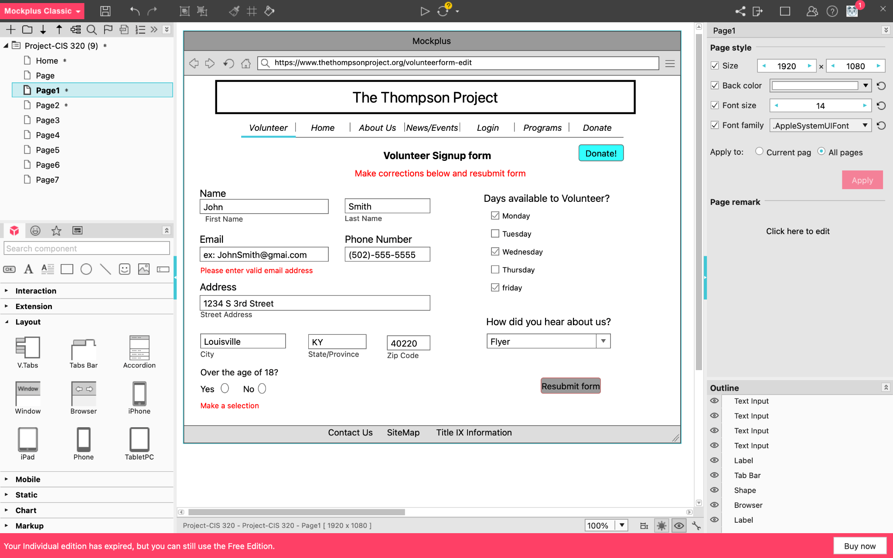

1. **Delete Volunteer Records**

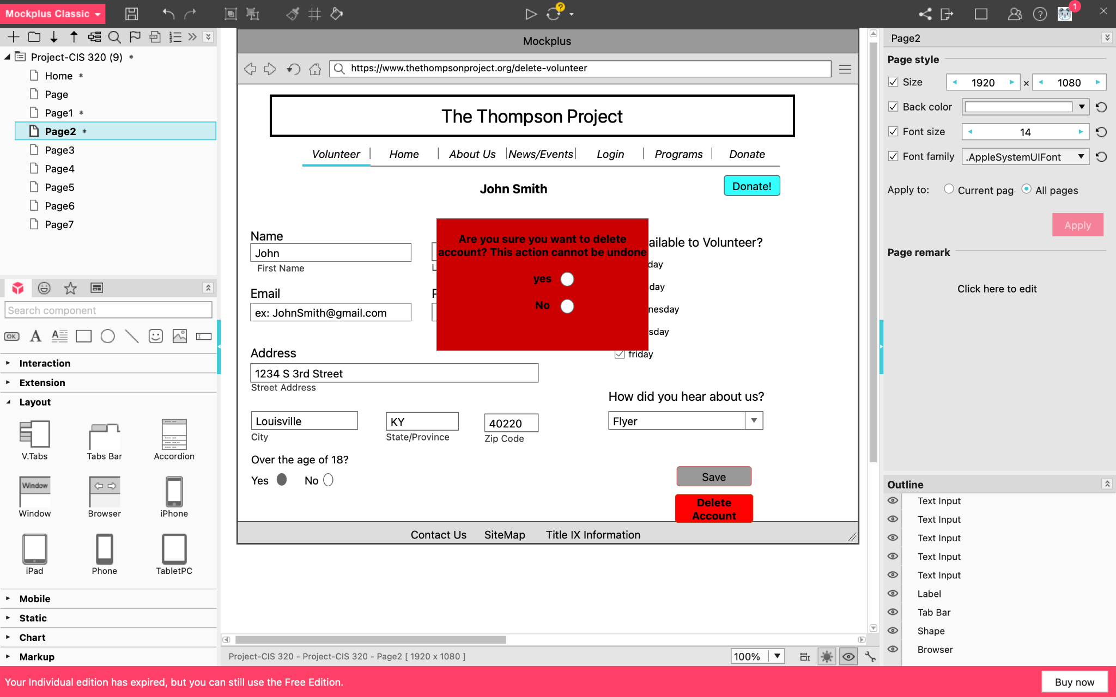

1. **Create Information Page**

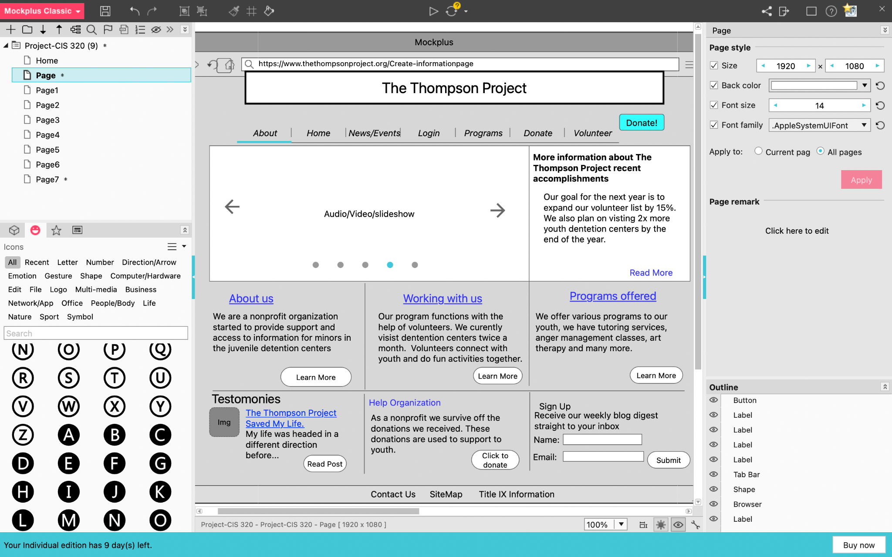

1. **Edit Information Page**

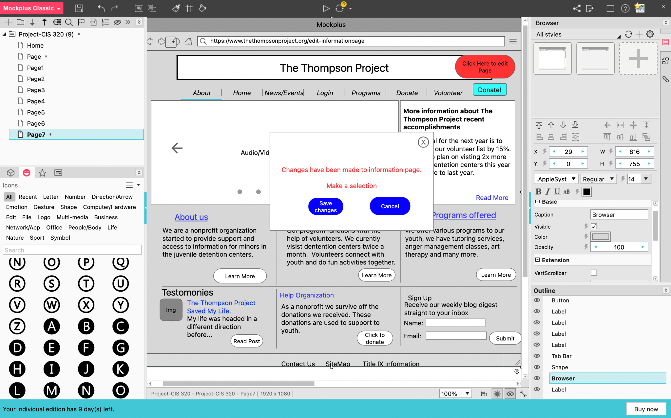

1. **Delete Information Page**

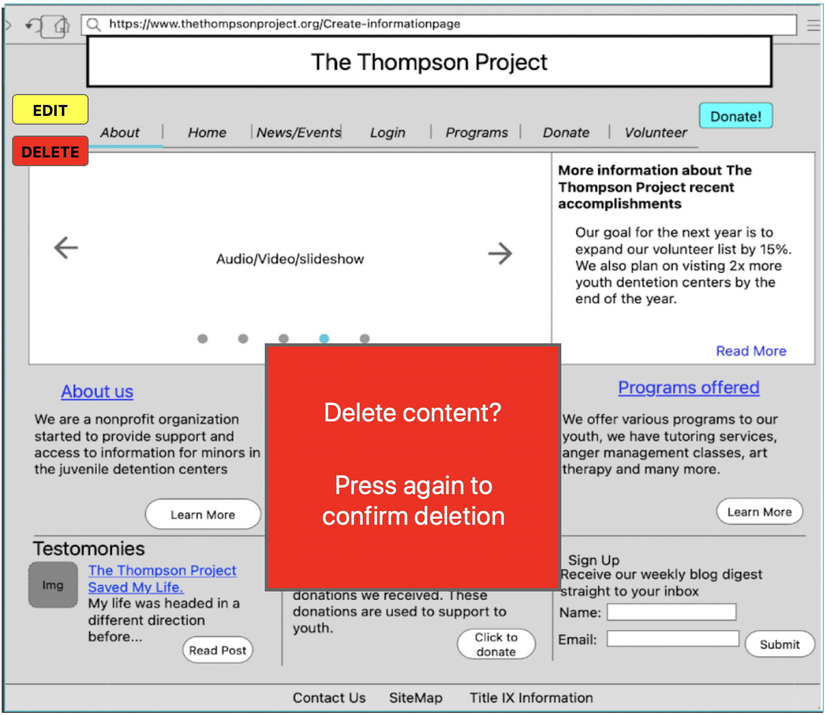

1. **Create a Homepage**

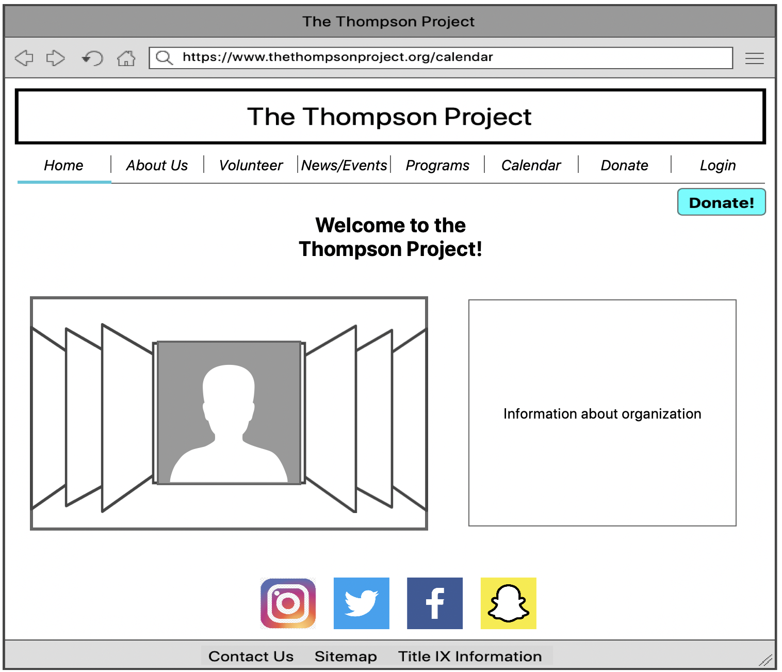

1. **Create Contact Page**

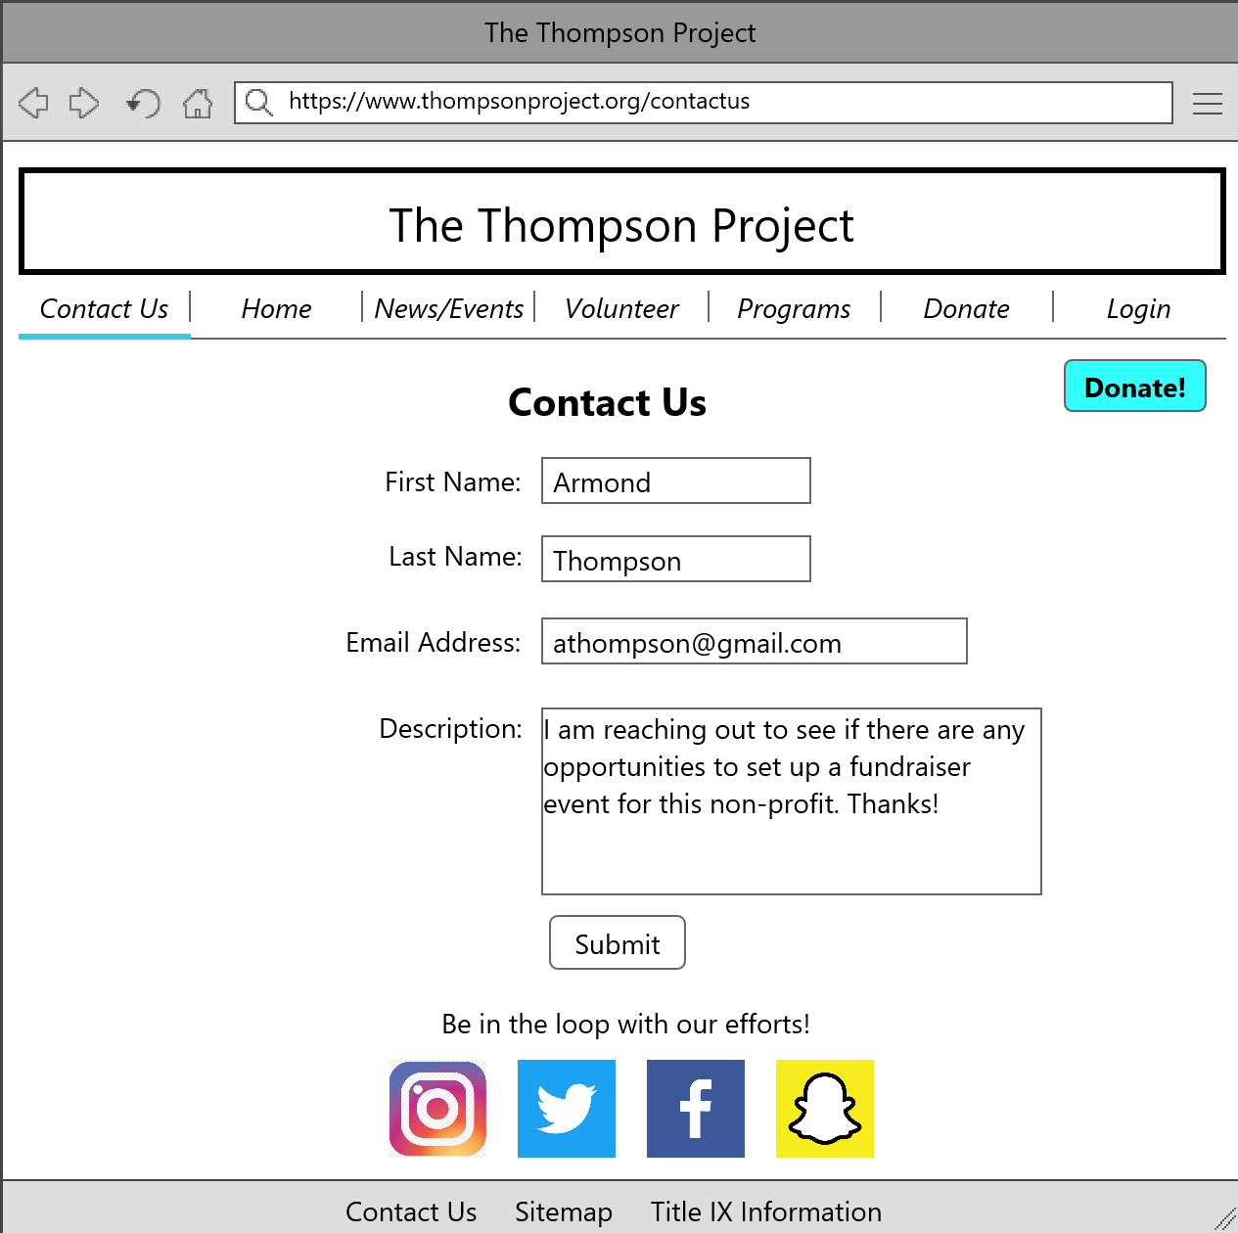

1. **Create Calendar Events**

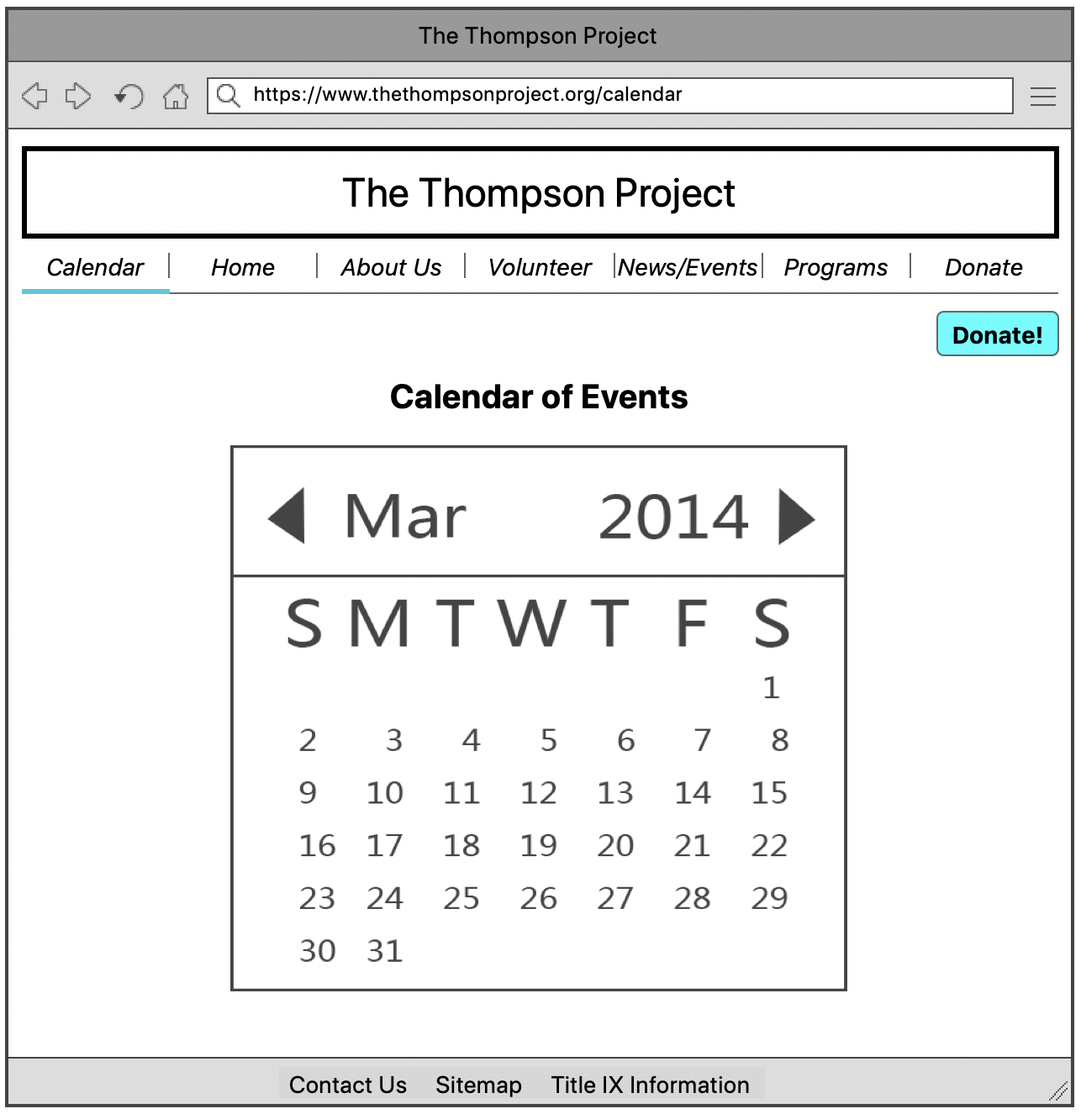

1. **Edit Calendar Events**

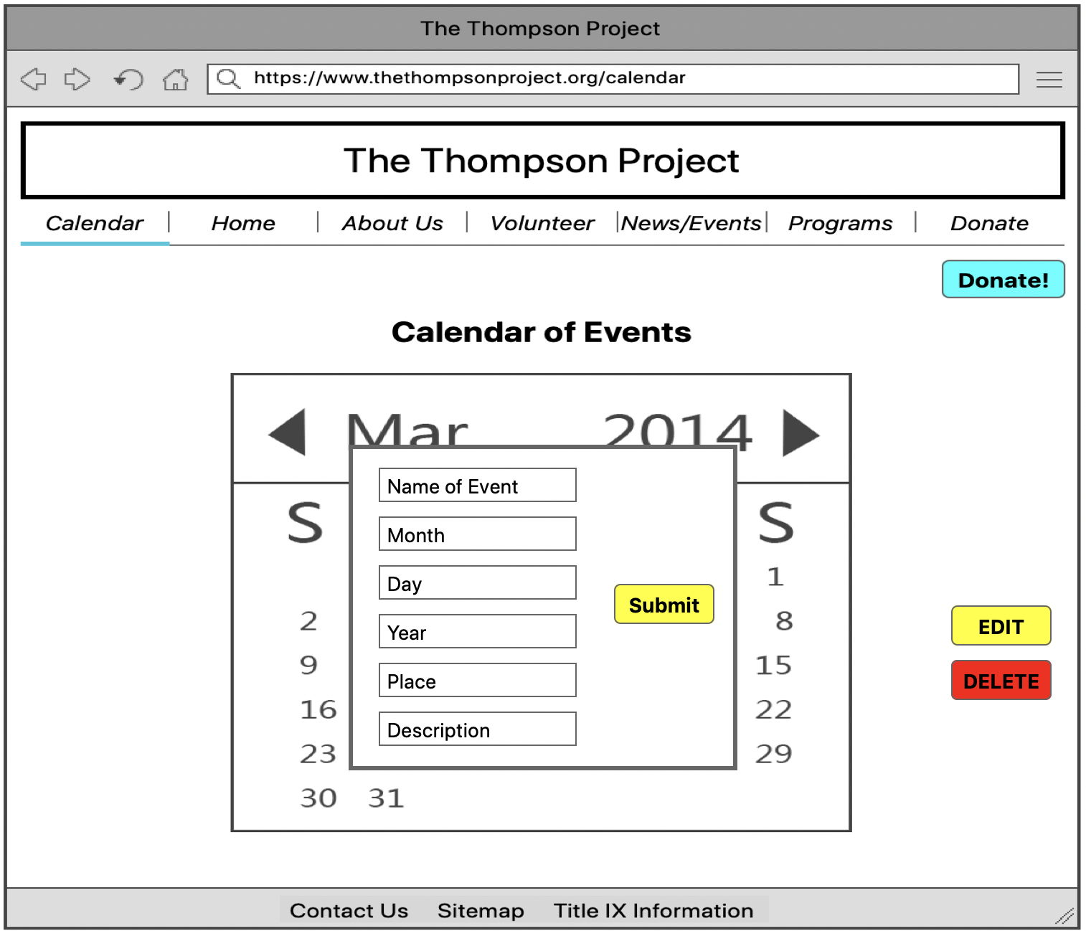

1. **Delete Calendar Events**

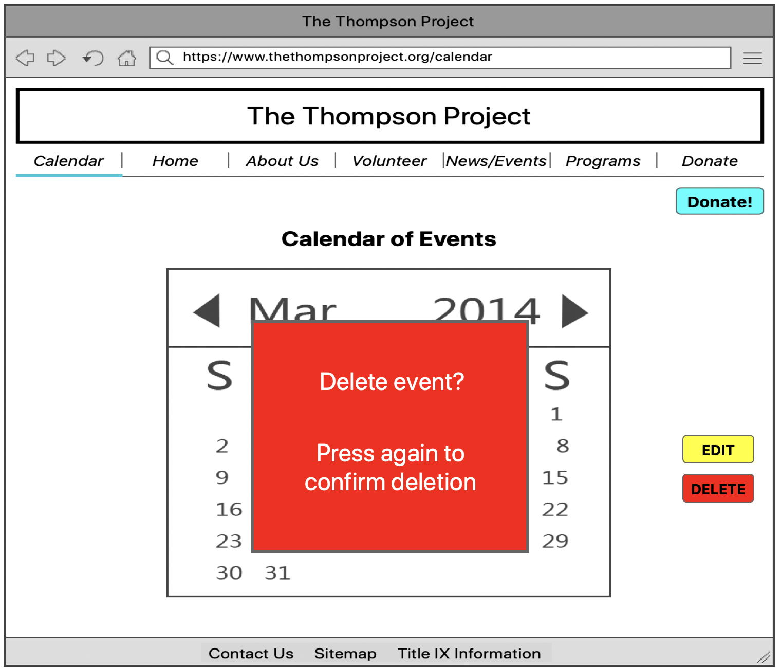

1. **Create Photo Library Contents**

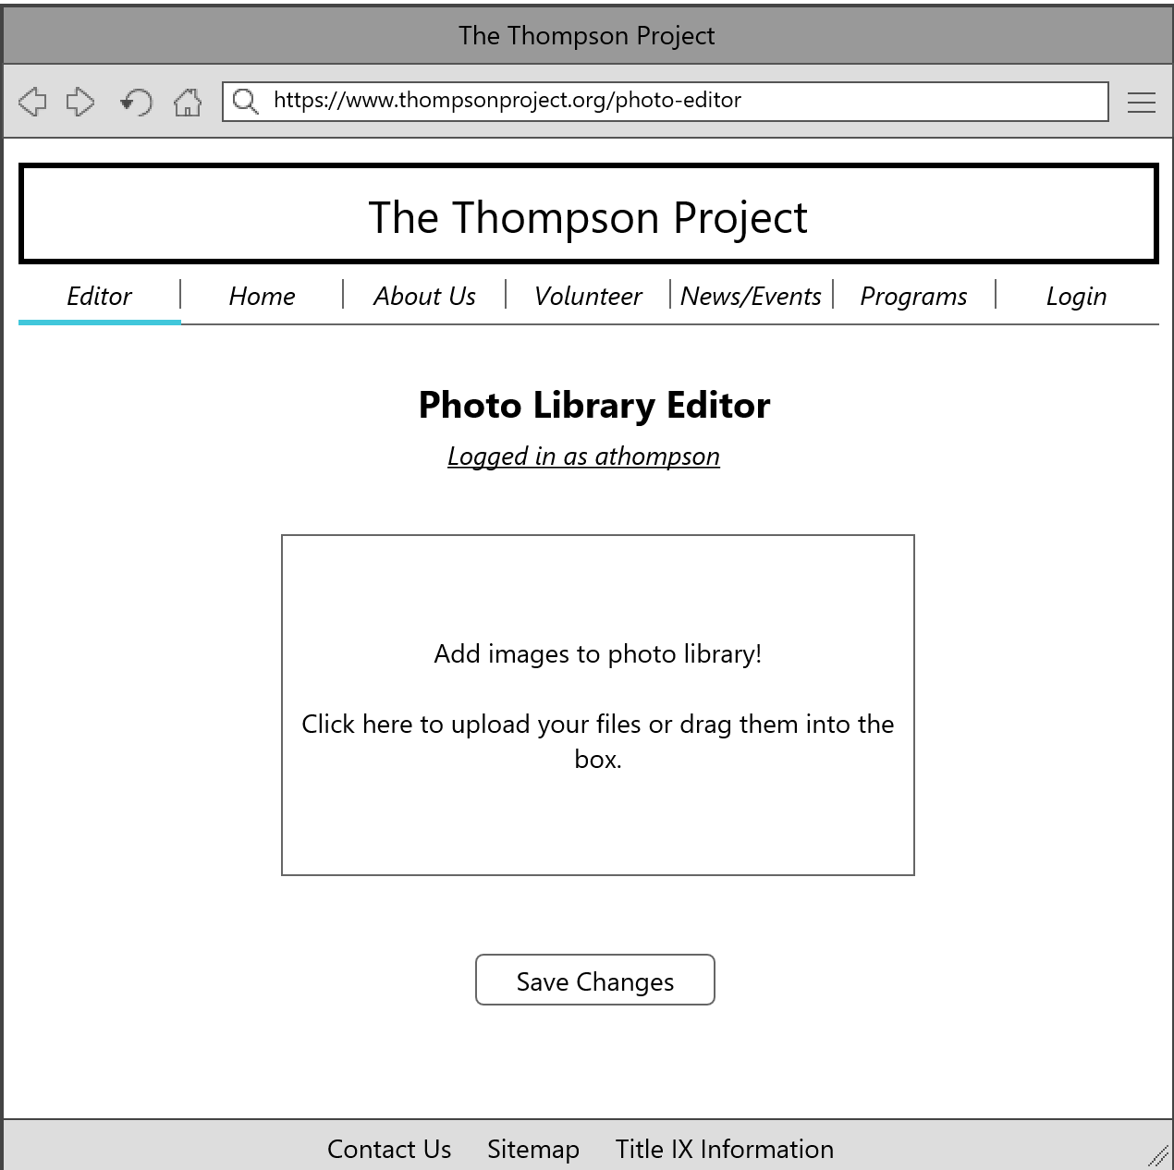

1. **Edit Photo Library Contents**

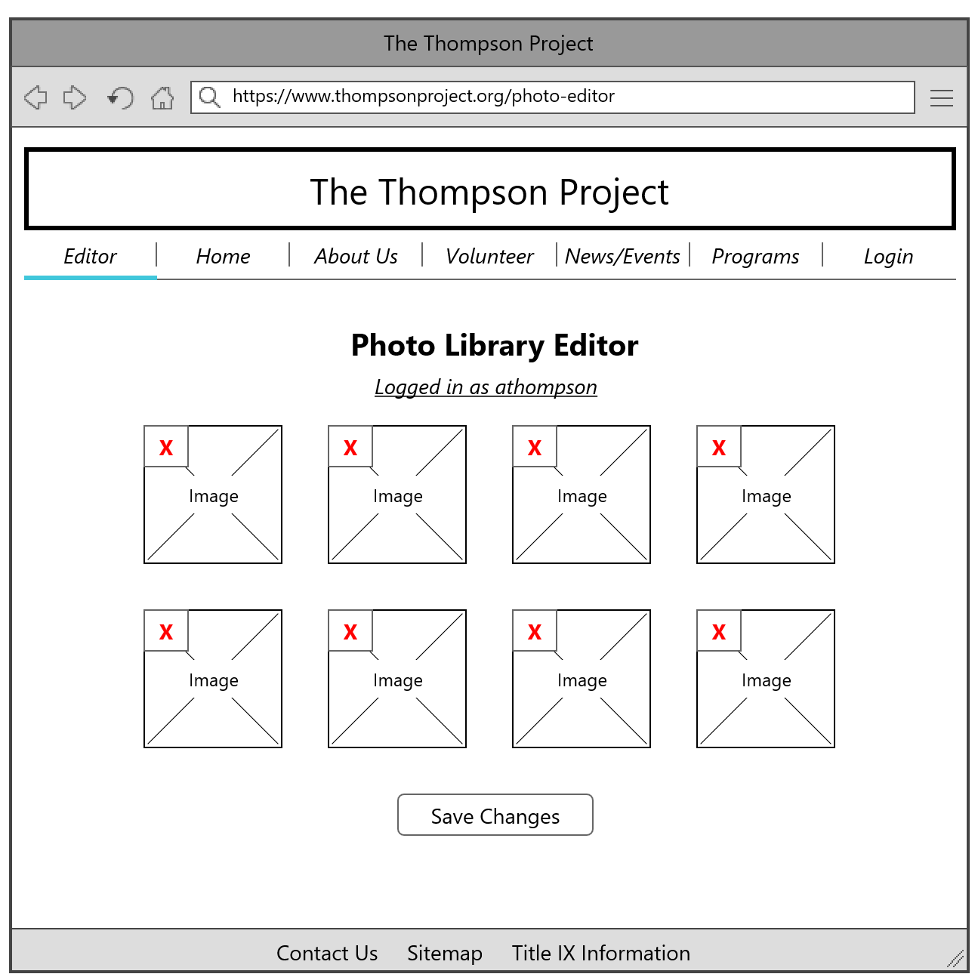

1. **Delete Photo Library Contents**

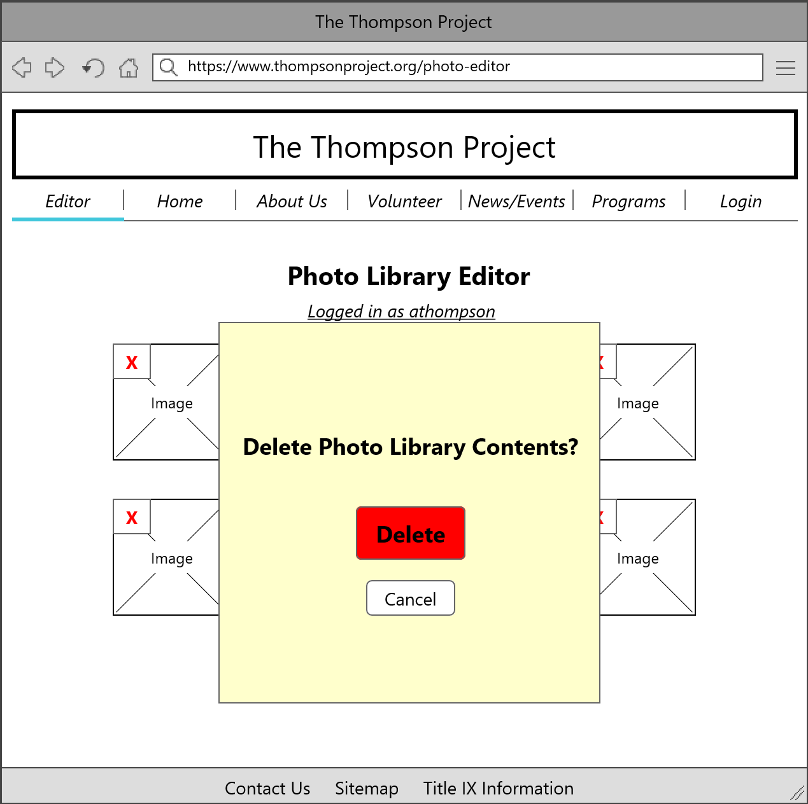

1. **Create Background Check**

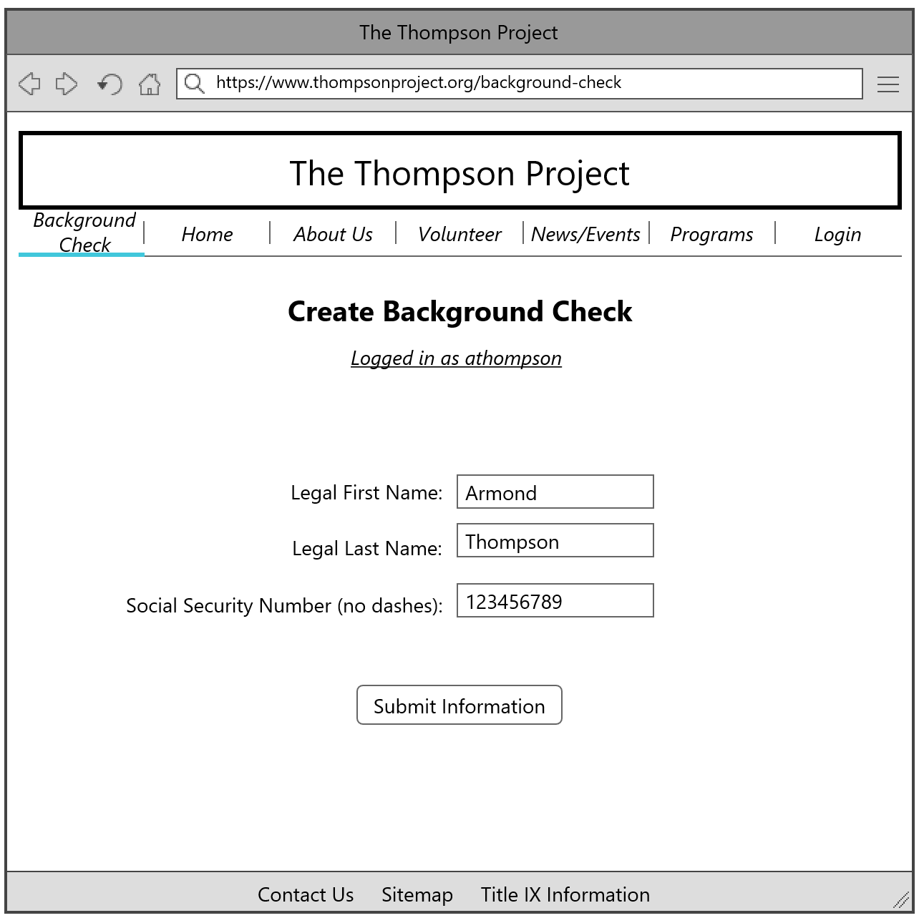

1. **Edit Background Check**

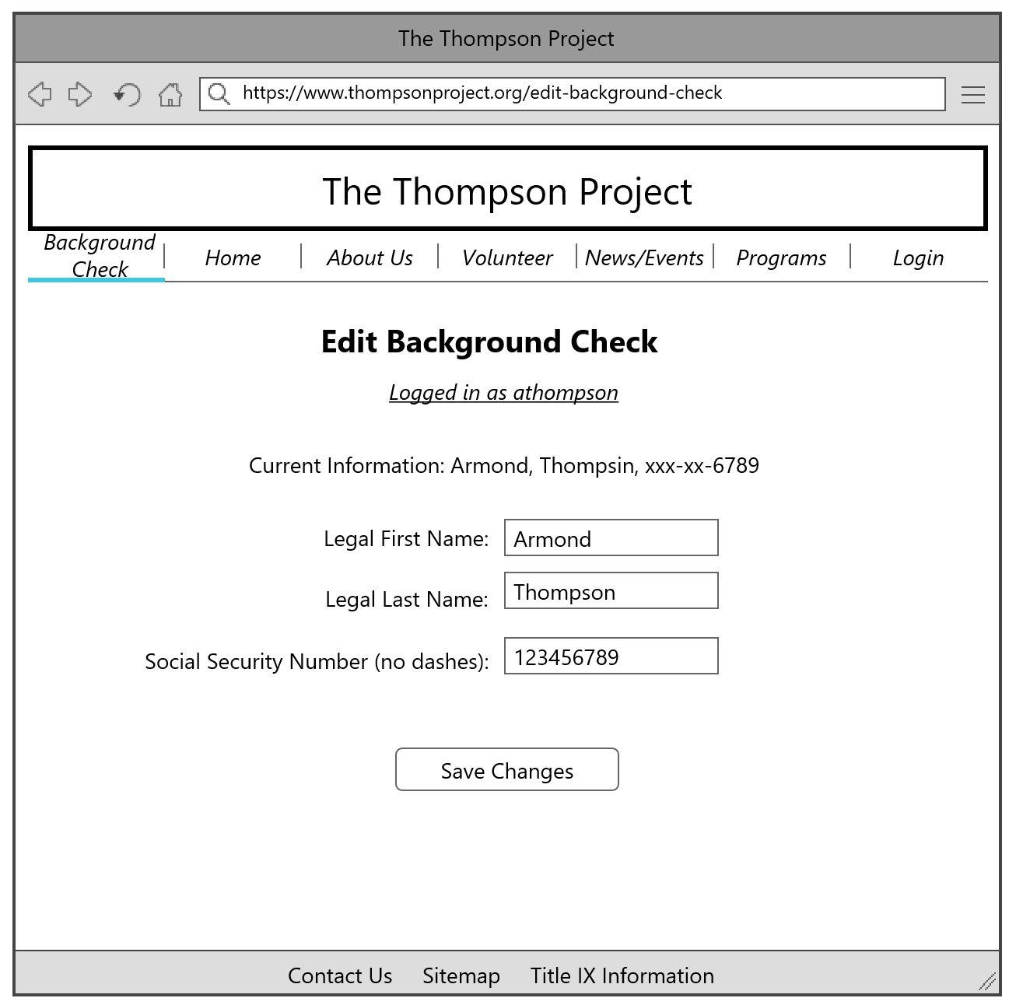

1. **Delete Background Check**

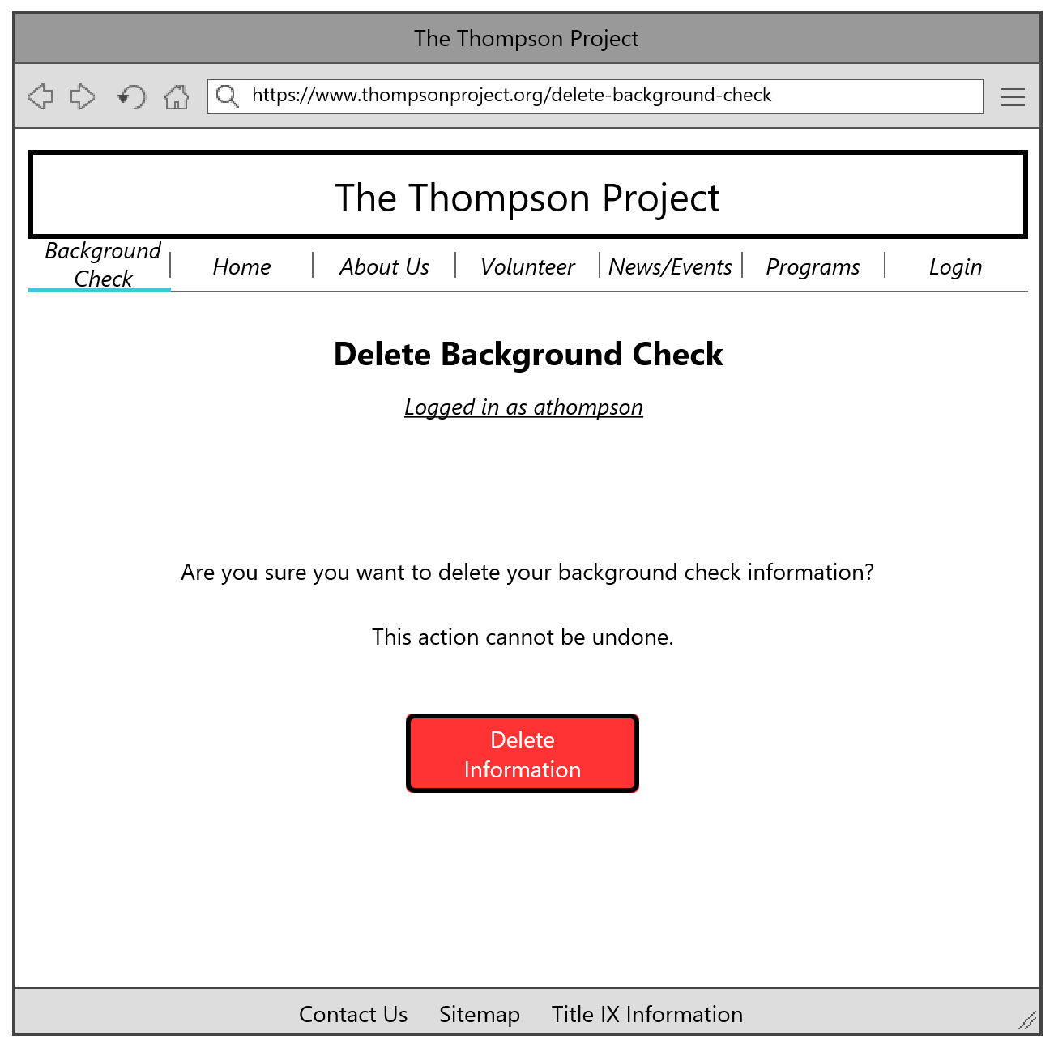

1. **Create Inventory Tracker**
2. **Edit Inventory Tracker**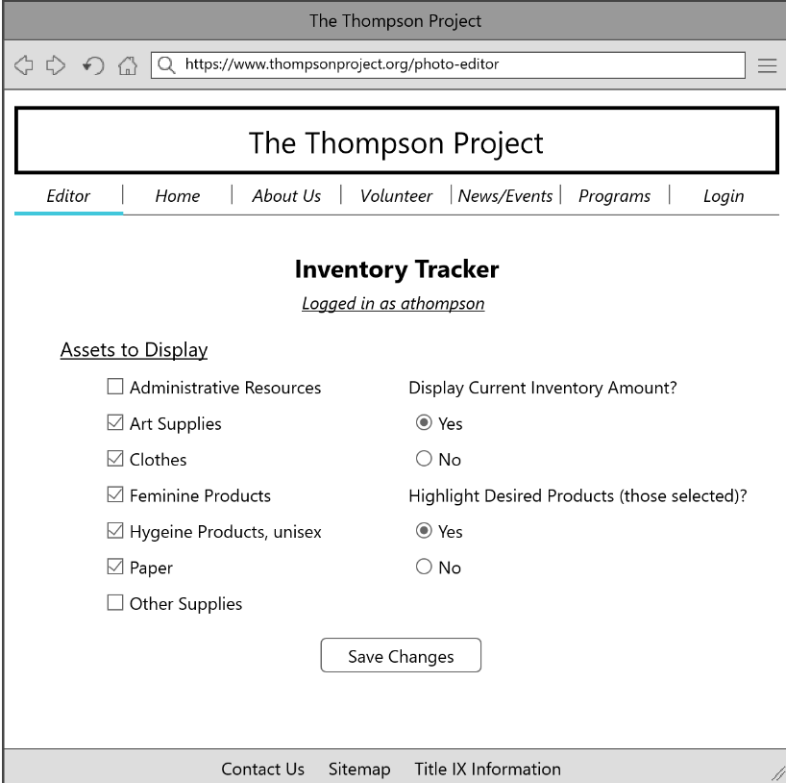

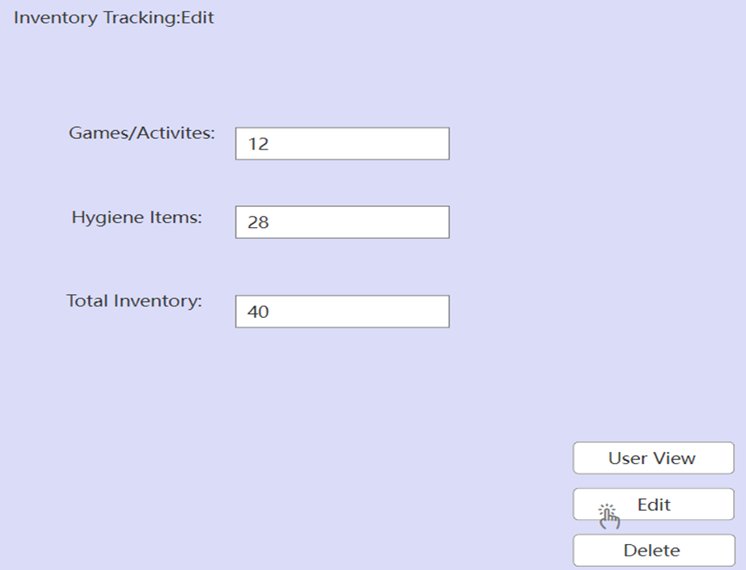

1. **Delete Inventory Tracker**

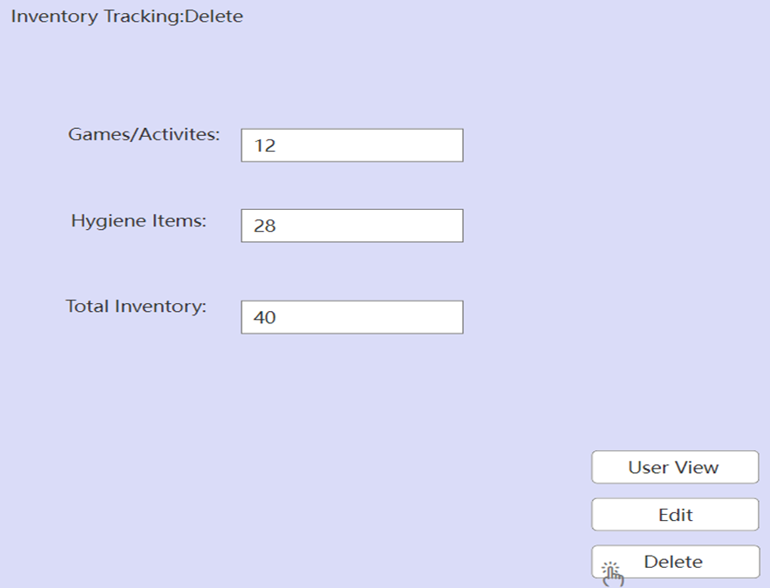

1. **Create Title IX Training**

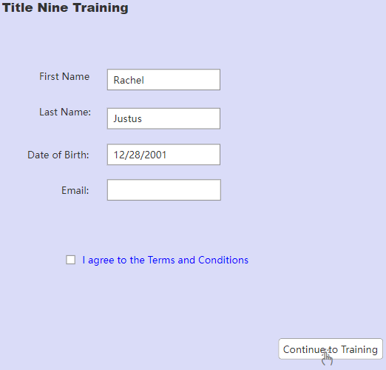

1. **Create Testimonial**



1. **Edit Testimonial**

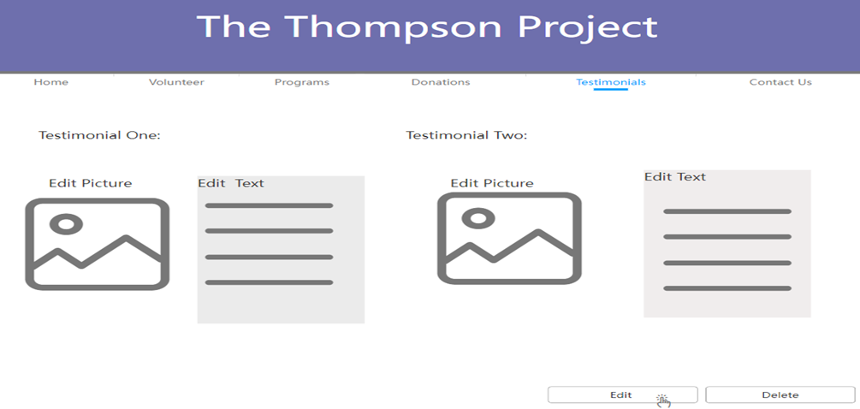

1. **Delete Testimonial**

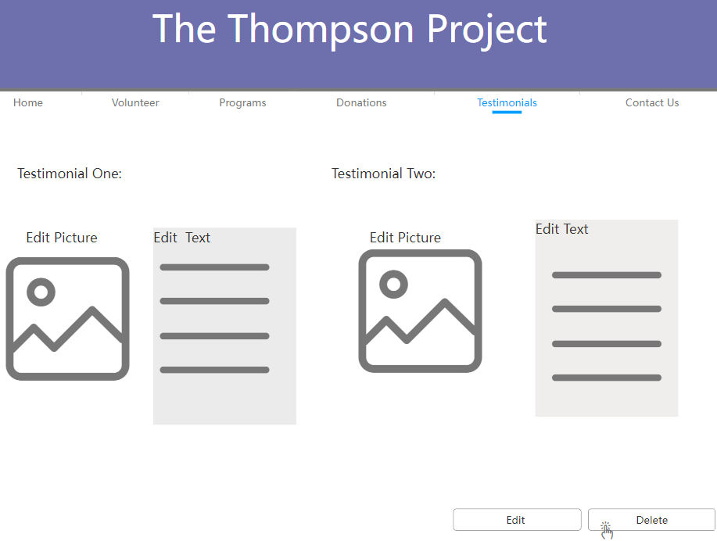

1. **Create Social Media Ties**

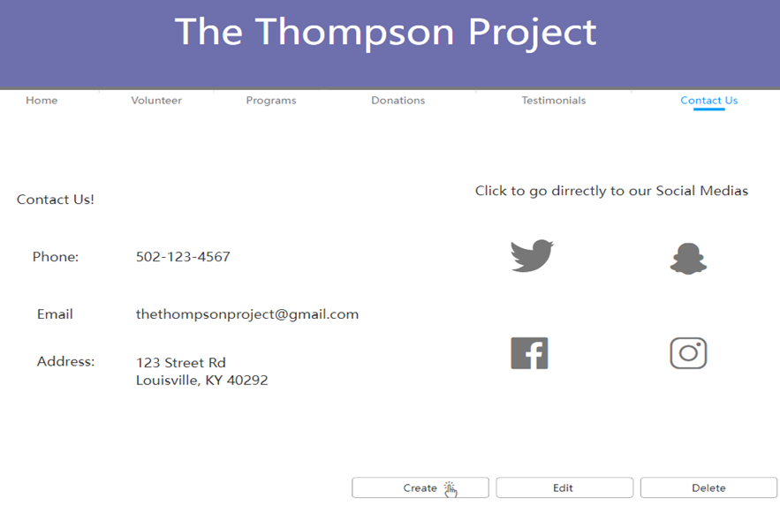

1. **Edit Social Media Ties**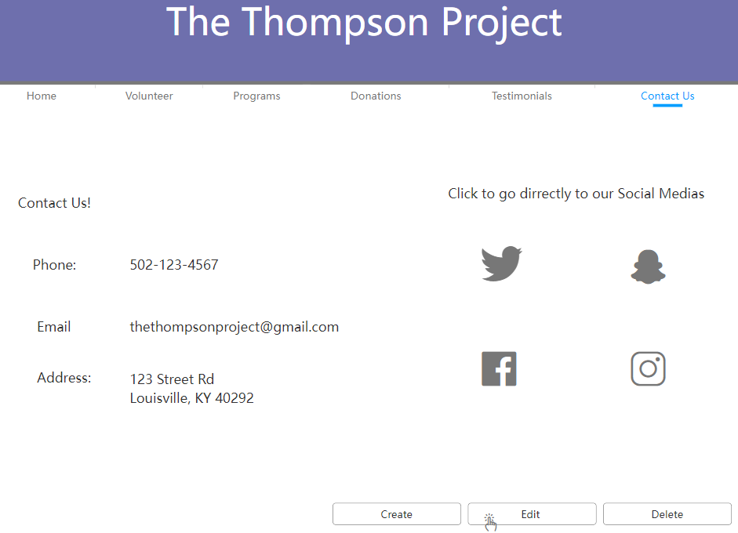
2. **Delete Social Media Ties**



1. **Create Attendance Tracker**

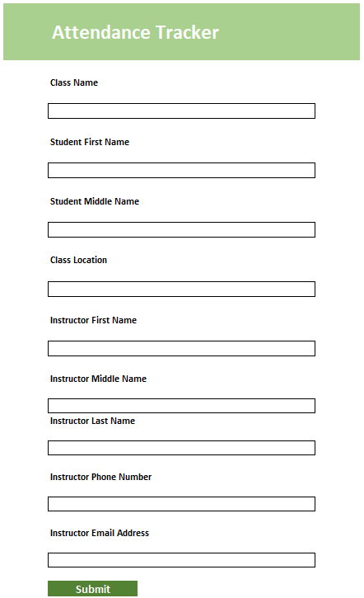

1. **Edit Attendance Tracker**



1. **Delete Attendance Tracker**

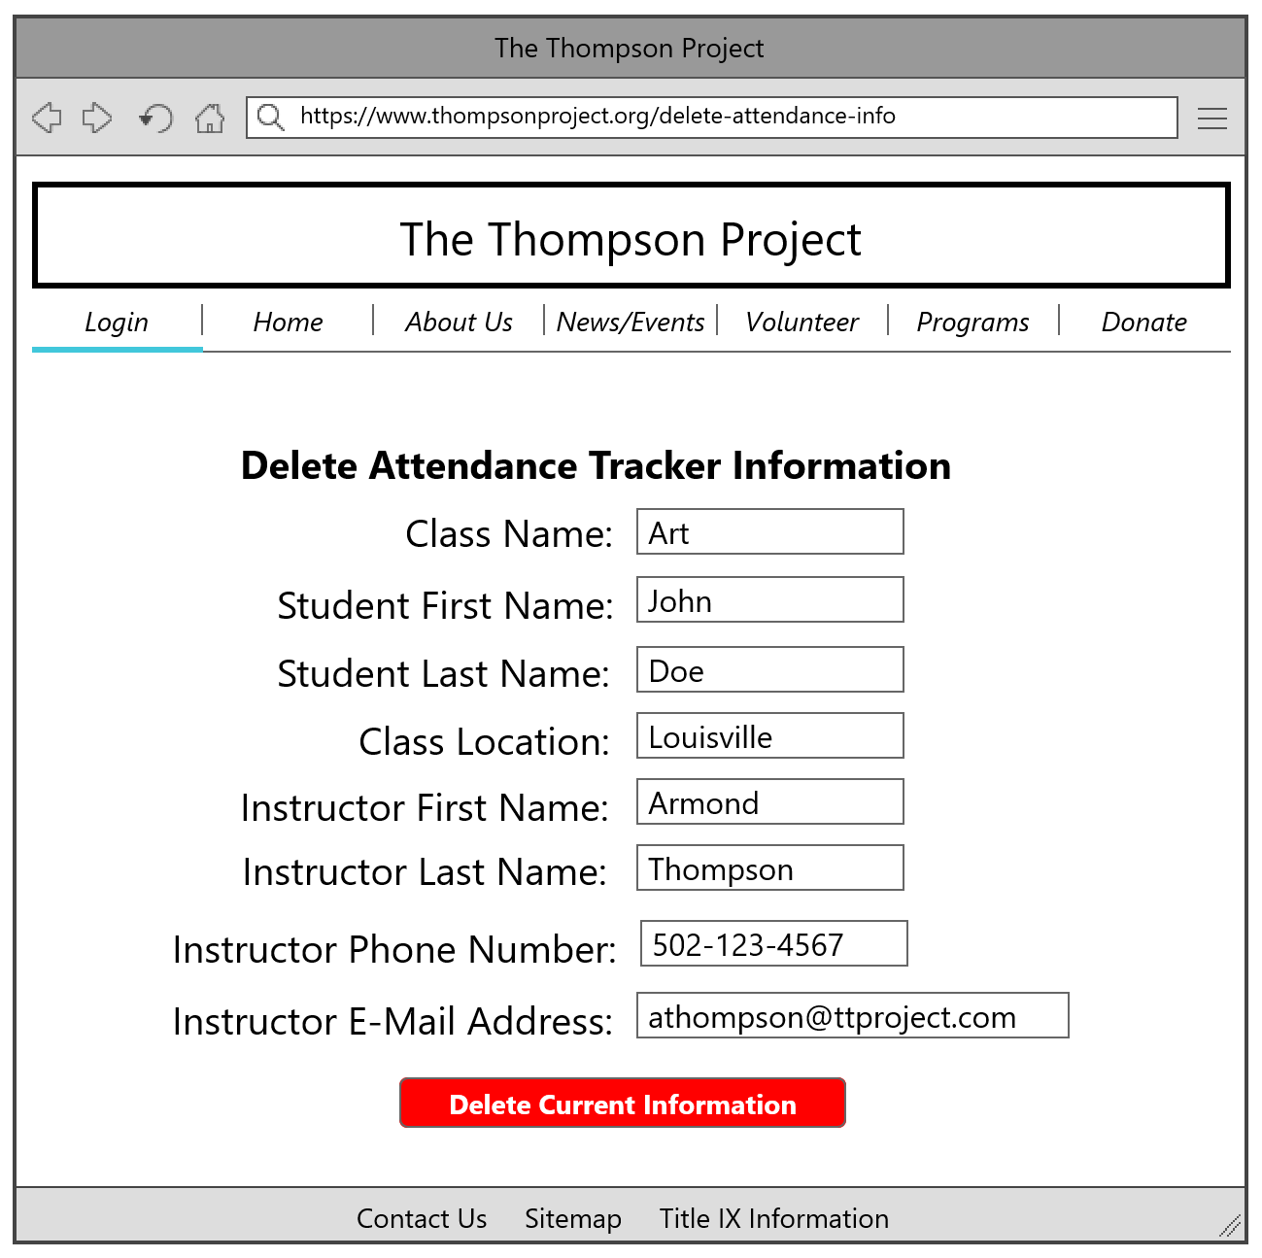

1. **Create Classes**

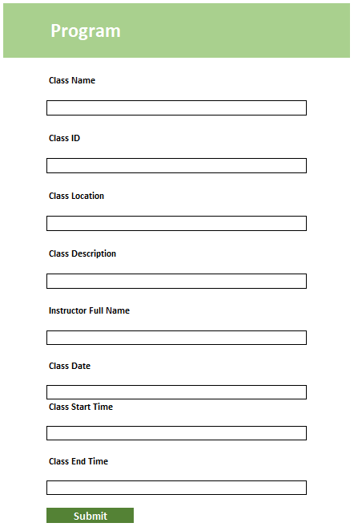

1. **Edit Classes**



1. **Delete Classes**

